Occupational Biomechanics

Brian Peacock

CONTENTS

SECTION 1: COURSE GUIDE
  - Introduction 1
  - Course Description and Aims 2
  - Learning Outcomes 2
  - Overall Assessment 3
  - Learning Materials 3
SECTION 2 : STUDY UNITS

STUDY UNIT 1

Learning Outcomes SU1-1

Overview SU1-1

Structural Functional and Surface Anatomy SU1-1

Skeleton SU1-2

Anatomical Planes and Movements SU1-4

Joints and Joint Structures SU1-5

Muscles SU1-7

Movements SU1-9

Controls of Movement SU1-9

STUDY UNIT 2

Learning Outcomes SU2-1

Overview SU2-1

Mechanics SU2-1

Postures by Pythagoras SU2-3

Scalars and Vectors SU2-5

Angle-Time Diagrams SU2-6

Acceleration SU2-9

Gravity SU2-9

Momentum SU2-10

Newton’s Laws SU2-10

Force SU2-11

Resolution of Forces SU2-12

Friction SU2-12

Inertia SU2-13

Moment SU2-14

Elasticity SU2-15Torque SU2-16

Surface Area SU2-16

Pressure SU2-17

Biomechanical Pressure SU2-17

Biomechanical Model SU2-18

STUDY UNIT 3

Learning Outcomes SU3-1

Overview SU3-1

Anthropometry SU3-2

Workplace Design SU3-7

Fitting Trials SU3-8

Joint Angles and Planes of Motion SU3-8

Motion Analysis SU3-10

Strength Testing SU3-10

Motor Skills Testing SU3-14

References SU3-15

STUDY UNIT 4

Learning Outcomes SU4-1

Overview SU4-1

Lifting Injuries SU4-1

The NIOSH Lifting Equation SU4-3

Snook Tables SU4-5

STUDY UNIT 5

Learning Outcomes SU5-1

Overview SU5-1

Musculo Skeletal Disorders SU5-1

Biomedical Risk Factors SU5-2

Other Risk Factors SU5-3

Anatomical Locations of WRMSDs SU5-4

Localised Fatigue SU5-4

Tendon SU5-5

Bursae SU5-6

Nerve Disorders SU5-6

The Neck SU5-7

The Shoulder SU5-8

The Elbow SU5-8

The Wrist SU5-9

The Hand SU5-10

Causation SU5-10

Diagnosis SU5-11

Treatment SU5-11

Engineering Controls SU5-11

Administrative Controls SU5-12

STUDY UNIT 6

Learning Outcomes SU6-1

Overview SU6-1

Anthropometry and Workplace Design Principles SU6-1

Biomechanical Limits SU6-2

Equipment and Hand Tool Design SU6-3

Spatial, Force and Temporal Analysis of Workplaces and Tasks SU6-4

Task and Job Analysis and Design SU6-5
Ergonomics Analysis and Interventions SU6-

Occupational Biomechanics

COURSE GUIDE

Course Description and Aims
Occupational Biomechanics addresses the structures, functions, capabilities and limitations of the musculo-skeletal system. The biological basis addresses structural, surface and functional anatomy, and some of the physiological processes underlying muscle contraction and control. The mechanics basis covers mechanical units, statics and dynamics. The biomechanics content addresses the measurement of posture and movement, and the associated moments, compressions and tensions in the various structures. The application content covers working postures, manual materials handling and manipulation activities. Contemporary occupational biomechanics also includes a collection of computer based biomechanical models. The pathology / epidemiology component addresses such things as low back strain and other work related musculo-skeletal disorders. Finally, the physical ergonomics component introduces various laboratory and field measurement tools and preventive approaches such as workplace, equipment, tool and task design.

Learning Outcomes

Knowledge & Understanding (Theory Component)

- Identify the structures and functions of the musculo skeletal system.

- Describe the processes of measurement of posture and motion.

- Illustrate the principles of statics and dynamics to biomechanics.

- Discuss the stresses associated with various occupations

- Understand the pathology of work related musculo skeletal disorders.

Key Skills (Practical Component)

- Determine appropriate field measurements and modelling tools to occupational situations.

- Analyse the results of both laboratory and field occupational biomechanics scenarios.

- Propose and design appropriate ergonomics interventions to occupational stresses.

Learning Materials

The following is a list of the required learning materials to complete this course.

Required Textbook

Authors  Last name, First name | Title | Year | Publisher
Kroemer K, Kroemer H and Kroemer-Elbert K | Ergonomics Chapters 1, 2, 5, 7, 8,  9, 11, 12 | 2001 | Prentice Hall

Occupational Biomechanics

STUDY UNIT 1

LEARNING OUTCOMES

At the end of this unit, you are expected to:
    - Identify the structures and functions of the musculo skeletal system
    - Describe the major musculo skeletal structures
    - Identify the major bones, joints and muscle groups
    - Describe the processes of measurement of posture and motion
    - Describe the motions of the joints
    - Describe the various muscle group functions associated with posture and movement

OVERVIEW

This unit covers an introduction to structural, surface and functional anatomy. Students will use Internet Images to visualise structures such as bones, joints and muscles. Next, they will carry out palpation and observation of body movements to learn the principles of kinesiology.

- Structural, Surface and Functional Anatomy
- Joint Movement
- Muscles
(Access videos via iStudyGuide)

STRUCTURAL, FUNCTIONAL AND SURFACE ANATOMY

- Structural, surface and functional anatomy is best learned by looking at palpating and moving your own body.

- The Internet has many very good pictures of anatomical structures; you should match your personal observations with these pictures.

- The anatomical names are often difficult to remember, but the general structures and functions are easy to visualise.

- Every time there is an anatomical term used, check out images on the Internet.

- To learn about anatomy, you should copy or sketch the structure image and create an annotated scrapbook. Examples of visual web sites include:

InnerBody: http://www.innerbody.com/htm/body.html Wikipeda: Skeletal Muscles of Homo Sapiens
http://en.wikipedia.org/wiki/File:Skeletal_muscles_homo_sapiens.JPG

- One fascinating source is the original Grey’s Anatomy (1918) – we haven’t changed much since then, but the pictures are getting better:

Grey’s Anatomy published by Bartleby.com: http://www.bartleby.com/107/

SKELETON

- Your limbs, legs and arms consist of long bones which provide levers for strong large range of motion movements.

- The ends of the long bones are enlarged to provide joint surfaces and attachments for ligaments and tendons.

ACTIVITY 1.1

- Refer to anatomical images on the Internet by typing in the joint name.
- Move your legs, arms or hands and watch your muscles contract as the bones
/ levers rotate around a joint.
- Palpate the ends of long bones around your knee, elbow, ankle and wrist and note where there are attachments of tendons and ligaments.
  - The middles of long bones are approximately cylindrical while the ends are enlarged to form joints.
- Sketch the bones of your limbs by joining up the bony points that you have palpated.
- Look at images of the femur, tibia, fibula, humerus, ulna and radius:
  - Identify the bony points that you can palpate on your own body.
  - How many bones can you palpate?
  - What are their shapes?
  - What are their names?

- Your spine consists of vertebrae separated by intervertebral discs; each vertebra consists of a short cylindrical body, an arch (through which the spinal cord runs), facet joints and various processes for the attachment of muscles and ligaments.

- Note that in the upright position, the upper part of your spine:
  - the cervical region has 7 vertebrae, and is concave backwards (lordosis).
  - the thoracic region has 12 vertebrae and is concave forwards (kyphosis).
  - while the lumbar region has 5 vertebrae and is concave backwards (lordosis).

ACTIVITY 1.2

- Bend forwards, backwards and sideways and rotate your back and neck. Measure the ranges of motion in the sagittal, frontal and horizontal planes.
  - Most rotation occurs in the thoracic region.
  - The full range of motion of your back is made up of many small movements in the facet joints and deformations in the discs.
  - The top two cervical vertebrae have special rocking and rotational movements – nod and shake your head.

- Examine a picture of the spine and describe the different shapes and facet joint orientations in the three main sections – cervical, thoracic and lumbar.

- Explain how different facet joint orientations allow different directions of movement in each spinal region.
  - Note that the sacral vertebrae are fused and together with the two hip bones, which consist of fused Ilium, Ischium and Pubis bones, form a protective wall (the pelvis) around your lower abdomen.

- Your hands and feet consist of short bones (wrist and ankle) and small “long bones” – fingers and toes:
  - Hands: carpals, metacarpals, phalanges
  - Feet: tarsals, metatarsals, phalanges

ACTIVITY 1.3

- Palpate all the bones in your wrist and feet. How many separate bones can you see? What are their shapes?
- Sketch the hand and foot skeleton.
- Identify the small irregularly shaped carpal (wrist) and tarsal (ankle) bones and the longer metatarsals, metacarpals and phalanges.
- Count the phalanges in your toes and fingers (and thumb).

- Your head, pelvis, shoulder girdle and rib cage have flat protective bones.

ACTIVITY 1.4

- How does breathing occur? Where is your diaphragm?
- Palpate the iliac crest and anterior superior iliac spine.
- What bones do you sit on? (ischial tuberosities)
- Palpate your Acromion Process, Spine of your Scapula, Clavicle, Sternum.
- Count your ribs.

ANATOMICAL PLANES AND MOVEMENTS

- Sagittal – divides the body into left and right sides
- Flexion and extension take place in the sagittal plane
- Frontal – divides the body into front and back
- Abduction and adduction take place in the frontal plane
- Horizontal – divides the body into upper and lower parts
- Rotation takes place in the horizontal plane

ACTIVITY 1.5

- Describe the Anatomical Position.
- Sketch the three planes of anatomical movement.
- Demonstrate all the movements at your hip, knees, ankles and shoulder, elbow and wrist.
- Describe the ranges of motion.
- If you outwardly rotate your arm (shoulder joint), why is it easier to raise your hand above your head?
- Demonstrate protraction, retraction, elevation and depression of your shoulder girdle.
- Have your partner raise his / her hand above his / her head and feel the movement of the tip of the scapula around the chest wall.
- What are the ranges of motion in your knees, elbows and fingers?
- Note that when your knee is bent it will rotate. Why?
- How many bones make up the elbow joint? Knee joint?
- Describe the shapes of the articular surfaces of all the limb joints.
- What are the ranges of motion of your spine?

JOINTS AND JOINT STRUCTURES

- Joints allow body segments to rotate in various planes (sagittal, frontal and horizontal).

- The shape of the joint surfaces and placement of the joint ligaments dictate their direction and range of motion. Synovial Joints have a fibrous capsule with a lubricated lining.

- Ball and socket joints like the shoulder and hip move in all directions:
  - Flexion, extension, abduction, adduction, medial and lateral rotation, circumduction

- The Shoulder Girdle consists of the clavicle (collar bone) and scapula.

- Hinge joints like the knee, elbow, fingers and toes flex and extend (check out other movements).

- Spinal joints (facet joints) and joints in your ankle, wrist and shoulder girdle slide short distances.

- Your forearm uses two joints to supinate and pronate:
  - Radio – ulnar joint above the wrist
  - Humerus – radius – ulna joint at the elbow
ACTIVITY 1.6

- Check what happens to the biceps muscle when you supinate your forearm strongly.
- Where do the biceps tendons insert?

- Your ankle joint(s) consist of the joints on all sides of the talus, which lies between the tibia (and fibula) and calcaneum.
ACTIVITY 1.7

- Examine a model of the talus.
- Measure the ranges of motion in your ankle and wrist.
- Observe, palpate and name the tendons around your wrist and ankle.

- Special joints like your knuckles and thumb flex, extend, abduct and adduct; your thumb also “opposes” allowing you to pinch and grip.

ACTIVITY 1.8

- How many ways can you grasp, grip and pinch?
- Why is opposition so useful?

- Synovial joints are kept in place by fibrous capsules, ligaments and tendons (the extensions of muscles).
ACTIVITY 1.9

- Palpate the ligaments and tendons around your knee.
- The stronger ligaments are at the sides of the joint that have minimal movement.
- Look at pictures of the ankle, knee, hip, finger, wrist, elbow and shoulder joints and see where the ligaments attach.

- The bone ends that form the joints are covered in cartilage that facilitates smooth movement.

- Some joints like the knee have cartilages between the two bone ends to further enable joint movement.

ACTIVITY 1.10
- Next time you eat a chicken leg, check out the bone ends.
- Look at a picture of the knee joint:
  - See where the cartilages are.
  - See how the medial ligament attaches to the cartilage. How do you tear a cartilage?
  - What is a meniscus?

- Synovial joints are encased in a capsule that contains lubricating synovial fluid.

ACTIVITY 1.11

- Look at a picture of the shoulder joint capsule.
- Create a large table of all the joints and their movement directions and ranges.

- Spinal joints are composed of cartilaginous discs with a fibrous external structure (annulus fibrosis) and a fluid central nucleus (pulposus). In addition, adjacent vertebrae are connected by synovial, sliding facet joints.

- Examine the orientation of the facet joints at different parts of the spinal column.

- A sprained joint is usually a tear in a ligament or tendon that passes close to the joint. The tears usually occur at the junction with the bone.

- Examine a drawing of the ankle; note the medial and lateral ligaments and all the tendons that pass around the ankle.
- Sketch a series of cross-sections of the ankle.

MUSCLES

- Limb muscles are generally long and thin and are attached to the bone ends, or protuberances, through ligaments.

- Muscles are described by their primary action – flexors, extensors, adductors, abductors etc.

- Frequently, limb muscles pass over two joints.
ACTIVITY 1.14

- Name the muscles that pass over the hip, knee and ankle; note their origins and insertions.
- Name the muscles that pass over the shoulder, elbow and wrist; note their origins and insertions.

Other muscles, around the hip and shoulder, are flat.

- Identify the glutei, pectorals, deltoid, latissimus dorsi and serratus anterior muscles.
- Draw the trapezius muscle.
- Note the origins and insertions.
- Describe the rotator cuff muscles.

- The spinal muscles have many layers and run vertically from the ilium to the skull attaching to the vertebral processes.

ACTIVITY 1.16

- Examine the two bands of erector spinae muscle when you arch (extend) your back.

- The abdominal muscles have four layers: rectus abdominus (your “six pack”) has vertical fibres, and the internal and external obliques have diagonal fibres.

- The deep transversus abdominis has horizontal fibres.
ACTIVITY 1.17

- Observe the activities of the abdominal muscles during lifting.

- Most muscles pass over two joints.

ACTIVITY 1.18

- Bend (flex) your wrist and then try to make a fist; next make a fist with your wrist extended. Examine the tendons of your finger extensors.
- Lift your (bent) knee up to your chin and then try to do the same with a straight knee. Check the attachments of your hamstrings.

MOVEMENTS

- The direction and range of movement of joints are dictated by the shape of the joint surfaces, the ligaments and muscles and contact with other soft tissues; clothing may also restrict joint movement.

- For the purpose of classification, joint movements are described in three orthogonal planes: Sagittal, Frontal and Horizontal.

- Flexion and extension occurs in the sagittal plane.

- Abduction and adduction occur in the frontal plane.

- Rotation occurs in the horizontal plane.

- Generally, however, most functional movements occur in complex oblique planes, usually involving rotation.
ACTIVITY 1.19

- Sketch the anatomical planes of motion.
- Demonstrate flexion, extension, abduction, adduction, internal and external rotation, circumduction, pronation, supination, inversion, eversion, opposition in as many joints as you can.
- Identify the prime mover and antagonist muscles involved in these movements.
- Describe some oblique pattern movements.

CONTROL OF MOVEMENT

- The prime mover or agonist shortens pulling two bones / segments together.

- The opposing muscles (antagonists) give out to produce a smooth movement.

- Synergists prevent unwanted movements when muscles pass over two joints.

- Fixators stabilise the proximal joints to allow fine control movements by the hands and feet.

- When a muscle contracts and shortens, this is called concentric contracts.

- When a muscle contracts but no joint movement occurs, this is called static or isometric contraction.

- When a muscle lengthens against an external force, this is called eccentric contraction.

- Give some examples of fixators and synergists.
- Demonstrate static (isometric), concentric and eccentric muscle activity.
- Describe four oblique pattern movements that occur during walking, kicking, pulling, pushing, throwing, eating etc.

HFS206e

Occupational Biomechanics

STUDY UNIT 2

LEARNING OUTCOMES

At the end of this unit, you are expected to:
- Employ the principles of statics and dynamics
- Describe the physical principles of motion, force, friction, pressure, momentum, inertia and moments
- Analyse the functions of the musculo skeletal system using statics and dynamics concepts
- Create free body diagrams to describe posture and static equilibrium
- Use the University of Michigan Static Strength Prediction model to analyse various postural and load bearing situations
- Create a series of Excel file to translate units and evaluate mechanical equations

OVERVIEW

This unit starts with the introduction of the mechanical principles of motion, force, friction, pressure, momentum, inertia, and moments. Next, the student will acquire knowledge of static equilibrium through group exercises and the creation of free body diagrams; the University of Michigan Three Dimensional Static Strength Prediction Program will be introduced. The principles of posture and movement will be learned through activities involving typical human postures and movements and described by the creation of sketches and angle time diagrams. Applied topics of force exertion in lifting, holding, carrying, pulling and pushing will be addressed through analysis of common human physical activities.

  - Introduction to Mechanics
  - Vectors and Movement
  - Newton’s Laws

MECHANICS

- All the basic mathematics and concepts related to this module are described very clearly at the Physics Classroom:
http://www.physicsclassroom.com/

- Dimensions:
  - Length can be measured as the distance between two points in any direction. Size (length, breadth, width, depth, radius, diameter, circumference) is measured in one dimensional units.
  - Shape and area are measured in two dimensions, such as length x breadth, and volume in three dimensions ‒ length x width x depth.
  - Location and displacement can be described in two or three dimensional space with reference to Cartesian or Polar coordinates.

ACTIVITY 2.1

- Measure the lengths, widths and girths of 5 body segments.
- Describe the body segments as standard geometrical volumes (truncated cone, cylinder, sphere etc).
  - Identify their centres of mass.
- Describe your shadow as the sun goes down.
- Why do racing bicycles have dropped handlebars?
- What did Archimedes say when he jumped in the bathtub? Why?
- Use Cartesian and Polar coordinates to describe the location of a point in two or three dimensional space with regard to a fiducial reference (0,0) or (0, 0, 0).
- Create an Excel matrix to translate length, area and volume units from Imperial to metric.
- What are rods, poles, perches, chains, links, furlongs and nautical miles?
- How far is it from Singapore to New York?
- Place 3 coins on a piece of paper; describe their relative and absolute locations and distances apart.
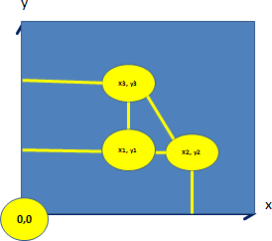

POSTURES BY PYTHAGORAS

- For a triangle, the sum of all the angles = 180 degrees.

- In a right-angled triangle:
2 2 2
c = a + b
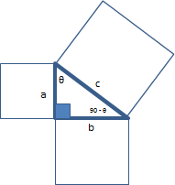
Sin(θ) = b / c Cos(θ) = a / c Tan(θ) = b / a

- Investigate the Sine and Cosine laws.

- Adopt 5 different postures:
  - Sketch sagittal, frontal and horizontal planes.
  - Measure the lengths of each body segment.
  - Identify the centre of mass of each segment.
  - Where is the overall centre of mass of your body?
  - Measure the joint angles.
  - Calculate the distances between alternate joints.
  - Measure the distances and check your calculations.
  - Develop an Excel program to perform all these calculations given a range of joint angles and segment lengths.
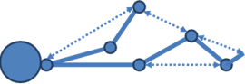

- While sitting at your desk, sketch a side view of your body.
- Describe the locations of your head, hip, knee, ankle, shoulder, elbow, and wrist.
- Measure the segment lengths between joint centres on your partner or obtain them from anthropometric tables.
- Develop an Excel spreadsheet to calculate the locations for each joint and the reach envelopes for the hand and foot by changing knee, shoulder and elbow angles.
- How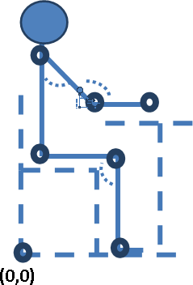 does sitting at a desk differ from driving a car in terms of posture?

SCALARS AND VECTORS

- Speed is a scalar quantity.

- Speed = Distance / Time

- Velocity is a vector quantity; it has both distance and direction.

- Velocity = Change in Location / Change in Time

- Draw two circles on a piece of paper, measure the distance between the centres; starting at A, alternately make 10 pencil dots in each circle and record the time taken.

- Calculate the Average Speed by dividing Distance * 10 by the Time taken.
- Sketch a Velocity-Time diagram for one cycle.

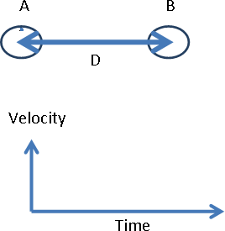

ANGLE-TIME DIAGRAMS

- Alternately flex and extend your shoulder, elbow and knee.
- Measure the joint angle at each end of the movements.
- Sketch Angle-Time diagrams for a single cycle.
- Indicate the full range of motion for each joint.

Repeat each movement 10 times, record the time taken and calculate the average angular velocity.
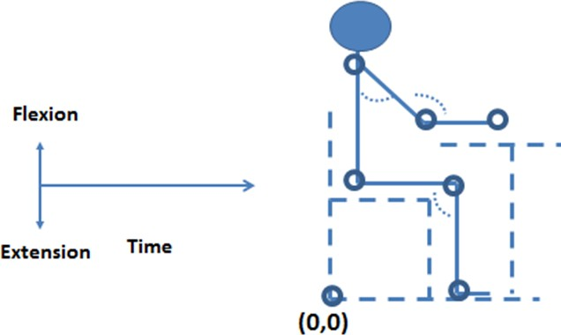

Two Joint Motions

- Throw a ball.
- Sketch a Shoulder Angle / Elbow Angle / Time diagram.
- Measure the angles at the beginning and end of the throw.
- How fast will the ball travel when it is released?
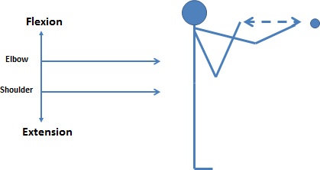
- Record the time taken to repeat the activity 10 times and calculate the average angular velocity of each joint.

Walking

- Sketch Hip and Knee Flexion and Extension Angle Time diagrams.

- Sketch Angular Velocity-Time diagrams for each joint.

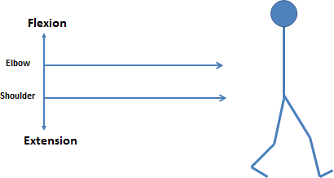
- What changes occur when you run or sprint?

ACCELERATION

1. Acceleration is the Rate of Change of Velocity.

- Sketch Velocity-Time diagrams for the hand and foot while throwing and walking.
- Note that the velocity starts at 0, increases (accelerates) and then decreases (rapidly) to zero at the end of the cycle.
- The slope of the Velocity-Time line represents the acceleration.

GRAVITY

- On earth the “force of gravity” causes objects to accelerate towards the earth at g = 9.81 m/s2 = 32.2 ft/s2.

- The weight (a force) of an object is its mass times the acceleration due to gravity.

- How heavy would you weigh on Mars and the Moon?
- How fast does a skydiver fall?
  - Why?
  - Sketch
    - Altitude – Time
    - Velocity – Time
    - Acceleration – Time
- How does gravity affect running and cycling? What is the effect of body weight?
- Why can you cycle faster than you can run?
- Why is it easier to run uphill than cycle uphill?
- What is the effect of shoe weight on long distance running performance?

MOMENTUM

1. Momentum is mass time velocity.

- Place a 50 cent, 20 cent and 10 cent coins on a piece of paper.
- Alternately pick up one of the coins and use it to flick the second coin into the third.
- Measure the distances moved with each combination of coins.
- Explain the different distances.
- Explain and demonstrate Conservation of Momentum
  - m1v1 = m2v2
- What stops the coins?
- What happens when:
  - you clap your hands?
  - you kick or head a football?
  - you hit a ball with a bat or racquet?
  - a bus hits a motorcycle?
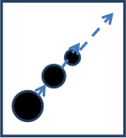

NEWTON’S LAWS

- An object at rest stays at rest and an object in motion stays in motion with the same speed and in the same direction unless acted on by an unbalanced force (such as gravity or friction or a collision with another object).

- The acceleration of an object as produced by a net force is directly proportional to the magnitude of the net force, in the same direction as the net force, and inversely proportional to the mass of the object.

- Force = mass x acceleration F = ma

- For every action, there is an equal and opposite reaction.

- Demonstrate Newton’s Laws using the coins on the paper.
FORCE

- Velocity = distance / time
- Momentum = mass * velocity
- Acceleration = Velocity / time
- Force = mass * Acceleration

- What happens when you:
  - kick a football?
  - lift a box?
  - push a hand cart?
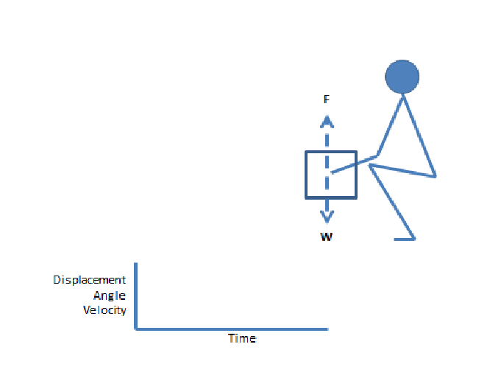

- For Sagittal plane lifting
  - Sketch knee and hip angle-time, box displacement-time, and velocity- time diagrams.
  - Calculate the moment of Force around the hip, knee and shoulder.

RESOLUTION OF FORCES

1. A force may be resolved into its orthogonal components ‒ x , y, and z.

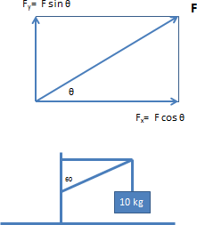
- Indicate the directions and calculate the magnitudes of the force components in the first diagram given different values of F and Ѳ. Analyse the forces in the second diagram.

FRICTION

- Repeat the momentum exercise; explain why the small coin slides further.
- What happens in the diagram below when W and Ѳ change?

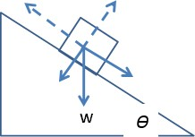

- Place three coins on a book and gradually tilt the book. Which coin moves first? Why?
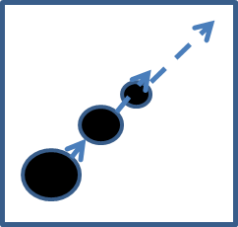

- Why can airplanes fly?
- What happens when you run on ice?

INERTIA

1. Inertia – Newton’s first law – an object keeps doing what it has been doing unless it meets some resistance (another force).

- In the coin pushing experiment, why do the coins stop moving?
- How does a pendulum work?
- What happens when the two coins collide?

MOMENTS

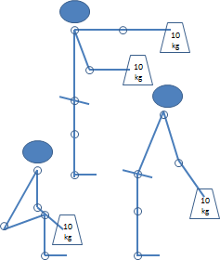
- Moment = Force times Distance

Refer to the diagram above:
  - Measure the segment (joint centre to joint centre) lengths on your own body.
  - Estimate the joint angles.
  - Calculate the moment of Force around the shoulder and hip in each posture.
  - Create an Excel spreadsheet to calculate moments around each joint given segment lengths and joint angles.

ELASTICITY

- Elasticity is a physical property of materials which return to their original shape after they are deformed:

  - If you stretch a spring, it will return to its original length when you let go.

  - If you drop a ball, it will change shape and rebound back up.

  - Hooke's law is a principle of physics that states that the force F needed to extend or compress a spring by some distance X is proportional to that distance.

  - F = kX, where k is a constant factor characteristic of the spring, its stiffness.

  - The coefficient of restitution is the ratio of speeds of a falling object, from when it hits a given surface to when it leaves the surface. This explains how high a ball bounces.

  - Many human body materials have elastic properties.

  - The ligamentum flavum that connects the vertebrae behind the body is elastic.

  - Tendons have stretch sensors (Golgi organs).

- What happens when you poke a soft area of your hand with your finger?
- Drop or throw various balls on the floor. Why do they rebound differently?

TORQUE

- Torque: “The turning moment”

Explain:
  - How bicycle gears work.
  - How a wrench works.
  - How a screwdriver works.
  - How much force / torque it takes to unscrew a bottle cap.
  - Why buses have power assisted steering.
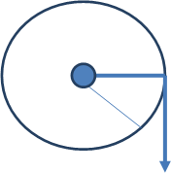

SURFACE AREA

- Surface Area: Two dimensions

- A Rectangle
SA = Length X Width

- A Triangle
SA = ½ B * H

- A Circle
  - Radius R
  - Diameter D = 2R
  - Circumference Surface Area = ∏R2

- Rotate different objects (pencil, piece of paper, hand phone) on your desk and measure the changes in surface area of the shadow.
- Sketch the light directions and the subtended angles caused by the object in different orientations.

PRESSURE

1. Pressure = Force/ Area

- What is a “Newton”?
- Take a pen or pencil and press the blunt end into your hand then with the same force press again with the sharp end. You just experienced PRESSURE.
- Describe 5 kinds of handle.
- Create an Excel spreadsheet to translate pounds / square inch to kilograms / square centimetres.

BIOMECHANICAL PRESSURE

- Calculate the vertical pressure on the discs in the Cervical, Thoracic and Lumbar regions in upright standing.
- The moment created by the load has to be balanced by that of the back muscles, with help from the spinal ligaments and intra-abdominal pressure.
- Explore the shear forces during lifting.
- What is torsion?
- Sketch the directions and magnitudes of forces on the spine during lifting. Include muscle forces.
- What is the effect of intra-abdominal pressure during lifting? How does posture affect the disc pressure during lifting?

BIOMECHANICAL MODEL

- A free body diagram is a pictorial device to describe all the forces acting on a structure.

F
N
mg
Ѳ

- Static equilibrium occurs when the sums of forces in each direction (including rotational forces) equal zero.

Draw free body diagrams for the following static equilibrium situations:
  - Standing on a slope
  - Sitting in a chair with arms and back “supported”
  - Holding your book bag at arm’s length
  - Bending over while lifting a weight (don’t forget to include the muscle forces)
  - Pinching a (vertical) piece of paper between your fingers
  - Holding the “push up” position
  - Walking on crutches
  - “Standing” on your hands

- Draw a Saggital plane view of a lifting task; indicate all the joint angles (from the Horizontal plane) and the forces due to body segment weight, load weight, major muscle group contraction, compression in the spinal column and reaction forces in the leg and arm joints.

- Create an Excel model to investigate changes in forces due to postural change and load weight change.

- The University of Michigan Three Dimensional Static Strength Prediction Program is a very elaborate model that analyses all the forces that occur when a person holds an object in various (static) postures.

- Explore the use of the UofM3DSSPP in the Human Factors Laboratory.

Occupational Biomechanics

STUDY UNIT 3

LEARNING OUTCOMES

At the end of this unit, you are expected to:
- Carry out standard anthropometric measurement
- Apply anthropometric data to the design of workplaces involving different postures
- Apply video methods to the analysis of gait, manual materials handling and upper limb motions
- Use standard measures for the assessment of back and arm strength
- Use standard tools for the assessment of sensory motor skills
OVERVIEW

This laboratory session will cover the techniques of anthropometry, and strength, movement and motor skills measurement and analysis as applies to workplace and task design. Students will carry out standard anthropometric measurements based on International Standards and use the Drillis and Contini and similar models and data to predict segment length, breadth and girth dimensions. Motion analysis will use observational methods and the use of a video based motional analysis system. Strength testing will involve the measurement using various dynamometers to establish a class strength profile. The Minnesota Blocks Test and Lafayette Instruments Manual Dexterity test will be used to assess sensory motor skills along with a demonstration of Fitts Law.

- Laboratory Methods
- Experimental Procedures

ANTHROPOMETRY

- Anthropometry is the measurement of body size and shape for the purpose of workplace, equipment and clothing design, growth and physical performance analysis and prediction.

- Common methods employ jigs and fixtures to standardise body postures and various tapes and callipers for measuring defined dimensions. Over the past two decades, body scanning has expanded the science and utility of anthropometry.

- Measurements include segment length, width and girth, and weight.

- Measurement consistency is achieved through the application of International Standards:
  - ISO (7250-!:2006 Basic human body measurements for technological design
– Part 1: Body measurement definitions and landmarks
  - ISO/TR 7250-2 2010 Basic human body measurement for technological design – Part 2: Statistical summaries of body measurements from individual ISO populations

- Measurement procedures start with the identification and marking of standard palpable bony points.

- It should be noted that the reference points for anthropometry as applied to workplace design are generally not the joint centres of rotation, that are used for anthropometric modelling purposes.

- Standard segment length measures include: stature, sitting height, arm length, knee height, buttock popliteal length.

- Standard widths include biacromial width, bideltoid width, elbow width and hip width. Depth measures include chest and abdominal depth, and thigh thickness. It should be noted that width measurements may be between bony points or include the slight compression of soft tissues; Girth measures include chest, abdomen and limbs.

- Statistical methods
- Population sampling is usually through convenience sampling, although large populations such as the military are able to assure representativeness.
- Error reduction is achieved by repeated measurements of each dimension.
- Each dimension is tabulated for all the subjects and standard statistical parameters are calculated including mean, range, standard deviation and various percentiles. Commonly, the 5th and 95th percentiles are used for work place design. Typical data for a Singapore population is shown below:
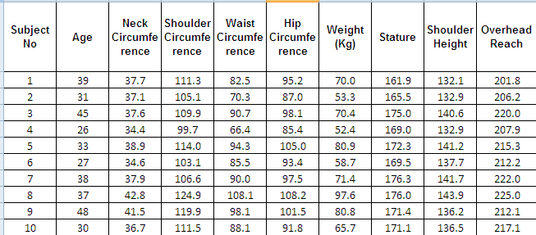

- Summary data from the Tong, Low and Chui (2011) Singapore study is in the following table:

 | Average | SD | Weight Correlation | Stature Correlation | Average  Weight Ratio | Average  Stature Ratio
Age | 30.89 | 6.24 | 0.21 | -0.23 | 0.45 | 0.18
Neck Circumference | 37.17 | 2.92 | 0.82 | 0.00 | 0.54 | 0.22
Shoulder  Circumference | 112.60 | 7.76 | 0.88 | 0.12 | 1.65 | 0.66
Waist Circumference | 84.02 | 10.16 | 0.87 | 0.00 | 1.22 | 0.49
Hip Circumference | 96.81 | 7.15 | 0.90 | 0.16 | 1.42 | 0.56
Weight (Kg) | 69.28 | 14.96 | 1.00 | 0.26 | 1.00 | 0.40
Stature | 171.73 | 7.27 | 0.26 | 1.00 | 2.53 | 1.00
Shoulder Height | 139.11 | 6.89 | 0.36 | 0.96 | 2.05 | 0.81
Overhead Reach | 215.05 | 12.99 | 0.31 | 0.95 | 3.17 | 1.25
Span | 172.89 | 9.93 | 0.30 | 0.86 | 2.55 | 1.01
Shoulder to Elbow  Length | 34.56 | 2.08 | 0.37 | 0.79 | 0.51 | 0.20
Chest Breadth | 31.35 | 3.34 | 0.81 | 0.11 | 0.46 | 0.18
Chest Depth | 20.06 | 2.98 | 0.83 | 0.01 | 0.29 | 0.12
Sitting Waist Depth | 21.60 | 2.75 | 0.80 | -0.03 | 0.31 | 0.13
Shoulder Breadth | 45.92 | 2.69 | 0.77 | 0.22 | 0.67 | 0.27
Biacromial Breadth | 40.23 | 1.35 | 0.30 | 0.34 | 0.59 | 0.23
Forearm To Forearm | 47.21 | 5.87 | 0.91 | 0.10 | 0.69 | 0.28
Maximum Head  Length | 20.90 | 0.76 | 0.58 | 0.06 | 0.31 | 0.12
Head Length | 19.05 | 0.94 | 0.64 | 0.06 | 0.28 | 0.11
Maximum Head  Height | 23.23 | 0.99 | 0.32 | 0.25 | 0.34 | 0.14
Head Breadth | 16.12 | 0.35 | 0.22 | 0.21 | 0.24 | 0.09
Head Circumference | 57.79 | 1.66 | 0.59 | 0.24 | 0.85 | 0.34
Hand Length | 18.79 | 1.04 | 0.33 | 0.53 | 0.28 | 0.11
Hand Breadth  (Metacarpal) | 8.08 | 0.42 | 0.68 | 0.34 | 0.12 | 0.05
Wrist Circumference | 16.59 | 0.71 | 0.80 | 0.16 | 0.24 | 0.10
Sitting Buttock To  Popliteal Length | 45.75 | 3.25 | 0.43 | 0.63 | 0.67 | 0.27
Sitting Buttock To  Knee Length | 58.78 | 3.32 | 0.45 | 0.71 | 0.86 | 0.34
Elbow To Fingertip | 46.13 | 2.67 | 0.30 | 0.77 | 0.68 | 0.27
Forward Reach | 83.62 | 5.48 | 0.43 | 0.75 | 1.23 | 0.49
Sitting Eye Height | 78.86 | 2.99 | 0.31 | 0.78 | 1.16 | 0.46
Sitting Shoulder  Height | 58.98 | 3.29 | 0.35 | 0.67 | 0.87 | 0.34
Elbow Rest Height | 25.47 | 3.43 | 0.15 | 0.12 | 0.37 | 0.15
Thigh Clearance | 14.99 | 1.34 | 0.61 | -0.02 | 0.22 | 0.09
Sitting Knee Height | 52.66 | 2.64 | 0.30 | 0.73 | 0.78 | 0.31
Sitting Popliteal  Height | 40.67 | 1.71 | 0.03 | 0.72 | 0.60 | 0.24
Sitting Height | 91.24 | 2.95 | 0.26 | 0.83 | 1.34 | 0.53
Sitting Overhead  Reach | 134.81 | 6.97 | 0.23 | 0.84 | 1.99 | 0.78
Sitting Hip Breadth | 36.46 | 3.66 | 0.87 | 0.13 | 0.53 | 0.21
Foot Length | 25.44 | 1.35 | 0.35 | 0.67 | 0.37 | 0.15
Ankle Height | 6.98 | 0.31 | 0.15 | 0.35 | 0.10 | 0.04
Heel Breadth | 5.86 | 0.38 | 0.55 | 0.23 | 0.09 | 0.03
Ball Of Foot Width | 9.75 | 0.41 | 0.61 | 0.06 | 0.14 | 0.06
Ball Of Foot  Circumference | 24.28 | 1.06 | 0.47 | 0.01 | 0.36 | 0.14
BMI | 23.52 | 4.56 | 0.88 | -0.22 | 0.34 | 0.14

- In general, many dimensions are highly correlated as shown by Drillis and Contini (1966), length measures are correlated with stature, whereas width and girth are more highly correlated with weight.

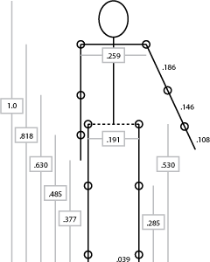

- Sample correlations among dimensions from the Singapore study are as follows:
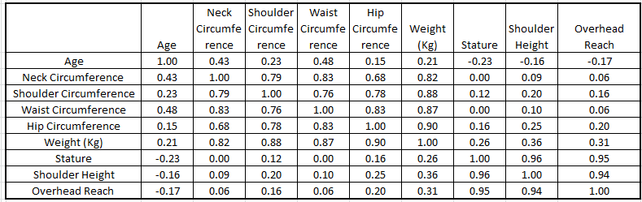

SOURCE: Tong, X, Low, WP and Chui YP, 2011

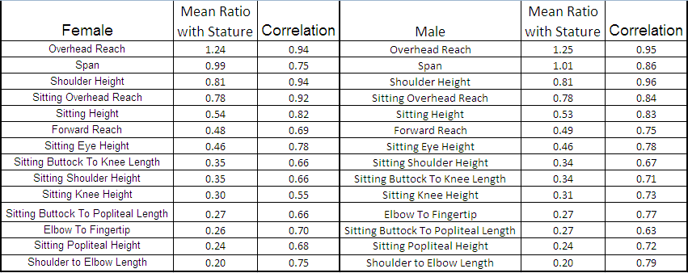

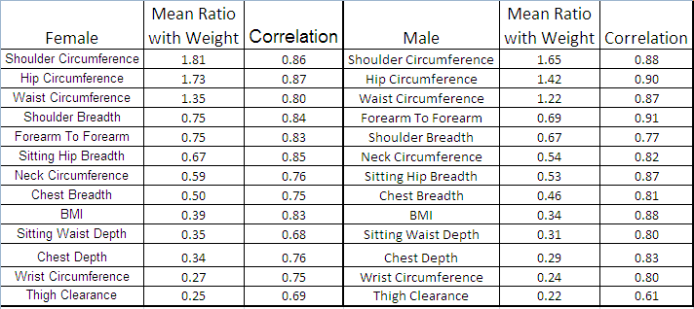
SOURCE: Tong, X, Low, WP and Chui YP, 2011

- Sheldon (1940) described body shape on a three dimensional 7 point scales of ectomorphic (lengthiness), mesomorphic (broad shoulders and muscularity) and endomorphic (rotund).

- Carry out an anthropometric survey of the class members as described in the laboratory procedures manual.

WORKPLACE DESIGN

- Workplace design or workspace design is one of the earliest and basic ergonomics methods. The purpose of the application of anthropometric data is to facilitate physical and visual access, allow small people to comfortably reach necessary objects in the area, and to allow large people to fit comfortably without interference with items such as controls.

- The general principles are to accommodate the 95th percentile for fit and the 5th percentile for reach. However these principles are somewhat simplistic and sometimes infeasible because of the less than perfect correlation among body segments, the need to address multiple segments and postures in a particular and the conflicting reach / fit requirements in many workplaces. An alternative principle is to accommodate 90% or 95% of the population.

- Identify the dimensions needed to design a chair and table.

- Define the reference points for measurement.
  - Note that the measures will not be to the centres of joint rotation, but rather to some external joint feature that is perhaps covered by soft tissue.
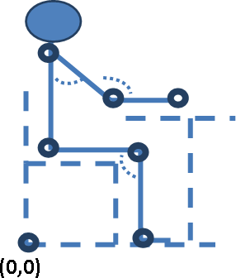

- Repeat the activity to accommodate a car driver, a bank teller and a bus standing or sitting passenger.

FITTING TRIALS

- An alternative or adjunct to anthropometry is the process of “Fitting Trials”.

- This process involves presenting adjustable workplaces systematically to subjects and have them choose which is the most comfortable dimension or combination of dimensions.

- The procedures of fitting trials are derived from the Weber-Fechner method of psychophysics. It should be noted that the design recommendations based on anthropometry are not always the same as those derived from fitting trials.

- Using an adjustable height chair, have (blind folded) class members systematically judge the most comfortable height, using both ascending and descending trials.

- Repeat the exercise with an adjustable height computer workstation.

JOINT ANGLES AND PLANES OF MOTION

- Joint movements and range of motion are determined by the shape of the joint surfaces, the muscles and ligaments passing over the joint, the position of adjacent joints and the proximity of soft tissues.

- Joint angles are measured with a goniometer.

- More sophisticated joint measurement tools use electrical potentiometers or video analysis.

- The standard anthropometric planes of motion are:
  - Sagittal (divides the body into left and right halves)
  - Frontal (divides the body into front and back halves)

  - Horizontal (divides the body into upper and lower halves)

- There are a number of terminology variations among these planes. Search Internet Images for “Anatomical Planes”.

- Anatomical movements for the major joints, including the spine, are:
  - Flexion / Extension in the sagittal plane
  - Abduction and adduction in the frontal plane
  - Internal and external rotation in the horizontal plane
  - Circumduction which is a combined movement at the shoulder and hip

- Other movements include:
  - Pronation and supination in the forearm
  - Inversion and eversion at the ankle
  - Opposition of the thumb
  - Sliding motion in the spinal facet joints

- Compile a list of joints and planes and ranges of motion.

- Most functional movements involve oblique patterns:
  - Eating ‒ Flexion, adduction and external rotation
  - Throwing ‒ Flexion, adduction and medial rotation

- Describe some oblique functional pattern movements at the shoulder and hip.

MOTION ANALYSIS

- All movements involve spatial locations and time, and hence velocity, acceleration and sometimes jerk. Because of the mass of the body / limb, the manipulated object and gravity, all movements involve force and inertia.

- Single joint movements require polar coordinate analysis.

- A single joint movement may be described by:
  - Angle-time diagrams
  - Velocity-time diagrams
  - Force-time diagrams

- Multiple joint movements may be described by:
  - Angle / angle / time diagrams
  - Polar coordinates of the hands or feet

- Complex motions such as gait are usually analysed by video motion analysis: http://www.vicon.com/applications/

- Sketch an angle-time diagram for the knee during a full gait cycle (toe off to toe off).
- Sketch a coordinated hip and knee angle time diagram for a gait cycle.
- Sketch a force-time diagram for a gait cycle.
- Sketch angle-time diagrams for the elbow and shoulder during throwing.
- Sketch a velocity-time diagram for a ball during throwing.
  - How far will the ball travel before it hits the ground?

STRENGTH TESTING

- Strength is determined by muscle size (cross-sectional area), muscle type (red and white fibres), conditioning, range of motion (inner, middle, outer), knowledge of results, motivation, fatigue, direction of movement (concentric, isometric or eccentric), speed of movement, and individual differences such as age and sex.

- Strength testing may involve individual muscles / joints, multiple joint activity, complex functional activities, such as lifting, holding, carrying, pulling or pushing, or competition, such as jumping or throwing.

- In general, simple standardised measures will be predictive of complex performance, for example, a standard grip test will be predictive of upper body strength and a static lifting test will be predictive of occupational manual materials handling capability.

- For comparison reliability purposes, it is important that laboratory methods address, control or standardise for all of these variables.

- Muscle Size – Large muscles can exert more force than smaller muscles; the leg muscles – glutei, quadriceps, gastrocnemius – that collectively develop the thrust action – lifting the body weight against gravity are particularly large and strong, but their movements tend to be coarse. Smaller muscles such as those of the hands and eyes need to exert less force, but offer more precise control.

- Compare the relative sizes of the leg, hip, trunk, shoulder and arm muscles. Describe their habitual actions in relation to gravity.

- Muscle Type ‒ Range of Motion – Muscles tend to be stronger in their middle range as compared with outer and inner ranges.

- Compare your grip strength with a wide, narrow and medium grasp.

- Conditioning – Athletes are stronger than ordinary people and workers with a history of heavy manual work are stronger than office workers.

- Message, if you want to be strong, work out!

- Knowledge of Results and Motivation ‒ A test of maximum voluntary contraction of isolated quadriceps contraction using an isokinetic dynamometer, demonstrated conclusively that the provision of objective feedback of performance (a force gauge) had a greater effect on force output than encouragement from an attendant therapist. Whereas therapists generally offer encouragement to patients, this may be less effective than objective feedback.

- Compare grip, pinch and back lift tests with and without objective feedback.

- Fatigue – Muscles become weaker with continued activity (especially static activity) due to the physiological need to remove the waste products of contraction, namely lactic acid, carbon dioxide and heat. Consequently, it is important to provide sufficient rest between exertions in strength tests.

- Perform repeated maximum effort grip, pinch, leg and back strength tests with varied between test intervals. Analyse the effect of rest and recovery on performance.

- Direction of movement – Muscles work concentrically (shortening), statically (isometrically) and eccentrically (lengthening). The hip and knee extensors and ankle plantar flexors work eccentrically when you walk down stairs or jump down from a height.

- Age and Sex – Older people and women are generally weaker than young men, although this difference may be predicted by muscle size and conditioning.

- Individual joint tests require the stabilisation of the proximal joint. For example, a quadriceps strength test requires that the thigh be strapped to the chair or plinth. Care must be taken to control for range of motion (inner, middle or outer).

- Multiple joints – Many strength tests as in weight lifting involve coordination of multiple joints and muscle groups – as in the squat (ankle, knee and hip) and press (shoulder and elbow).

- Complex functional activities – Most functional activities involve combined contributions of the legs, trunk and arms. Consider the muscle and joint actions involved in pushing or pulling a hand cart, or lifting a box or suitcase from the floor.

- Discuss the wisdom of allowing airplane carry-on baggage to have wheels. Passengers are able to pull greater weights than they can lift into the overhead bins.
- Analyse the strength requirements of lifting luggage into the overhead bin in an airplane.

- Speed of movement – In weight lifting, competitors can usually “clean and jerk” greater weights than they can “clean and press”.

- Discuss the mechanics of these two actions.
- Competition is a familiar way of comparing strength. Carry out
  - Grip test
  - Pinch test
  - Static lift test
  - Isokinetic dynamometers
  - Free weights
- Create a histogram of individual differences.

- Go to a gymnasium.
- Describe the ranges of joint motions associated with 5 weight machines.
- Look at the pictures on the wall.
- Name the muscle groups associated with each piece of apparatus.

MOTOR SKILLS TESTING

Task “difficulty” – distances and targets - Fitts Law.

- Draw pairs of circles of different diameters and distances apart.
- Carry out timed reciprocal tapping tests.
- Plot the associations between times and target size / distance.
- Explore Fitts Law and variations.
- Note how performance improves with practice.
- Explore De Jong’s law.
- Carry out the following motor skills activities as described in the Laboratory manual:
  - Purdue pegboard
  - Minnesota blocks tests

REFERENCES

  - Contini, R., Drillis, R. and Bluestein, M. (1963) Determination of body segment parameters, Human Factors, 5 (5)
  - Drillis, R. and Contini, R. (1966) Body segment parameters. DHEW 1166-
03. New York University, School of Engineering and Science, New York
  - Harrison, C. R. and Robinette, K. M. (2002) CAESAR: Summary statistics for the adult population (ages 18-65) of the United States of America. AFRL-HE-WP-TR-2002-0170. United States Air Force Research Laboratory
  - Pheasant, S. and Haslegrave, C. M. (2006) Bodyspace, Taylor and Francis
  - Pheasant, S. (1982) A technique for estimating anthropometric data from the parameters of the distribution of posture, Ergonomics, 25, 981:982
6. Rajulu, S. (2009)
http://ntrs.nasa.gov/archive/nasa/casi.ntrs.nasa.gov/20090026488_200902 6743.pdf
- Roe, R. (1993) “Occupant packaging,” in Automotive Ergonomics, Peacock and Karwowski, Taylor and Francis
- Roebuck, J. A., Kroemer, K. H. E. and Thompson, W. G. (1975) Engineering anthropometry methods, New York, Wiley
- Sheldon, William H. (1940) The varieties of human physique (An Introduction to Constitutional Psychology), Harper & Brothers
- Tan, K. C., Hartono, M. and Kumar, N. (2010) Anthropometry of the Singaporean and Indonesian populations, International Journal of Industrial Ergonomics, 40, (757-766)
- Tong, X, Low, W. P. and Chui, Y. P. (2011) Anthropometry analyses of Singapore populace. Final Report submitted to Centre for Applied Research (CFAR), Project Number: RT 10SST103, SIM University

Occupational Biomechanics
STUDY UNIT 4

LEARNING OUTCOMES

At the end of this unit, you are expected to:
- Understand the pathology of work related musculo skeletal disorders
- Recognise the stresses associated with various occupations
- Describe the structures and functions of the spinal column and the causes and sites of injury
- Apply the NIOSH Lift equation (NLE) to the analysis of manual materials handling tasks
- Understand the limitations of the NLE
- Apply the Liberty Mutual (Snook) Tables to the analysis of lifting, carrying, pulling and pushing tasks
- Understand the principles of psychophysics

OVERVIEW

This unit starts with a revision of anatomy and a discussion of the vulnerability of the lower back to injury caused by inappropriate manual materials handling. Manual materials handling will be addressed through the application of the NIOSH Lifting Equation and the Liberty Mutual (Snook) Psychophysical Tables for lifting, carrying, pulling and pushing. Students will carry out various exercises, using these tools, to analyse common manual materials handling tasks and identify task design interventions.

- Mechanics of Manual Materials Handling
- Processes and Outcomes of Manual Material Handling – Part 1
- Processes and Outcomes of Manual Material Handling – Part 2
- Measurement and Intervention of MMH

LIFTING INJURIES

- Manual materials handling involves moving loads between two locations within a reach envelop centred on the middle of the body; when the legs or feet move, the reach envelop moves with the body.

- Objects on the floor may be reached by bending the knees or bending the back or a combination of both.

- Large range shoulder movements are needed when the objects are placed in a high position.

- Frequently, objects must be moved to / from the side.

- This picture is meant to communicate a wide variety of locations and directions of movement centred around the lower back and the complexity of moments, compression, shear and torsional forces that are imposed on the lumbar spine.

- The mechanical capabilities and limitations of this centre of activity are dependent on the instantaneous postures, movements and loads.

- Describe a series of tasks in which the end points of a materials handling task can be anywhere in the reach envelop.
- Calculate the moment of each of these tasks around the lumbar spine.
- The lumbar spine consists of 5 vertebrae, intervertebral discs, a vertebral arch, facet joints, inelastic and elastic ligaments (ligamentum flavum). Erector spinae muscles run vertically behind the vertebrae, flanked by the quadratus lumborum muscle, which is responsible for side flexion. The lumbar spine is surrounded by the sacrum below and the abdominal cavity in front which is formed by the pelvis, diaphragm and abdominal muscles (rectus abdominis, internal and external oblique and transverse abdominis).

- Note that the rigidity of the lumbar spine during lifting is enhanced by increased intra-abdominal pressure. Also note that in the flexed (bent forwards) posture, the lumbar spine extensor muscles cease to contract and the straightening up is partly due to the activity in the ligamentum flavum, which has elastic, but non-contractile properties

- Search for images of the lumbar spine and abdomen on the Internet and sketch the important structural elements that both facilitate manual materials handling and that may be vulnerable to failure when over stressed.

- Scenario:
A particularly vulnerable area is the L5-S1 joint. Depending on the location of the load (plus the weight of the upper body) and the degree of flexion / extension of the lumbar spine, the intervertebral disc may be subject to considerable compression, shear and torsional forces. The facet joints and interspinal ligaments may also be stressed considerably. If the disc fails – the nucleus pulposis herniates through the annulus fibrosis, the space between the vertebrae is reduced and the root of the (L5-S1) spinal nerve may be compressed, giving rise to referred pain down the leg known as sciatica.

- This scenario is only one of the failure modes of the spinal column during manual materials handling. Because of the complexity of the region, precise diagnosis may be difficult and conservative treatment (analgesics, heat and graduated exercise) plus avoidance of heavy work and long periods of sitting are warranted until recovery occurs or the condition persists or worsens. It should be noted that most people have low back pain to some degree at some time during their lives.

- Search the Internet for epidemiological evidence of the prevalence of low back pain among different occupational cohorts.

- Damage to the low back may involve a sudden acute recognisable incident or may appear to evolve after a long period of sitting or working.

- The Ergonomics Perspective recognises that damage to the low back is often due to strenuous and repeated manual materials handling. Consequently, the ergonomics approach is to analyse those components of lifting tasks that can be measured and where indicated, modified.

THE NIOSH LIFTING EQUATION

- The NIOSH Lifting Equation is a comprehensive analysis tool that was developed by representatives of the ergonomics and medical professions from the perspectives of epidemiology, biomechanics, physiology and psychophysics. The result was a discounting equation (1981 and 1991 versions) in which a Load constant is discounted by spatial and operational factors to produce a recommended weight limit and a lifting index.

- Download the Applications Manual for the Revised NIOSH Lifting Equation from http://www.cdc.gov/niosh/docs/94-110/
- Note the equations for each of the multipliers.
- Search the Internet for interactive NLE tools.
- Download an iOS or Android application.
- The discounting equation is:

LC x HM x VM x DM x AM x FM x CM = RWL

where LC is the load constant (23 kg) and other factors are:

  - HM, the Horizontal Multiplier factor
  - VM, the Vertical Multiplier factor
  - DM, the Distance Multiplier factor
  - FM, the Frequency Multiplier factor
  - AM, the Asymmetric Multiplier factor
  - CM, the Coupling Multiplier factor

- The Lift Index is the actual Load Weight / Recommended Weight Limit.
- A Duration Factor addresses the need for rest pauses for extended task durations.
- Other refinements include consideration of multiple materials handling tasks.

- Simulate a manual materials handling task, explore the effects of the various NLE multipliers and discuss the feasibility of the various interventions.

- The NLE approach is very perceptive, powerful and easy to use and has come over considerable scrutiny. One outcome of this scrutiny is that it is not recommended for the following situations:

  - One handed lifts
  - More than 8 hours
  - Seated or kneeling
  - Restricted work space
  - Unstable objects

  - Carrying, pushing or pulling while lifting
  - Wheelbarrows or shovels
  - High speed motion
  - Unreasonable foot/floor coupling
  - Unfavourable environment

- It should be added that the equation generally pertains to Western populations.

- Another observation is that it should be used as a microscope not a hammer. There are dogmatic views, some referring to epidemiological evidence, that argue that a lift index cut off of 3 is appropriate and others who opt for a lift index of 1. It is generally accepted that caution or administrative controls should be exercised for tasks with the lift index greater than 1 and the engineering controls are appropriate if the lift index is greater than 3. However, intelligent use of the tool should explore the effects of changing the different discounting factors before opting for an intervention.

- In this respect, it should be noted that:
- The object weight and coupling are the responsibility of a product engineer (it may be impossible to change the weight of a television set).
- The horizontal, vertical, distance and asymmetry multipliers are the responsibility of plant or manufacturing engineers.
- The frequency and duration factors are the province of industrial engineers and supervisors.
- Consequently, simulation of alternatives is warranted before particular interventions are pursued.

- Simulate a manual materials handling task, explore the effects of the various NLE multipliers, and discuss the feasibility of the various interventions.

SNOOK TABLES

- An alternative approach to manual materials handling was developed by Stover Snook of the Liberty Mutual Safety Research Center. He, like Dr Ayoub of Texas Tech University, used a psychophysical approach to determine acceptable manual materials handling limits.

- The psychophysical approach presents representative manual materials tasks to a representative sample of people and solicits their subjective opinion regarding an acceptable or maximum load under those conditions.

- Explore the process of psychophysics and carry out a psychophysical experiment in the exercise room to determine maximum acceptable weight of lift.
- Download the Liberty Mutual Manual Materials Handling Tables from: http://libertymmhtables.libertmutual.com/CM_LMTablesWeb/pdf/LibertyMutualTa bles.pdf

- The tables compiled from this extensive research present the percentage of the population capable of handling a given load under the prescribed conditions.

- The Liberty Mutual (Snook) Tables address the following tasks:

Lifting Tasks
Female | Lifting Task Ending Below Knuckle Height (<28")
Male | Lifting Task Ending Below Knuckle Height (<31")
Female | Lifting Task Ending Between Knuckle Height (≥28") &  Shoulder Height (≤53")
Male | Lifting Task Ending Between Knuckle Height (≥31") &  Shoulder Height (≤57")
Female | Lifting Task Ending Above Shoulder Height (>53")
Male | Lifting Task Ending Above Shoulder Height (>57")

Lowering Tasks

Female | Lowering Task Beginning Below Knuckle Height (<28")
Male | Lowering Task Beginning Below Knuckle Height (<31")
Female | Lowering Task Beginning Between Knuckle Height (≥28") &  Shoulder Height (≤53")
Male | Lowering Task Beginning Between Knuckle Height (≥31") &  Shoulder Height (≤57")
Female | Lowering Task Beginning Above Shoulder Height (>53")
Male | Lowering Task Beginning Above Shoulder Height (>57")

Pushing Tasks

Female | Pushing Task Initial Forces
Male | Pushing Task Initial Forces
Female | Pushing Task Sustained Force
Male | Pushing Task Sustained Force

Pulling Tasks

Female | Pulling Task Initial Forces
Male | Pulling Task Initial Forces
Female | Pulling Task Sustained Force
Male | Pulling Task Sustained Force

Carrying Tasks

Female | Carrying Task
Male | Carrying Task

- An example of the Liberty Mutual (Snook) Tables for lifting is as follows:

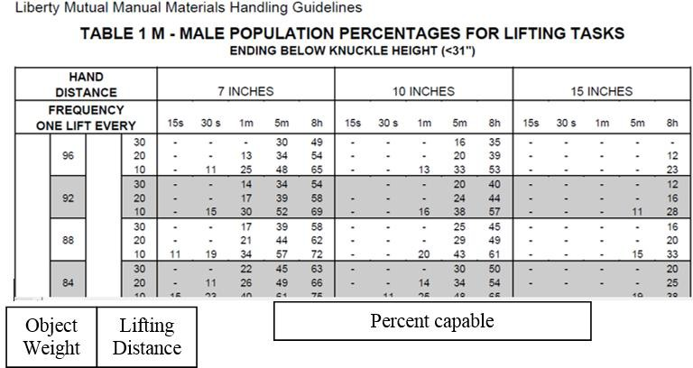

- There are various other manual materials handling tools available on the Internet with different rational, development approaches and ease of use.

  - Explore the Internet for Manual Materials Handling Analysis tools.

Occupational Biomechanics
STUDY UNIT 5

LEARNING OUTCOMES

At the end of this unit, you are expected to:
  - Understand the causes and pathology of upper limb musculo skeletal disorders
  - Describe the anatomical locations and structures involved in CTDs
  - Recognise the stresses associated with various occupations
  - Describe the functional role of the shoulder during overhead work
  - Describe the causes and effects of shoulder injuries
  - Identify the factors associated with musculo skeletal disorders of the upper limb
  - Describe the postures, motions and forces associated with upper limb work related musculo skeletal disorders

OVERVIEW

This unit discusses the causes and sites of upper limb musculo skeletal disorders (MSDs). The general causes of posture, movement, force and frequency are introduced with reference to common functional activities. Next, specific attention is paid to frequently occurring MSDs in the shoulder, elbow, wrist and hand. Finally the student groups will discuss intervention strategies including engineering and administrative controls.

MUSCULO SKELETAL DISORDERS

- Musculo skeletal disorders may be acute or cumulative.

- The former include fractures to bones, sprains and strains to ligaments and muscles and lacerations or blunt trauma to any tissue, including blood vessels and nerves.

- The cumulative form, often called Cumulative Trauma Disorders (CTDs), is usually caused by repetitive strains – Repetitive Strain Injuries (RSI).

- These injuries may have any cause such as hobbies or sports, but by far the most common cause is due to repetitive work; hence a general term is Work Related Musculo Skeletal Disorders (WRMSD).

- There are three significant historical causes of WRMSD. First, there was the predominantly manual nature of agriculture, construction and manufacturing before the industrial revolution that grew from the introduction of powered machinery. The second cause was the introduction of the production line where short cycle work created enormous improvements in productivity over traditional craft and batch work. The third surge in WRMSD has been the recent “Information Revolution” which confines workers to computer and communication interfaces, such as keyboards.

- Search the Internet and Library for a history of work, occupations and work related injuries and diseases.
- Obtain at least 10 Internet sources that discuss CTDs, RSI and WRMSDs.
- Search for articles that narrowly define “ergonomics” as the study and prevention of CTDs. Discuss other purposes and applications of Ergonomics.

BIOMEDICAL RISK FACTORS

- Biomechanical risk factors for WRMSDs include force, posture, movement, vibration, frequency, repetition, duration and insufficient recovery time.

- The first four factors are due to product and interface design, and are generally the responsibility of the product, tooling or manufacturing engineer.

- The last four risk factors – frequency, repetition, duration and insufficient recovery time – are all time based and are the responsibility of industrial or production engineering or job design and assignment by supervision.

- Therefore, a major challenge in the management or prevention of WRMSDs is the collaboration among all these stakeholders at the systems engineering level or job design and assignment by supervision.

- Therefore, a major challenge in the management or prevention of WRMSDs is the collaboration among all these stakeholders at the systems engineering level.

- Sketch a supermarket checkout: plan view and elevation.
- Describe, using angle-time diagrams, the movements of the legs, trunk, neck, shoulder, elbow, forearm, wrist, fingers and thumb as the operator moves items from the shopper’s basket to the takeaway plastic bag.
- Estimate the number of times each movement is made per day.
- Calculate the force required to move different item shapes, sizes and weights.
- Develop a process for the collection of operational and operator data related to this task.
- Propose engineering design interventions, including automation to improve throughput and reduce musculo skeletal stresses (posture, movement and force).
- Propose administrative (operational) interventions to reduce the daily repetition stress.

OTHER RISK FACTORS

- There are genetic, anatomical, gender and other personal factors that may contribute to the occurrence of WRMSD. For example, different people may have different pain tolerance thresholds.

- There are also psychosocial factors such as attitude to work and supervision, financial rewards, family and social context, and non-occupational factors such as hobbies.

- Another factor that has led to the rise in reporting, diagnosing and prevalence of WRMSDs is the relatively recent classification, labelling, formalisation and acceptance of the disorder.

- Thus the medical and insurance professions have contributed greatly to the recognition of the disorder and this recognition has spread widely throughout manufacturing and other industries, such as manual materials handling and office occupations.

- How would you investigate non work related contributions to musculo skeletal disorders that are exacerbated by work tasks?

ANATOMICAL LOCATIONS OF WRMSDS

- WRMSDs are found in many different kinds of body tissues and structures, such as ligaments, tendons, bursae, bones, cartilage, muscles, nerves, and, in the case of repeated vibration, the peripheral circulatory system.

- Generally, WRMSD are found at interfaces between these tissues and structures, such as the tendon – bone interface, or where a tendon, nerves and bony structures exist close together.

- It is common for WRMSD to be identified by the particular location or structure involved, or by the person who first identified and described the particular condition. Consequently, these distinct conditions will be addressed individually with regard to their aetiology, diagnosis and treatment.

- Identify by palpation and observation of Internet anatomical images upper limb joint structures, including articular surface shapes, ligaments, tendons, tendon sheaths and bursae.
- Use Google to search for “Wrist anatomy”.
- Move the joints through full active ranges of motion and describe the muscles and tendons involved.
- Repeat the exercise with different postures of the proximal joints. How are the motions of adjacent joints related?

LOCALISED FATIGUE

- A localised fatigue is a normal, on-going result of physical activity that is relieved by rest of the tissues involved and circulation to provide the necessary oxygen and nutrients and to remove the waste products of muscle contraction such as lactic acid and heat.

- With insufficient recovery opportunities, localised fatigue may progress to cumulative trauma disorders, especially if the movements involved cause micro damage to the structures.

- Hold your heavy book bag out with a horizontal straight arm; see how long you can hold this posture.
- Move your book bag up and down repeatedly by flexing your elbow, or by lifting it above your head. Observe and describe the sensations of fatigue.
- Repeat the activity with rest pauses for recovery.
- Compare the static, continuous and intermittent processes.

TENDON

- Tendon Disorders include tendinitis and tenosynovitis; the latter is inflammation of the synovial sheath that facilitates smooth movements of the tendon.

- The site of damage may be the tendon (or sheath) itself or the connection between the tendon and the muscle or the tendon and the bone.

- Symptoms of tendon disorders include:
  - inflammation of tendon and tendon sheath
  - may result in either micro- or macrotrauma
  - localised swelling (resulting in narrowing or stenosing) of the sheath
  - may form nodule on tendon – resulting in tendon entrapment (e.g. trigger finger)

- Search Internet images for “Tendon Insertions”.
- Identify the tendon – bone junctions (insertions) around the wrist, elbow and shoulder.
- Palpate the finger flexor tendons in your palm while you flex and extend your fingers.
- Search Internet images for de Quervain’s disease, tennis elbow, golfer’s elbow and supraspinatus tendinitis.
- Identify the location of the injury.
- Recreate the movements associated with each of these MSDs.

BURSAE

- Bursae are fluid filled sacks that facilitate joint and tendon movement.

- Common sites of bursa damage occur in the front of the knee (carpet layer’s knee) or in the shoulder (sub acromial bursitis).

- Search the Internet images for “Bursa”. Describe the locations and the surrounding tendons and bones.
- Palpate the locations of bursae vulnerable to occupational stress.

NERVE DISORDERS

- Nerve Disorders occur where peripheral nerves are compressed by the activities of surrounding muscles, ligaments, bones and joints, or by direct external pressure.

- The damage to the nerve causes interference with sensory (afferent) and motor (efferent) impulse transmission.

- The compression may occur as the nerve exits from the spinal column (e.g. Sciatica), along its pathway (e.g. Thoracic Outlet Syndrome / Brachial Plexus damage) or distally (e.g. Carpal Tunnel Syndrome).

- Carpal Tunnel Syndrome is probably the most often discussed nerve disorder due to compression of the Median Nerve as it passes through the Carpal Tunnel.

- Hypothenar hammer syndrome may occur due to repeated hammering with the (medial) side of the hand.

- Search the Internet for images of carpal tunnel syndrome.
- Sketch a cross-section of the Carpal Tunnel.
- Identify the bones, ligaments, tendons and nerves that are associated with the Carpal Tunnel.
- Describe the routes of the Median, Ulnar and Radial nerves.
- Describe activities that could give rise to nerve damage around the neck, shoulder, elbow, wrist or hand.
- Where / what is your “funny bone”?
- Where should a police officer strike an aggressive suspect to temporarily disable him?

THE NECK

- The Neck is a very mobile structure that serves as a passageway for many nerves and blood vessels to the head, trunk and arms as well as the oesophagus (to the stomach) and trachea (to the lungs).

- Structurally, the neck (cervical region of the spine) consists of 7 small vertebrae with their associated discs, facet joint articulations and muscle attachments.

- Strong muscles that create cervical spine stability during static work and mobility during dynamic work, such as visual search include trapezius, splenius and sterno-mastoid.

- The neck structures are particularly vulnerable to prolonged static postures as in computer work station use.

- Sketch the Cervical Spine and its associated muscles and nerves.
- Examine the ranges of motion of the axis and atlas vertebrae (C1 and C2).
- Measure the range of motion of the neck in the three anatomical planes.
- Investigate the Brachial plexus.
- Suggest ways of reducing stress in the neck region due to prolonged visual work.

THE SHOULDER

- The Shoulder is a very mobile joint with 360 degrees of Circumduction. This mobility is enhanced by coordinated movement of the shoulder girdle consisting of the clavicle and the scapula.

- Stability of the shallow shoulder joint is assisted by 4 small rotator cuff muscles (Supra spinatus, Infra spinatus, Teres minor, subscapularis) while the major muscles – deltoid, pectorals, trapezii, teres major, latissimus dorsi, serratus anterior, biceps etc – provide the wide range of movement.

- Nerves and blood vessels to the arm pass through the axilla and are very vulnerable to pressure from, for example, walking with crutches.

- One unique feature of shoulder movement is the contribution of lateral rotation to elevation; overhead work that involves abduction and medial rotation is a common cause of shoulder injury.

- Other recreational stresses come from throwing and racquet games.

- Measure the ranges of motion of the shoulder and the shoulder girdle in the three anatomical planes.
- Describe the anatomical plane motions associated with functional diagonal shoulder movements with particular attention to rotation.
- Sketch the shoulder structures including bones, joint surfaces, muscles and tendons.
- Investigate the shoulder movement needed to bowl a “Googly” in Cricket.
- Describe occupations that involve overhead work or large range of shoulder motion.

THE ELBOW

- The Elbow articulation is between the humerus and both the ulna and radius.

- The shapes of the joint surfaces allow flexion and extension of the elbow and pronation and supination of the forearm.

- These movements are created by contraction of large muscles such as brachialis, biceps, brachioradialis and triceps.

- It should also be noted that the wrist flexors and extensor muscle attach to the humeral epicondyles.

- Examine Internet images for the elbow articulations and muscles.
- Measure the ranges of motion of extension, flexion, pronation and supination.
- Develop angle-time diagrams for the shoulder and elbow for throwing, and eating.
- Explain how the position of the wrist and fingers could cause stress on the common extensor and flexor tendons that attach to the elbow epicondyles (epiconylitis).

- How can the shape of the handle of a hammer affect the stress around the elbow and wrist?
o Draw angle-time diagrams with straight and bent handled hammering.

THE WRIST

- The Wrist consists of 8 small carpal bones which articulate with the metacarpals distally and radius and ulna proximally.

- As most of the muscles that cause hand and finger movement are attached to the radius and ulna, they have to pass through the wrist to carry out their functions.

- Similarly, the blood vessels and nerves that supply the hand must also pass through the wrist.

- Injury to structures around the wrist will greatly affect the functionality of the hand.

- Sketch and describe the muscles and tendons that control the wrist, fingers and thumb.
- Sketch and describe the ranges of motion at the wrist.
- Sketch and describe the blood vessels and nerves that pass over the wrist.
- Sketch and describe the dermatomes associated with the median, ulnar and radial nerves.
- Draw cross-sections of the wrist and name the structures.

- Observe and describe the postures of the wrist during typing, hand tool use and manual assembly of small components.
- Describe the sensory and motor changes associated with Carpal Tunnel Syndrome.
- Investigate Phalen’s, Tinel’s and Finkelstein’s tests.

THE HAND

- The Hand is a multifunctional device that differentiates primates from other animals.

- This functionality is particularly due to the movements of the thumb, including flexion, extension, abduction, adduction and opposition, to allow grasping.

- The fingers and thumb are controlled by relatively large muscles located in the forearm, the thenar and hypothenar muscles and small lumbricals and interossei in the palm.

- The carpo-meta carpal joints allow flexion extension, abduction and adduction while only flexion and extension are possible in the interphalangeal joints.

- While holding the proximal bone, observe and sketch the ranges of motion of all your hand, finger and thumb joints.
- Observe the contraction of muscles in your forearm while you are moving your fingers and thumb.
- How might De Quervain’s syndrome be caused by texting?
- How does the posture of your wrist affect the movements of your finger joints and your grip strength?
- Examine the routes of nerves and blood vessels in your hand.
- Describe the muscles involved in a strong grasp and pinch.
- Explore the causes and effects of Raynaud’s syndrome.

CAUSATION

1. Causation of Work Related Musculo Skeletal Disorders may be due to extreme postures, large range movements, high forces, insufficient recovery time and high frequencies.

- Describe 10 jobs where these factors may occur.
- In each case draw angle-time, velocity-time and force-time diagrams.

DIAGNOSIS

- Diagnosis of Work Related Musculo Skeletal Disorders is through reporting of persistent pain, pain on movement, local tenderness, redness and heat, and functional disability.

- Investigation of task factors may help to confirm the diagnosis.

- See hand-out on Medical Management of Work Related Musculo Skeletal Disorders.
- Explore the purposes of the various diagnostic tests.

TREATMENT

- Treatment of Work Related Musculo Skeletal Disorders is through analgesics, anti-inflammatory medicine, physiotherapy – cold / heat, massage, splinting, graduated ROM and strengthening exercise, and in the last resort, surgery.

- An essential component of return to work is task modification to either remove or reduce the stressors that caused the injury.

ENGINEERING CONTROLS

- Engineering Controls include automation and the reduction of force and extreme postures by appropriate use of appropriately designed powered or manual hand tools.

- Workplace design interventions such as bench / carrier heights and tool assists / balancers may also improve the postural demand.

- Develop a pictorial chart of handtools, handles, tasks and postures.
- Explore task aids to reduce force, posture and movement stresses, including tool support devices.
- Describe inline and right angle tools.
- What is the Fibonacci angle? Does it relate to ergonomics?
- What is a torque bar?
- What is a pulse tool?
- How could you use engineering controls to reduce postural, movement and force factors?

ADMINISTRATIVE CONTROLS

- Administrative Controls are aimed at reducing “exposure”, frequency and repetition. Common interventions include job rotation and enlargement. Care must be taken to ensure that the tasks involved are physically dissimilar.

- Other administrative controls involve the assignment of restricted work orders that protect the employee from potentially damaging activities.

- Read handout on “Job Rotation”.
- Develop a checklist to record job physical and operational factors.
- How could you use administrative controls, such as job rotation and enlargement, to reduce the frequency and duration factors?

- Investigate official records that report Musculo Skeletal Disorders in Singapore and other countries.
- Carry out a casual survey of colleagues, friends and family regarding their experience of MSDs.
- Create a symptom / diagnosis / treatment / intervention process for WRMSDs.

Occupational Biomechanics

STUDY UNIT 6

LEARNING OUTCOMES

At the end of this unit, you are expected to:
- Apply anthropometric data and biomechanical analysis tools to the design of workplaces
- Evaluate workplaces from the occupational biomechanics angle
- Apply ergonomics principles to the design of equipment interfaces
- Apply ergonomics principles to the design of tasks
- Apply the principles of design and selection of hand tools
- Apply the Physical Work Strain Index to analyse jobs over the full workday
- Apply activity sampling methods
- Develop job design arrangements to address fatigue and recovery
- Develop and evaluate ergonomics analysis tools

OVERVIEW

This study unit addresses the opportunities for ergonomics analysis and design of workplaces, equipment, tools, tasks and jobs using laboratory and field techniques of anthropometry, biomechanics and observational methods. Students will use various analysis tools that are well established globally and develop their own checklists and analysis tools from first principles.

  - Workplace Design
  - Angles and Working Postures
  - Anthropometry and Biomechanics of Design
  - Biomechanics and Job Design (Access videos via iStudyGuide)

ANTHROPOMETRY AND WORKPLACE DESIGN PRINCIPLES

- A purpose of ergonomics is to assure that people can access (reach) objects in their environment without physical interference (fit). Because of human variability in size and shape the ergonomics challenge is to allow small people to reach and large people to fit.

- The principle of “universal design” with regard to anthropometry and workplace, equipment and tool design is somewhat ambitious because of the wide variation of human sizes and shapes.

- A compromise that has become part of ergonomics dogma is to accommodate the 5th percentile for reach and 95th percentile for fit.

- Where complex multiple segment situations occur, this accommodation rule is modified to require fit and reach for 90% or 95% of the population.

- The challenge is eased somewhat by consideration of the intended “user population” – adults, children, males, females, Caucasian, Oriental, able bodied, handicapped etc.

- A human characteristic that eases the challenge somewhat is the individual tolerance of suboptimal designs. For example, bus, restaurant and theatre seats generally have fixed dimensions and their users usually have no ill effects. However, long airplane rides or office tasks with ill-fitting furniture may create increasing amounts of discomfort.

- A strategy to achieve accommodation of a greater proportion of the user population is to design adjustability into the workplace, equipment and tools. A familiar example is the adjustable height chair.

- Identify 10 workplaces, tools or pieces of equipment that have spatial designs (fit and reach) intended for adults or children.
- Discuss the application of anthropometry to shoe design.
- Why is two-way seat adjustability important for vehicle seats?
- Critique the anthropometry dogma of 5th and 95th percentile accommodation.
- Critique the extension of this dogma to biomechanical issues of force, physiological issues of energy, cognitive issues of information processing and usability issues of products and services.
- Discuss the issue of outcome frequency and severity in relationship to percentile accommodation.

BIOMECHANICAL LIMITS

- There are two general biomechanical limiting factors for design. First, there are force challenges that may be beyond the limits of intended users. Examples are the maximum weight of airline baggage or the force needed to remove the cap of a medicine bottle.

- At the other end of the force spectrum, a minimum amount of force may be needed to provide appropriate feedback for control. Examples include electrical

switches and knobs, steering wheels and cursor adjustment on a computer or tablet.

- What should be the upper weight limit of airline bags or raw materials containers to be handled by work hardened, injury free workers?
- Discuss the biomechanical problems of heavy doors.
- What should be the upper and lower limits of torque needed to open a medicine bottle, given the strength limitations of older people and prevention of access by children?
- What kind of resistance should be provided in gas or electric cooker controls?

- Design to accommodate human biomechanical variability must address gravitational and system force, friction and inertia.

- Gravity and inertia are universal challenges in manual materials handling, which involves both object weight and body weight. Similarly, gravity, inertia and friction are key components of slips, trips and falls.

- System force, such as the mass of a door or the lock mechanism, are dependent on inertia and friction, and perhaps spring resistance.

- Discuss the role of packaging for retail electronics items. Create a time line of the “biomechanical” life cycle of a television set.
- Analyse the design of doors and door locks from the biomechanical perspective.

EQUIPMENT AND HAND TOOL DESIGN

- Hand tools, such as baseball bats, hammers and wrenches, and powered hand tools such as drills and sanders, and paint guns need to address operator hand anthropometry and hand and arm strength.

- Heavier tools will impart greater force on the external target, but require greater strength for the operator. Lighter tools may be less effective.

- Powered hand tools have the added biomechanical features of trigger surface area, displacement and resistance; powered hand tools, if used frequently, may

also produce potentially harmful vibrations. When the fastener reaches its torque limit, there may be a strong ‘torque reaction / jerk” which over time may cause cumulative trauma.
- The shape of handles of hand tools dictates the angles and ranges of motion of the wrist, forearm and elbow.

- Repeated forceful use in extreme postures is responsible for such disorders as tennis elbow and carpal tunnel syndrome.

- Measure the hand size, grip strength and pinch grip strength of a sample of potential users of hand tools.
- Search your home and workplace for powered and non-powered hand tools. Measure their handle lengths, breadths, circumferences and shapes. Analyse their anthropometric suitability for a range of users of different sizes and strengths.
- Analyse the trigger sizes and forces for a selection of hand tools and explore design alternatives for frequent use.
- Some powered hand tools, such as screw drivers and nut runners produce a torque reaction (jerk) at the end of their duty cycle. Discuss external (torque bar) and internal drive mechanisms (impulse tools) to prevent cumulative trauma from this torque reaction.
- Research the etiology of Raynaud’s syndrome. Develop intervention measures to prevent this cumulative trauma.
- Measure the wrist range of motion during hammering; investigate the biomechanical advantage of a bent handle.
- Analyse the biomechanical demands of computer input devices such as keyboards, mice, keyboards and touch screen operation.
- How do people text?
- Investigate De Quervain’s disease.

SPATIAL, FORCE AND TEMPORAL ANALYSIS OF WORKPLACES AND TASKS

- Biomechanical analysis of postures, movements and forces can be carried out through checklist methods, graphical analysis, photographic and video methods and accelerometry.

- All tasks involve combinations of units of space, force and time and generally consist of well-defined repeatable cycles.

- Traditional Industrial Engineering approaches to manual task design involve the principle of motion economy and the reduction of non-value added movements. An example can be found in the design of supermarket checkouts that used bar code scanners, the purposes of which are accuracy and productivity. An unwanted result of this strategy is an increase in the temporal components of biomechanical stress.

- Close analysis of such operations also identifies large ranges of motion of upper limb joints.

- Observe a video of a supermarket checkout operation or line paced assembly operation (check out the comical I Love Lucy chocolate wrapping video). Describe the shoulder, elbow, forearm, wrist and grasping motions in terms of ranges, forces and cycle durations.
- Create angle-time, angle-velocity and angle-force diagrams for each joint over the job cycle.
- Reproduce the activities in the laboratory, place markers on prominent locations of the subjects arm and hand (e.g. lateral epicondyle, radial styloid process, knuckle and thumb nail, make a video recording of the operation and carry out a position/posture- time analysis.
- Repeat the field and laboratory investigations of the upper limb task with a manual materials handling task.
- Use the University of Michigan Static Strength Prediction Program to analyse the manual material handling task.

TASK AND JOB ANALYSIS AND DESIGN

- Useful task analyses may be carried out by checklist or ethnographic observation methods; on occasion more detailed quantitative models may be required, such as RULA, the Strain Index, Hand Activity Level or the Physical Work Stress Index.

- In a few cases, experimental simulations of work tasks may be needed to investigate the stresses and strains involved.

- Research the Internet for sources of ergonomics analysis tools and construct a data base describing the features, applications and limitations of the tools.

- The Physical Work Stress Index approach is a general observational activity sampling approach that takes snapshots of various work factors over a full day.

- Its purpose is to assess the balance between high levels of static stress and high levels of dynamic stress.

- The approach involves the identification of sampling intervals (regular or irregular depending on the job design) and various key factors of interest, such as locations, postures, activities and loads.

- Data analysis includes both the estimated proportion of time in each posture / activity and the frequency of changes among these factors.

- Low frequency of change will imply a high daily static load and high frequencies a high dynamic load.

- The technique may be modified for gross (body) or detailed (hand) activities.

- Apply the Physical Work Stress Index principles of optimal static dynamic biomechanical stress analysis to a construction, horticultural, retail and office job context.

- It is essential to note that these “ergonomics” analysis approaches are accompanied or preceded by an epidemiological study of job outcomes.

- Failure to address job outcomes will be time wasted at best and a potential cause of “iatrogenic ergonomics disease” at worst.

- Research the history of ergonomics and Work Related Musculo Skeletal Disorders over the past three decades. Discuss the reasons and forces behind this rise in attention to workplace ergonomics.

- The general solution to physical ergonomics (e.g. postural and biomechanical) problems is physical variety and the avoidance of extreme postural force and temporal stresses, except under controlled circumstances, such as deliberate strengthening or mobilisation exercises. Specific solutions to the prevention of biomechanical strain require domain sensitive analyses and outcome analysis and tradeoffs.

- Discuss the importance of domain knowledge as an essential adjunct to ergonomics knowledge in real world biomechanical analysis of a variety of occupations.

ERGONOMICS ANALYSIS AND INTERVENTIONS

- Anthropometry and Biomechanics deal with space, force and time and represent a subset of ergonomics; the purpose of these disciplines is usually the prevention of musculo skeletal disorders and the facilitation of comfortable, effective, efficient and safe physical work.

- However as in all human work, there may be interacting cognitive, social, environmental and affective factors that must be considered by a broader ergonomics view.

- As in all aspects of ergonomics, it is important to address human variability in such things as size, strength, speed, stamina and skill due to such things as age, sex, heredity and disease.

- Design may aspire to accommodate a wide range of possible users and deter possible “misusers”; however, from the anthropometry and biomechanics viewpoint, physical design may have to be supported by operations design and personnel selection and training.

- Discuss the contribution of anthropometry and biomechanics in the broader context of ergonomics.
- Select an occupation such as street cleaning, parcel handling, park maintenance, construction work etc and discuss the anthropometry and biomechanics opportunities and issues.

