Human Factors in Aerospace
Brian Peacock

STUDY UNITS

STUDY UNIT 1

Objectives

Overview

Definitions, Purpose and Scope
    - Definitions and History
    - Complexity
    - Outcomes and Purposes
    - Life Cycle Phases and Stakeholders
    - Usability and Human Variability
    - Analysing Complexity in System Design and Operations
    - The Process of Ergonomics
    - The Activities of Ergonomists
    - The Practice of Ergonomics
    - The Scope of Ergonomics

Anthropometry and Biomechanics
    - Anthropometry and Workplace Design
    - Biomechanics and Manual Materials Handling

STUDY UNIT 2

Objectives

Overview

Work Physiology

The Thermal Environment

Hypoxia

Circadian Rhythms and Shift Work

STUDY UNIT 3

Objectives

Overview
  - Human Information Processing
    - Attention
    - Cognition
    - Memory
  - Human-Machine Systems and Control
    - Interface Design
    - Control
    - Communication

STUDY UNIT 4

Objectives

Overview
  - Sensory Processes ‒ Vision and Hearing
    - Vision
    - Hearing
    - Fitts Law
    - Hicks Law
    - De Jong’s Law
    - Mental Work Load
    - Situation Awareness

STUDY UNIT 5

Objectives

Overview

5.1 Introduction to CRM

STUDY UNIT 6

Objectives

Overview
  - The SHEL Model
    - The Swiss Cheese Model
    - Human Factors Analysis and Classification Study

Course Description and Aims

The aim of this course is to introduce first year Aerospace Systems students to the purpose, scope, methods and applications of Human Factors with particular reference to aviation ground and flight operations; participants will also be given an introduction to Space Human Factors.

Learning Outcome Overall Assessment
Knowledge & Understanding (Theory Component)

Comprehend the scientific basis of Human Factors in Aerospace including:
- Anthropometry and Workplace and Equipment Design
- Biomechanics and Work Physiology
- Human sensory processes
- Human information processing
- Environmental effects on human performance
- Social factors and human behaviour

Key Skills (Practical Component)

Able to select and apply Human Factors methods of:
- Physical and cognitive task assessment
- Accident and incident investigation
- Design and intervention strategies to support human performance
- Communication of assessment, investigation and design findings
- Group based learning

The overall assessment weighting for this course is as follows:

Assessment | Description | Weight Allocation
Assignment 1 | Group One Page Report | 3%
Assignment 2 | Group One Page Report | 3%
Assignment 3 | Group One Page Report | 3%
Assignment 4 | Group One Page Report | 3%
Project | Group Poster Presentation | 18%
Examination | 4 Scenario Analysis Questions (Open  Book) | 70%
TOTAL |  | 100%

Learning Materials

The following is a list of the required learning materials to complete this course.

Required Textbook

Author Last name, First  name | Title | Year | Publisher
Hawkins, Frank | Human Factors in Flight | 2007 | Ashgate

Other recommended study material (Optional)

The following learning materials are required in order to complete the learning activities:
1 | Reference Books | Handbook of Aviation Human Factors by Garland Wise and Hopkin, Laurence Erlbaum, 1999  Safety Management Systems by Stolzer, Halford and Goglia, Ashgate, 2010
2 | Websites | http://hfacs.com/ http://www.caa.co.uk/
3 | Readings | List of copyrighted readings available in the website:  - The Evolution Of Crew Resource Management Training In Commercial Aviation  Robert L. Helmreich, Ashleigh C. Merritt & John A. Wilhelm  Department of Psychology Aerospace Crew Research Project The University of Texas at Austin  - CAP 737  Crew Resource Management (CRM) Training  Guidance For Flight Crew, CRM Instructors (CRMIS) and  CRM Instructor-Examiners (CRMIES)  www.caa.co.uk

- Nonstop Flying Is Safer Than Driving Michael Sivak
Daniel J. Weintraub Michael Flannagan
The University of Michigan Transportation Research Institute Ann Arbor, Michigan 481 09-21 50 U.S.A.
Report No. UMTRI-90-7 March 1990

- DoD HFACS
Department of Defense Human Factors Analysis and Classification System
A mishap investigation and data analysis tool

- ICAO. (1998). Human Factors Training Manual (2003 Ed.). Montreal: Secretary General International Civil Aviation Organisation.
Chapter 1
Fundamental Human Factors Concepts

- The Human Factors Analysis and Classification System–HFACS
Scott A. Shappell
FAA Civil Aeromedical Institute Oklahoma City, OK 73125 Douglas A. Wiegmann University of Illinois at Urbana- Champaign
Institute of Aviation Savoy, IL 61874
February 2000 Final Report

- Midwest Flight 5481, Jeff Avitable

- Chapter XX
Drillis and Contini Revisited
John Brian Peacock, Manoharan Aravindakshan, Tong Xin, Chui Yoon Ping, Low Wai Ping, Fabian Ding, Tan Kay Chuan Markus Hartono, Ng Yuwen Stella

Human Factors in Aerospace

STUDY UNIT 1

The Purposes and Scope of Human Factors

OBJECTIVES

At the end of this unit, you are expected to:

    - Describe and apply the E4S4, SHEL and 6U2M models
    - Identify the general causes of system failure and human error throughout the system life cycle
    - Recognise and explain the theory and applications of physical, cognitive, environmental, social and affective Human Factors
    - Comprehend the need for optimisation in design for customers throughout the life cycle of a product or process
    - Measure human body dimensions
    - Analyse anthropometry data
    - Apply anthropometry data to the design of workplaces and equipment
    - Analyse human postures and movements using biomechanics techniques
    - Evaluate and design manual materials handling tasks using biomechanics techniques

OVERVIEW

The first part of this module introduces the scope and purpose of Human Factors as applied to aerospace systems. A series of classification tools ‒ E4S4, SHEL and 6Us2Ms, RASDEI and Product Life Cycle ‒ are presented to orient the student to the complexity of Human Factors from the systems viewpoint. The broad scope of Human Factors in terms of human physical, cognitive, social and affective characteristics, capabilities and limitations, is discussed.

The second part of this module addresses anthropometry, biomechanics, workplace design and the design of manual materials handling tasks through examples of aerospace equipment, workspaces and tasks.
READ:

Hawkins
Chapter 1 - The Meaning of Human Factors Chapter 12 - Space and Layout

  - Definitions, Purpose and Scope
- Definitions and History
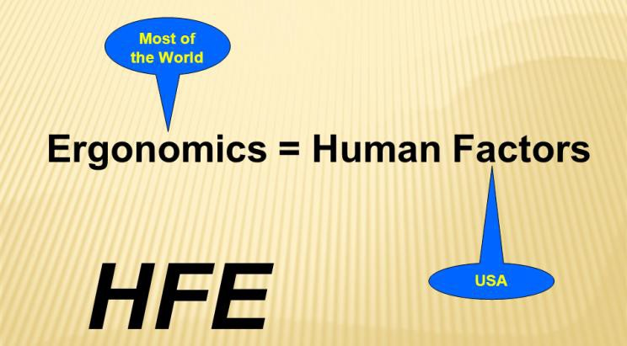

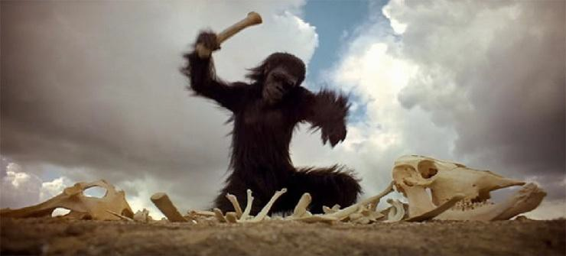
Tools
THE HISTORY OF ERGONOMICS
2

From “2001: A Space Odyssey”

Ergonomics and Human Factors are really the same subject although the term Human Factors
is mainly used in North America and is dominated by the psychology perspective. There are also many slightly different definitions of the subject. The broader view will be addressed in this course and an operational definition will be "Design with people in mind". There is a long history of the subject going back to when people first adopted tools or weapons to extend their capabilities and devices to protect them from the environment. Subsequently, ergonomics applications and opportunities may be found in any context where people are involved in work or other activities. Nowadays ergonomics is widely applied in manufacturing, consumer products, including smart technology, the military and even space exploration.

ACTIVITY 1:

Group Discussion: Describe three applications of ergonomics where the design of equipment provides an extension to human capabilities and protection against human limitations.

- Complexity

All ergonomics situations are by nature complex and involve interactions among and within people, technology, operations and the context. This complexity is succinctly described by the Edwards SHEL model:
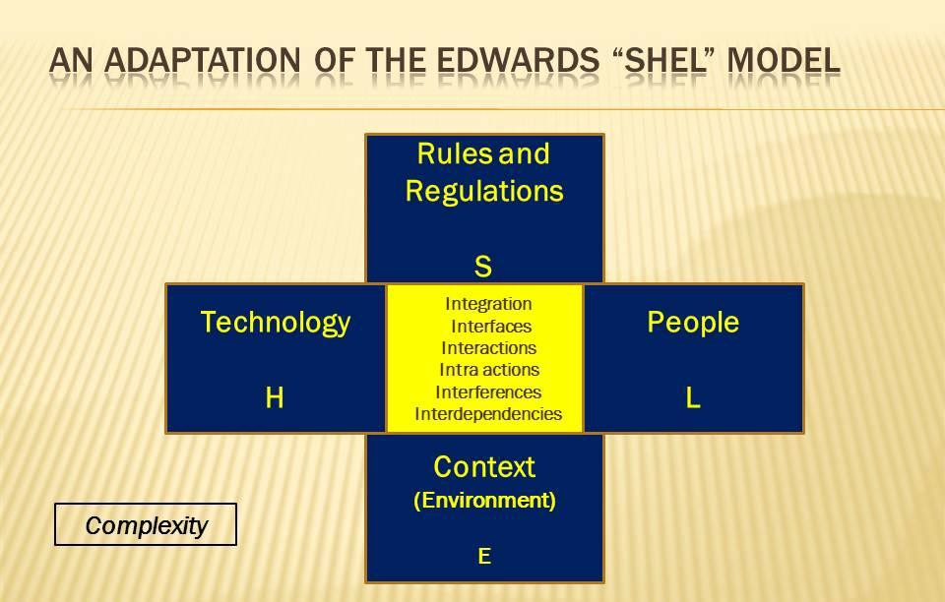

ACTIVITY 2:

Group Exercise:

- Search the Internet for the original description of the SHEL model.
- Discuss and describe the factors and their interactions that affect the success of a UAV surveillance mission or the operation of riding to work on a motorcycle.

The key to these complex system analyses is the investigation of the interfaces, interactions, intra-actions, interdependencies, interferences and integration of the human, technology, operations and contextual factors.
Another way of looking at complex systems is through the Donabedian (1995) classification of Structures, Processes and Outcomes. This approach is similar to the
SHEL model except that it does address context. One way of looking at context is to consider those things that cannot be changed, but may require protection. A good example is the physical environment, such as the weather. Structures are generally considered to be things, such as technology that can be specified and designed; they are described by nouns and adjectives. For example, the design of workplaces for pilots, baggage handlers and check in counter staff can affect the effectiveness and efficiency of performance. Processes on the other hand are activities, operations or tasks that are carried out by selected people and have a defined purpose. They are described by verbs and qualified or quantified by adjectives. Examples include flying an airplane or checking in for a flight.

ACTIVITY 3:

Group Exercise: Describe the structures, processes and outcomes of a food court or a bus service; include a discussion of the contextual factors that may affect the outcomes.

- Outcomes and Purposes

A simple view of the outcome or purpose of an operation is that of achieving a prescribed objective. For example, eating a meal, travelling to work or using a computer booking utility have well defined objectives ‒ providing energy, earning money or planning a holiday. But a deeper consideration of the operation reveals many more purposes and constraints.

These purposes are described by the E4S4 model:
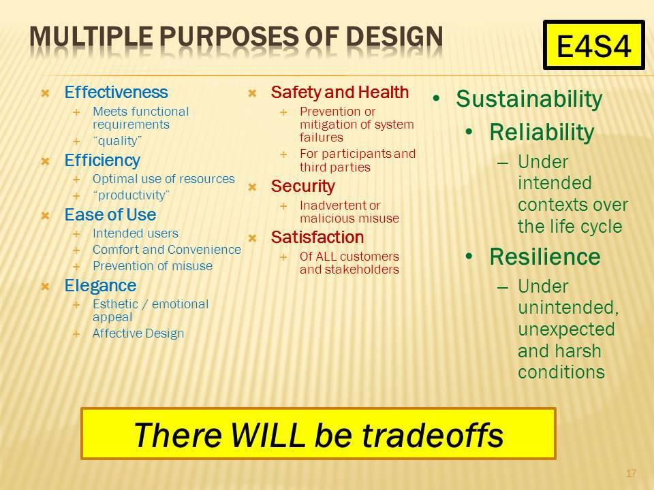

The basic purpose is process effectiveness ‒ does the process achieve its intended objective ‒ did you eat your food, get to work or book a holiday? But these outcomes will be constrained by efficiency (use of resources), likeability and ease of use. For example, going to work in a car may be costly, whereas taking the bus will be less expensive; but you may value comfort and convenience over cost or time spent in the activity may be very important. There will always be trade-offs!
ACTIVITY 4:

Group Activity: Discuss and describe the 4Es involved in the operation of getting money out of the bank, planning a celebration dinner or getting luggage out of a car boot.

The 4Ss (Safety, Security, Satisfaction and Sustainability) describe other constraints related to a process, activity or operation. For example, getting to the gate to board an airplane requires hazardous luggage lifting, complex security checks and satisfaction, both for you and the other people involved in the process.
ACTIVITY 5:

Group Exercise: What are the safety, security and satisfaction purposes or constraints to be considered in getting your child to school or carrying out an airplane refueling operation?

It can be seen from the forgoing example that there will always be trade-offs in any process, activity or operation.
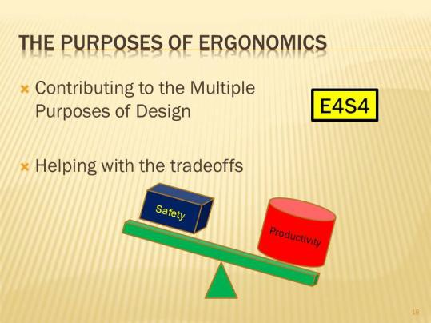

ACTIVITY 6:

Group Activity: Discuss some trade-offs associated with your everyday activities.

- Life Cycle Phases and Stakeholders

There are multiple phases and multiple stakeholders in any operation or system design:
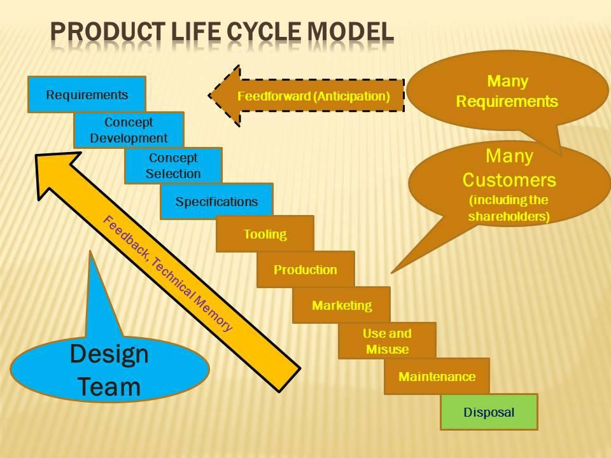

All simple or complex operations involve multiple phases and multiple stakeholders who may have conflicting purposes and requirements. These phases include design, production and use; in this "green" age we may also have to address disposal. Consider the life cycle of a meal or a car. There is planning and design, cooking and manufacturing, eating and driving. Many different people may be involved throughout this life cycle and they may all have different requirements. For example. the owner of a restaurant or car manufacturing company will probably want to make a profit, the cook or assembly line worker will want a salary and safe workplace and the end customer will want effectiveness, safety and elegance (emotional appeal).
ACTIVITY 7:

Group Activities:

- Discuss and describe the stakeholders and their requirements in the life cycle of a mobile phone.
- Consider the company shareholders, assembly line worker and the end user.
- Discuss the trade-offs among the different requirements.
- How are these trade-offs resolved?

Sustainability implies that the system or process continues to operate to the satisfaction of all stakeholders. System reliability implies that the process outcomes are successful throughout the life cycle under normal intended conditions. Resilience on the other hand implies that the outcomes are achieved even in harsh or unpredictable contexts.
ACTIVITY 8:

Group Activity: Use the E4S4 model to compare a car, a motor cycle and an airplane journey in variable weather conditions, with different schedules to meet, and with various expertise levels of the driver.

- Usability and Human Variability

A major challenge of system design is that people vary on many dimensions. Therefore systems must be designed to accommodate this variability. In particular it is important to address intended use (users) and foreseeable misuse (misusers).
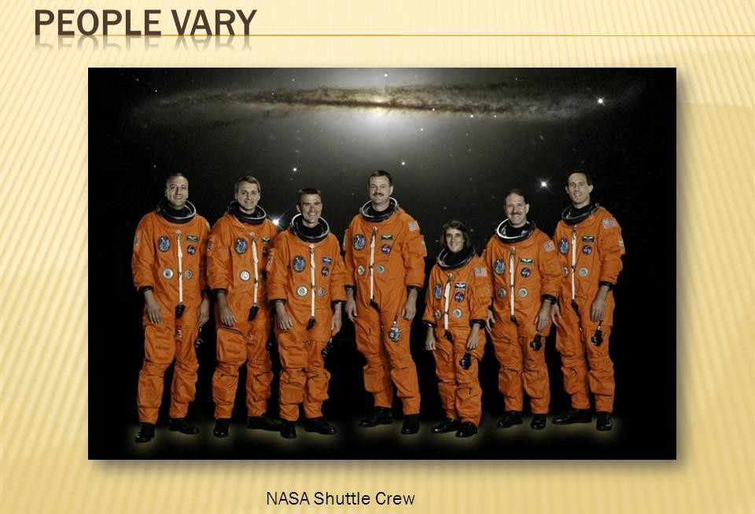
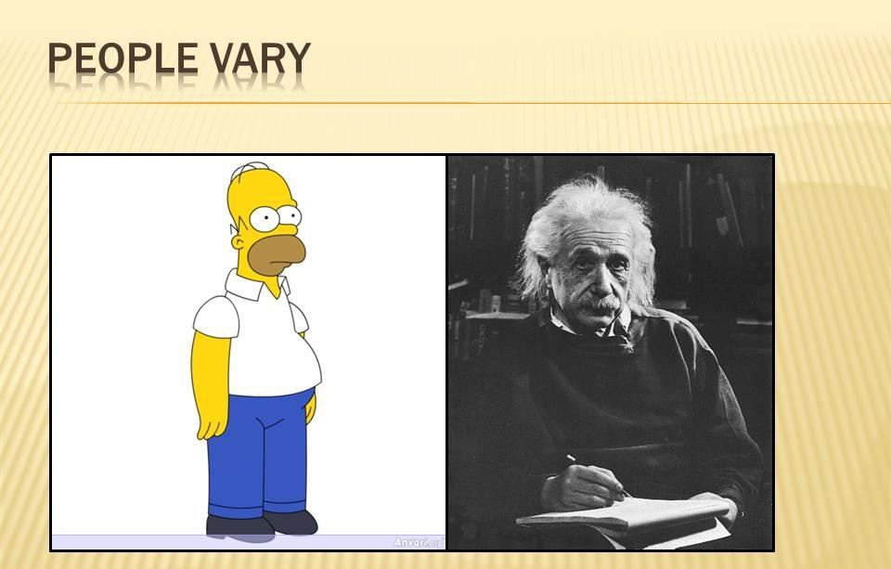

Consider the different capabilities and limitations of users in different age groups. Airlines must accommodate a wide range of people from babies to grandparents. Similarly cell phones may be used by tech savvy young people, inexperienced old people and normal people while they are driving. Systems designers must anticipate this variability through the use of ergonomics data and methods. The 6Us and 2Ms model draws attention to the variety of users and usages of systems as well as the possible misusers and misusages.
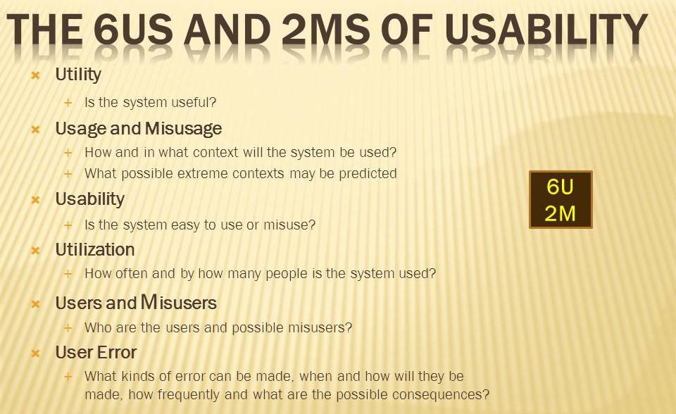

ACTIVITY 9:

Use the 6U2M model to discuss and describe the user and usage variability implications in the design and operation of a shopping mall or an apartment.

- Analyzing Complexity in System Design and Operations

ACTIVITY 10:

Integrative Homework: Combine the use of the SHEL, E4S4, Life Cycle and 6U2M models in the analysis, design and operation of a complex or simple system. Make liberal use of concept maps. Communicate your findings through a one page report.

- The Process of Ergonomics

As seen in the foregoing sections, ergonomics must deal with complexity, particularly with regard to user requirements and variable contexts of use. In any situation there may be many different requirements and outcomes, various uncontrollable contexts, a limited set of design or intervention opportunities and a wide range of possible users. Some interventions or designs may be easier or less expensive than others, some outcomes may be more important than others and some contexts more demanding than others.
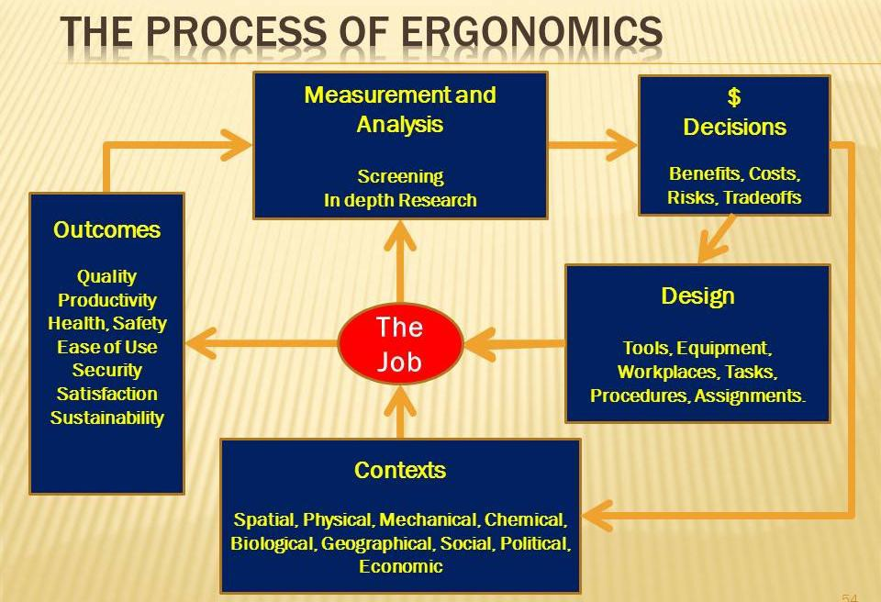

One temptation for ergonomists is to analyse and address those features of a system that are easy and inexpensive to change without due regard to the effect of these changes on the multiple outcomes. Another temptation may be to use overly sophisticated analyses where a simple checklist may suffice, and vice versa. Eventually any decision about change or intervention will be the prerogative of management, who will certainly consider costs and benefits to the various stakeholders.
ACTIVITY 11:

Group Activity: Consider the design of an airport baggage handling system that involves no physical involvement (lifting and carrying) by airport staff. What are the possible outcomes? What kinds of analyses could and should be done? What are the unchangeable contexts? What kinds of technology could be implemented? How should management make their intervention and design decisions?
- The Activities of Ergonomists

Ergonomists participate at various stages of a problem or system design. They may be involved in basic or applied research on human capabilities, limitations and requirements in the context of a process design.

For example, in flight reservations, in flight meal provision or airplane maintenance the ergonomist may need to explore in detail the characteristics of the various users and the nature of the specific tasks. Next, they may make use of simulations or simulators to explore the solution possibilities. Then they may have the opportunity to work with the designer or engineer to map the user requirements into design specifications. As the design progresses, the ergonomist may be involved in system evaluation and usability testing, again in various operational contexts.

Finally, when some unwanted outcome or accident occurs, the ergonomist may use his or her knowledge, tools and skills to participate in an investigation. It should be noted that this "failure" may be of any of the (E4S4) requirements, also the ergonomist should be involved in the investigation and analysis of "success." A key role of ergonomics is the provision of documentation and feedback, sometimes called technical memory, so that designs can be continuously improved (Kansei Engineering.)
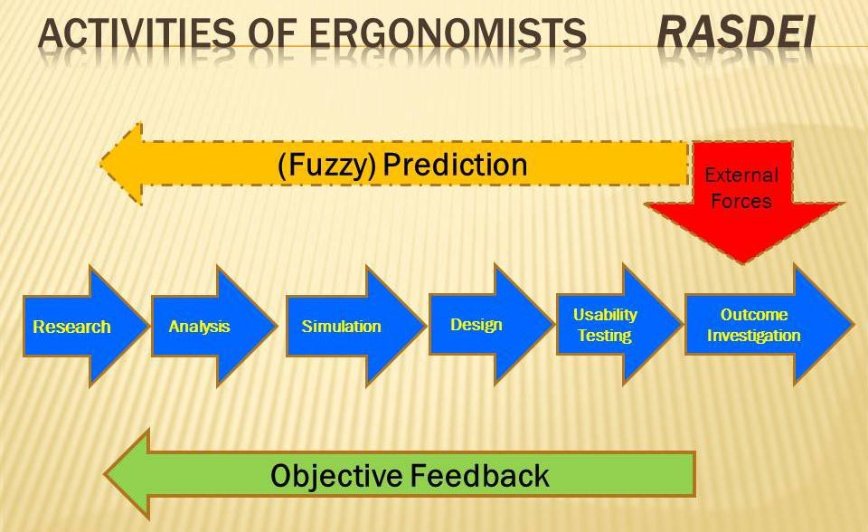
ACTIVITY 12:

Group Activity: Consider the challenges of evacuation of a large passenger airplane following an emergency landing. Use the RASDEI model to describe how an ergonomist may be involved at various stages of design and evaluation.

- The Practice of Ergonomics
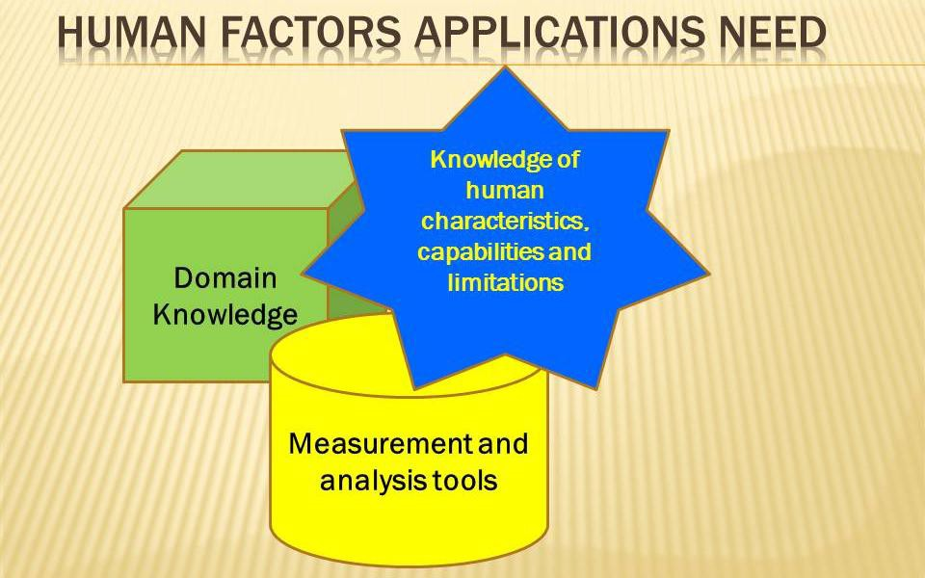
An ergonomist needs basic knowledge of human physical, sensory, cognitive and affective characteristics and the tools that are needed for measurement of human performance, behaviour and preference. Another important requirement is that the ergonomist has sufficient domain knowledge and the ability to work with domain experts. It is unthinkable that ergonomists should offer gratuitous advice to airplane cockpit designers without understanding the tasks of pilots or maintenance operations without understanding how airframes and engines function.
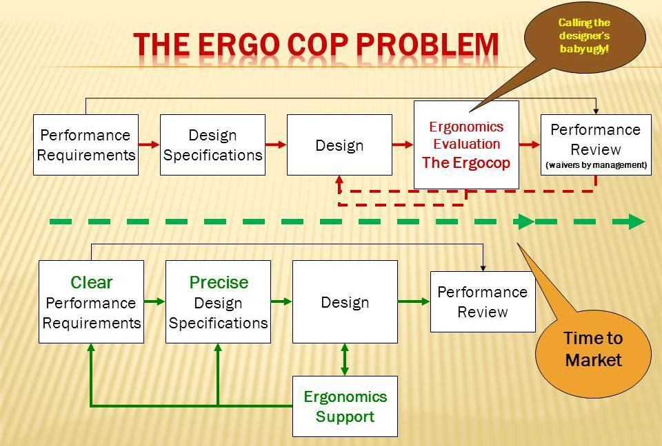
In this same context, it is important to not fall into the "ERGOCOP" trap. It is better to work with engineers, designers and operations managers than walk in after the event and "call their baby ugly".
ACTIVITY 13:

Group Activity: Discuss and describe the role of the ergonomist in the context of aviation safety, airplane maintenance and airport operations.

- The Scope of Ergonomics

People vary on many dimensions ‒ physical, sensory, cognitive, social and affective. They also must function in many environmental and operational contexts. People, like technology, vary over time ‒ they exhibit many individual differences, they learn, they fluctuate in their capabilities and preferences.
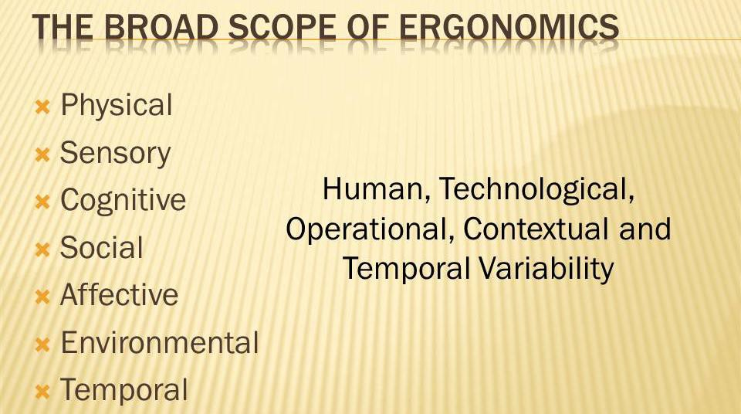

The later parts of this course will address many of these different human variables and the associated design options and process outcomes.
ACTIVITY 14:

Group Activity: Using the above model discuss and describe human variability, characteristics, capabilities, limitations, preferences, behaviours and performance in the context of air traffic control, airplane servicing or passenger accommodations. Develop a one page report to communicate your ideas.

  - Anthropometry and Biomechanics

- Anthropometry and Workplace Design

Anthropometry is the measurement of human body dimensions ‒ size, shape and posture. Anthropometric data are used for the design of workplaces, equipment, tools and clothing.
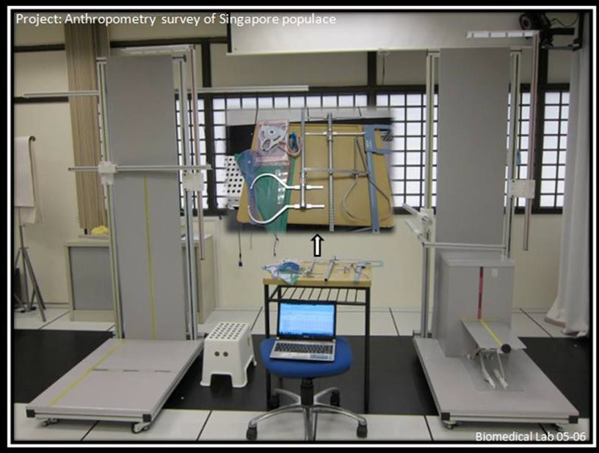

Anthropometric measurement is carried out with various fixtures, to standardise body position, and tapes and calipers to measure segment lengths, widths and girths. Usually, measurements are taken in standing and sitting postures. Consistency in measurement is obtained by the use of standard procedures and reference points which are usually subcutaneous bony prominences. The data are analysed to produce population (sample) parameters such as the mean and various percentiles.

ACTIVITY 15:

Class Exercise: Record and analyse the heights and weights of all the class members.

Generally, the 5th percentile is used to accommodate the reach capabilities of smaller people and the 95th percentile the fit capability of larger people. However, because of multiple segment involvement, clothing, work posture, movement ability, and various task functional requirements, it is usual to make compromises in the work space or equipment designs.
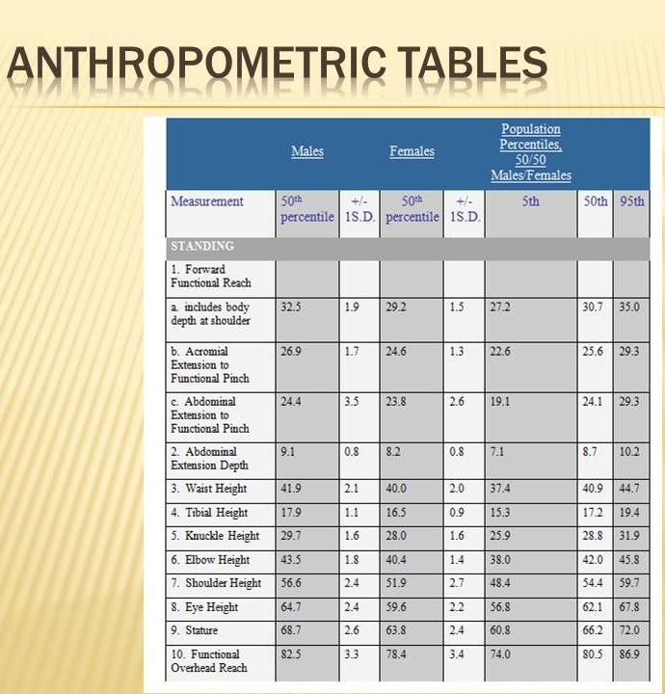

An alternative way of estimating body segment lengths is to use the Dillis and Contini segment proportions model. Contemporary anthropometric methods use body scanning methods. Data for the Singapore population are contained in the attached hand-out.
ACTIVITY 16:

Group Exercise: Using your own and your class data estimate your segment lengths and widths using the Drillis and Contini model. Discuss the issue of measurement landmarks.
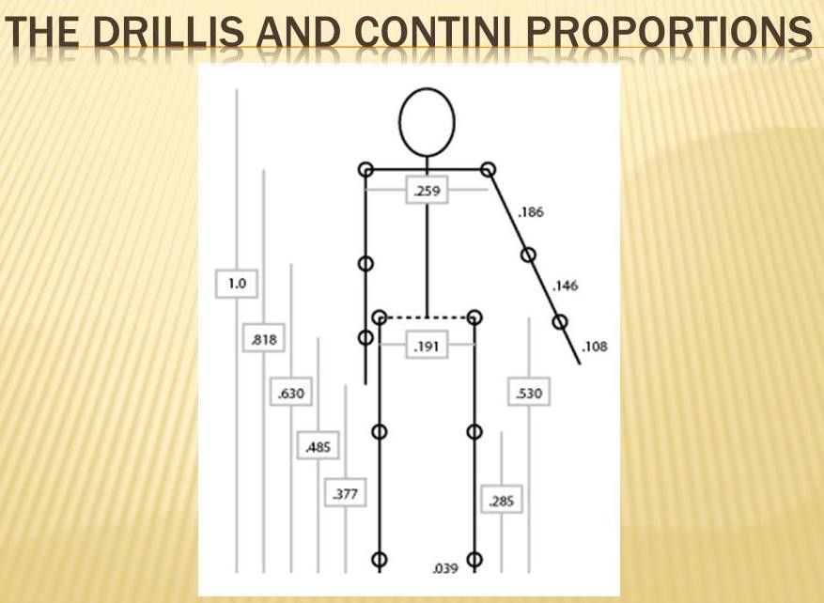

A typical application of anthropometry is in the design of the passenger accommodations in public transport, pilot or car driver workspaces and auditorium seating.

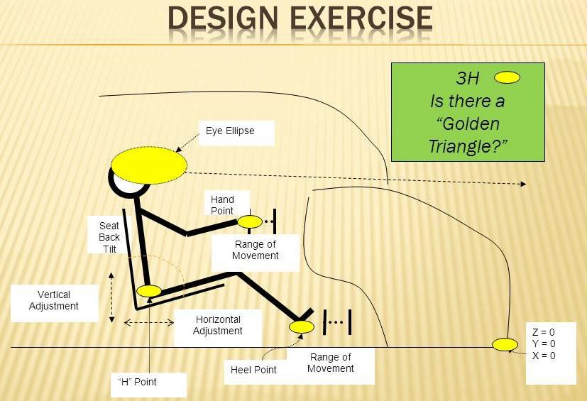

ACTIVITY 17:

Group Exercise: Use the class data to carry out the car design exercise. Convey the results of your workplace design exercise through a one page report.
Biomechanics and Manual Materials Handling

Mechanically speaking, the body consists of a bony framework with joints, muscles to control movement, a circulatory system to supply energy and a nervous system to precisely control the movements. In a given static posture with the various limb and trunk segments held still by muscle action, the forces involved may be analysed by drawing free body diagrams and analysing the moments around various joints. In addition, especially in the spinal joints, there are various tension, compression and shear forces.

ACTIVITY 18:

Group Activity: Draw a stick diagram of a person lifting a load from the floor. Identify the centres of gravity of the various body segments and the load.
Estimate the weight of each body segment. Calculate the moments around the hips and the shoulders and the compression forces on the spine.

Students are referred to the University of Michigan Three Dimensional Static Strength Prediction Program (UofM3DSSPP) for a detailed description of static biomechanical analysis.

http://www.engin.umich.edu/dept/ioe/3DSSPP/

Although static analysis does provide useful evidence regarding the biomechanical stresses in manual materials handling, in reality most activities are dynamic and the instantaneous and peak forces are difficult to measure. This complication along with the large variability between people in size, strength, postures and movements somewhat limits the utility and practicality of static analyses.
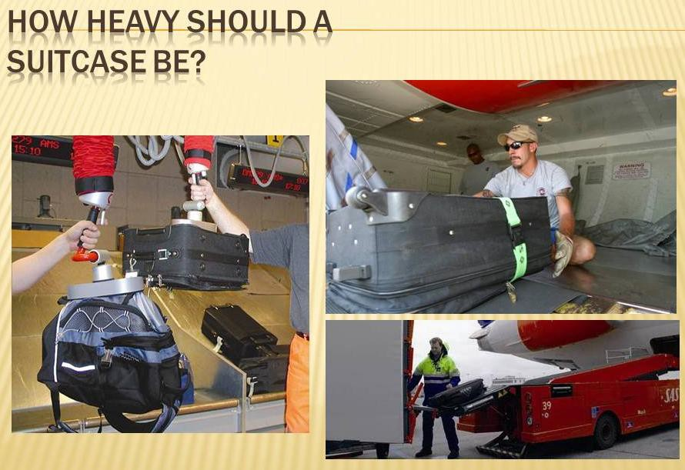

ACTIVITY 19:

Group Exercise: How heavy should a suitcase be? Discuss and describe how you would investigate this problem.

A major outcome and problem of manual materials handling is the high prevalence of back injuries. Consequently an analytic tool ‒ the NIOSH Lift Equation ‒ was developed to assess the contribution of key factors (Load, Horizontal Distance, Vertical Location and Movement, Asymmetry, Coupling, Frequency and Duration) to the overall stress in a Lifting Task and to provide recommendations for task parameter limits. The tool is available as a free smart phone / tablet app.

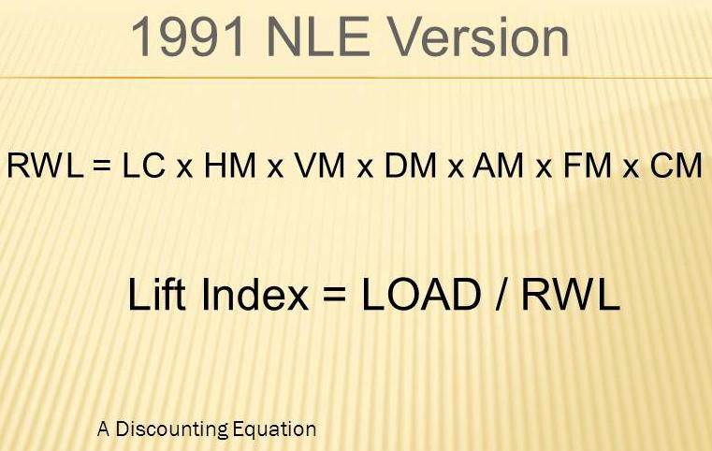

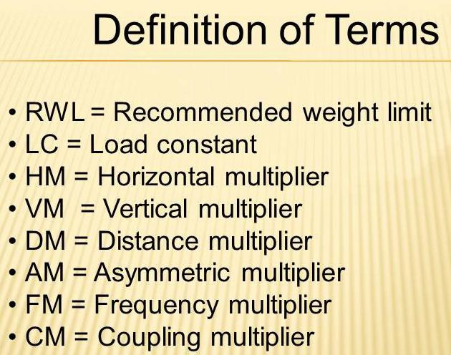
ACTIVITY 20:

Group Exercise: Download a smart phone / tablet NIOSH Lift Equation app and investigate the airline baggage handling tasks.

A second tool ‒ The Liberty Mutual (Snook) Manual Materials Handling Tables ‒ was developed using psychophysical techniques. Psychophysical methods are a way of obtaining estimates of human capabilities based on the subjective reports of experimental subjects carrying out various (both cognitive and physical) tasks. Tables are available for Lifting Carrying, Pulling and Pushing.

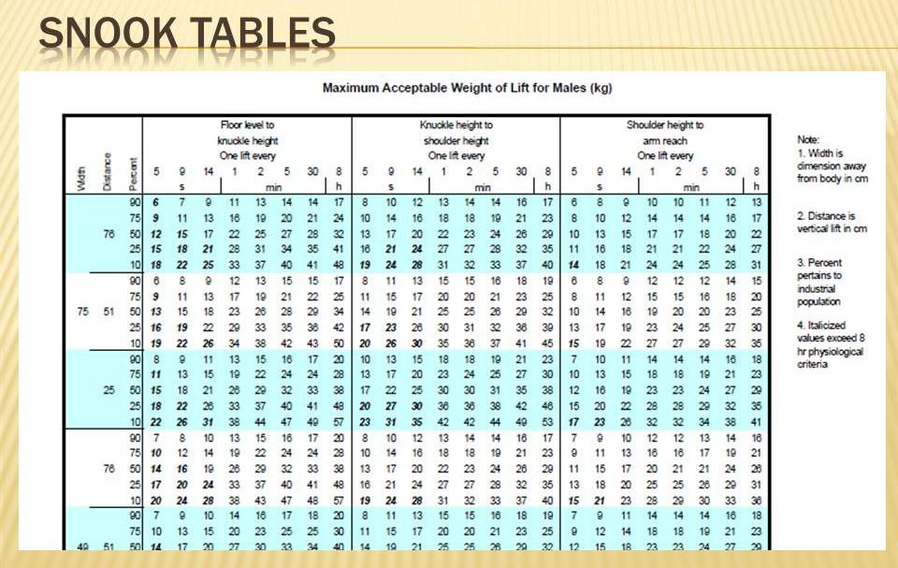

ACTIVITY 21:

Group Exercise: Search the Internet for the Liberty Mutual MMH Tables. Form small groups and design the task of moving a back pack to and from the floor to a table. Vary the horizontal reaches and calculate the moments around the L5/S1 spinal joint. Apply the NIOSH lift equation to estimate the recommended weight limit. Note that the biggest component of the load is your own body weight.

Human Factors in Aerospace

STUDY UNIT 2

Work Physiology, Thermal Environment and Circadian Rhythms

OBJECTIVES

At the end of this unit, you are expected to:

  - Understand how the body performs mechanical work
  - Recognize the symptoms and causes of fatigue
  - Assess and apply interventions for adverse effects of the thermal environment
  - Describe sleep patterns
  - Apply human factors principles to the design of work rest and shift schedules
OVERVIEW

This module will introduce human physiology, particularly the cardio - respiratory, thermo regulatory systems as affected by physical work, the thermal environment and disrupted sleep cycles.
READ:

Hawkins:
Chapter 3 - Fatigue, Body Rhythms and Sleep Chapter 4 - Fitness and Performance

2.1 Work Physiology

Work physiology is concerned with the conversion of food energy into mechanical energy through muscle contraction. Those students interested in the details of this conversion
ACTIVITY 1:

Group Exercise: Search the Internet for lists of the Calorific content of food and the energy demands of various activities.

process should study Krebs (Citric Acid) Cycle. A large component of the energy we use is
to enable the vertical movement of our body, and carried objects, against gravity. It should also be noted that only about 20% of the energy we convert is into mechanical energy; the rest is the production of heat. Another key issue is that if the food energy we consume is not converted into mechanical and heat forms, it is stored as fat.

Ergonomists aspire to measure key indicators of this process in order to assess the physical demands of heavy work and work in hot environments. Apart from measuring the Calorific content of food consumed, we may also estimate the physical work we do; however these methods are somewhat cumbersome and unreliable except in carefully controlled laboratory conditions. Consequently, we use the indirect methods of measuring oxygen uptake, circulation and body temperature to indicate physical workload. Less accurate methods involve the use of look up tables of food composition and activity demands. For example, brisk walking uses about 3 or 4 kilocalories (Physiological Calories) per minute.

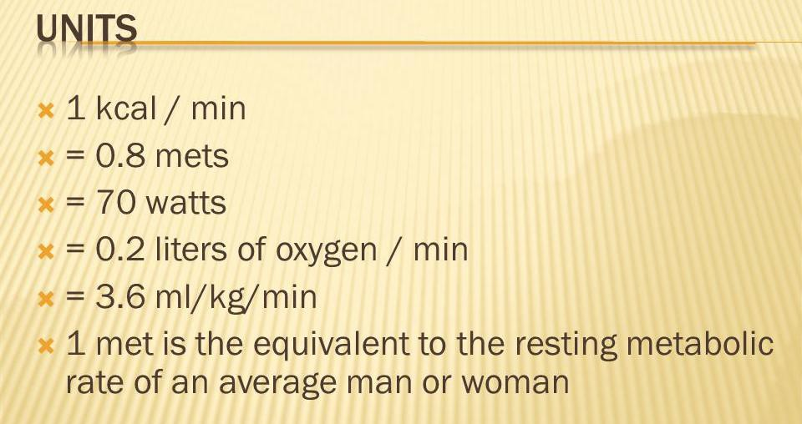

A widely used subjective method ‒ the Borg Scale ‒ is easy to obtain, relatively consistent and quite useful.
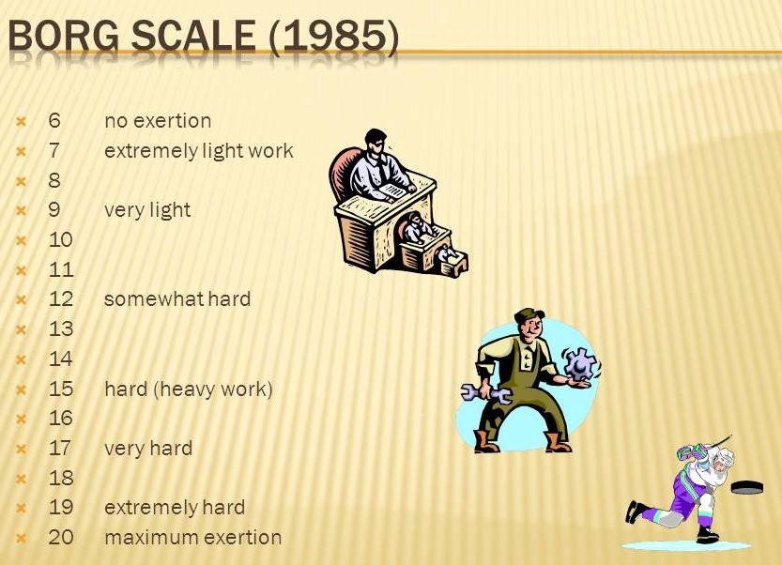

A general classification of physical work demands is shown below; however these estimates are affected by such things as body weight, age, sex, level of conditioning, motivation and fatigue:
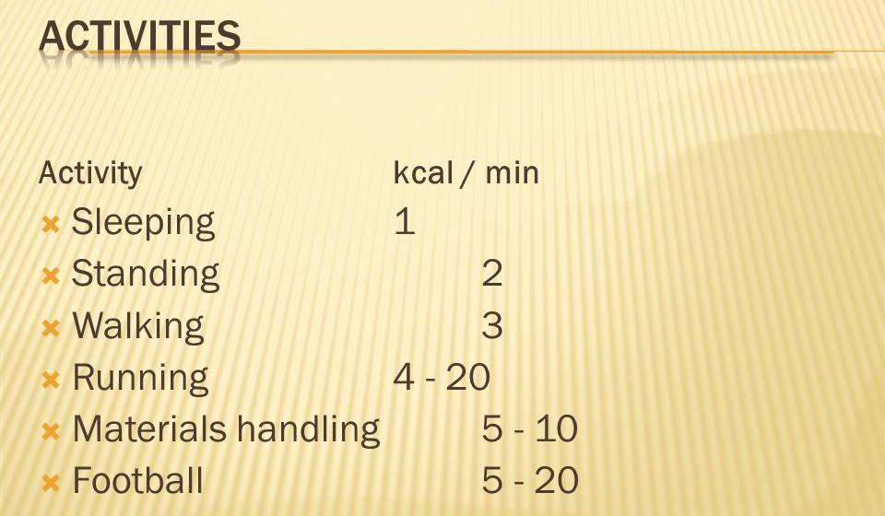

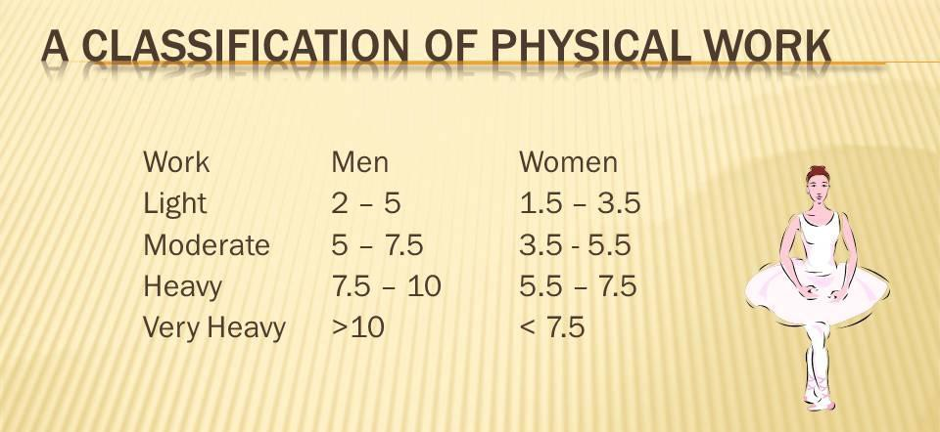

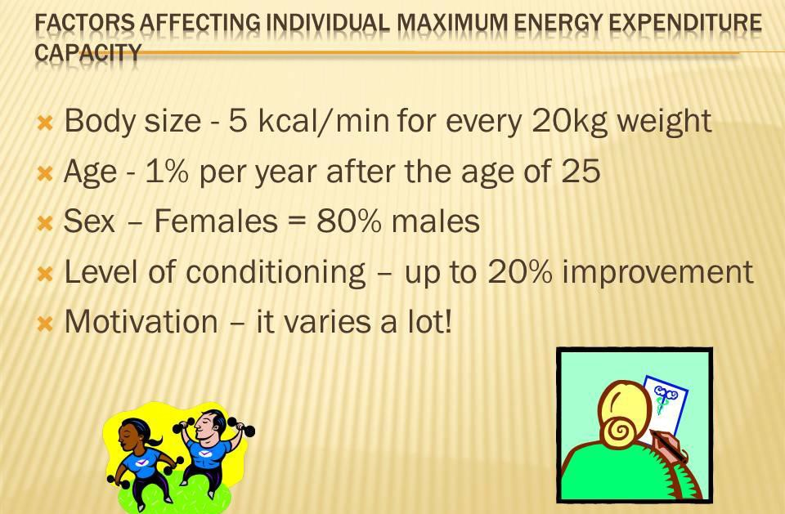

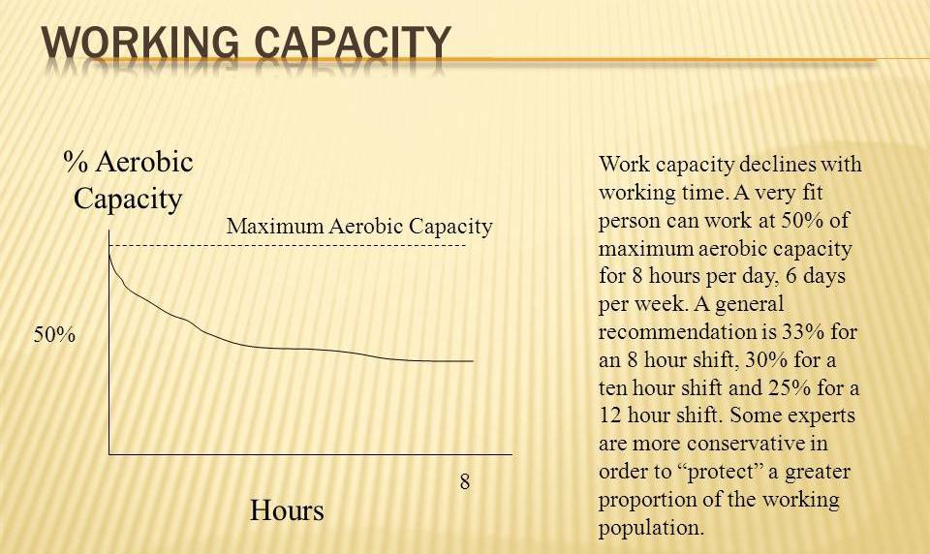

People's capacity for energy expenditure is also affected by the thermal environment and fatigue.

- The Thermal Environment

Because the majority of energy we use is converted into heat energy we need a sophisticated thermal balance mechanism to maintain our body temperature at relatively consistent levels. This is particularly important in hot and humid climates where the possibility of heat disorders is very real, especially where the physical workload demands are high and fluid (and nutrient) replacement is not sufficient. Heat is transferred between the body and environment by conduction, convection, radiation and evaporation. All of these mechanisms are potentially available for body temperature management. The biological process of thermal management involves the automatic control of heart output, cutaneous blood flow and sweating. Behaviourally we increase our heat production by activity and shivering in cold conditions and a reduction of physiological heat production by rest in hot conditions. Under normal thermal conditions, the core body temperature varies slightly (around 37oC) over the day and night, principally due to the varied physical work demands.

Measurement of the thermal environment includes temperature, humidity, air movement and various combined measures such as Effective Temperature and WBGT (Wet Bulb Globe Temperature). Humidity is measured by comparing dry and wet bulb temperatures. The (engineering) control of the thermal environment is by barriers to radiant heat, evaporative air conditioning and increased air movement - fans. Administrative controls include reduced physical work demands, reduced exposure durations, acclimatization programs, increased fluids and surveillance.

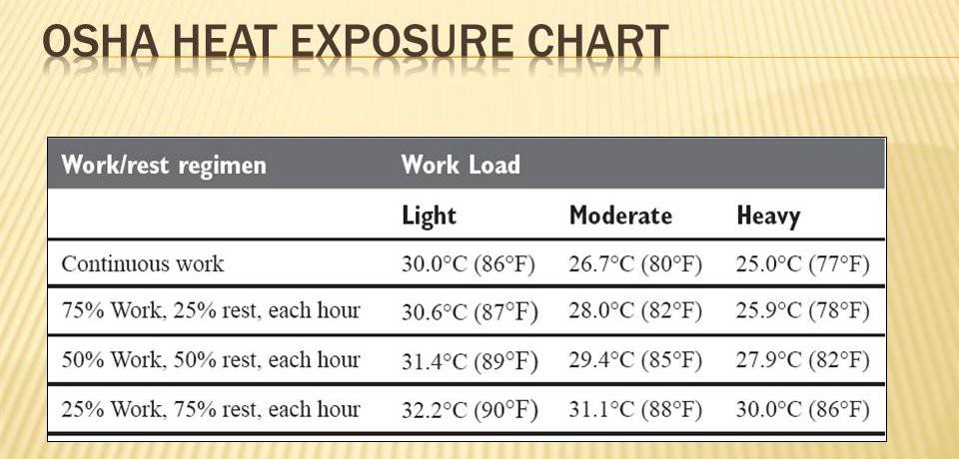
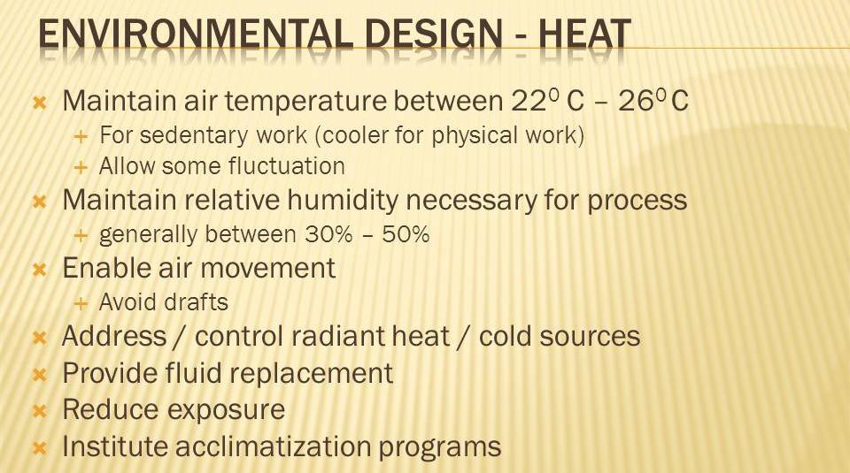

- Hypoxia

- Lack of Oxygen in the body tissues due to decreased quantity and molecular concentration.

- In aviation, it occurs due to fall in partial pressure of Oxygen in the inspired air with increasing altitudes.

Hypoxia Types
- Hypoxic Hypoxia ‒ reduction of a partial pressure of Oxygen in the inspired air
- Anemic Hypoxia ‒ reduction in Oxygen carrying capacity of the blood due to decreased hemoglobin content. (Carbon monoxide poisoning)

- Hypokinetic Hypoxia ‒ malfunction of the circulatory system where there is inadequate circulation of the blood.
- Histotoxic Hypoxia ‒ utilisation of Oxygen by the body tissues is interfered with by alcohol, narcotics, etc.

Signs and Symptoms of Hypoxia
- Breathlessness

- Excessive yawning
- Tiredness and fatigue

- Euphoria

- Impairment of psychomotor performance

- Decreased (night) visual acuity

- Impairment of mental performance (e.g. memory)

- Diminished alertness (maybe unconsciousness)

Predisposing Causes of Hypoxia
- Altitude. Higher altitude results in lower partial pressure of alveolar oxygen

- Rate of Ascent. The greater the rate of ascent the more rapid the onset

- Duration at Altitude. Effects more severe if the duration at altitude is prolonged

- Ambient Temperature. High or low environmental temperature

- Physical Activity. Physical effort at altitude raises the demand for Oxygen

- Individual Susceptibility

- Physical Fitness. Regular physical training improves the tolerance levels

- Smoking. Smoking makes an individual more liable to suffer from hypoxia

- Organic Diseases. Diseases of the heart, lungs or blood, which interfere with the normal oxygenation and circulation
- Emotional State. Apprehension and anxiety make an individual more susceptible
- Acclimatisation at high altitude raises the individual’s ability to withstand hypoxia

Altitude and Other Effects
  - < 10,000' No / minimal effect
  - 10000' - 15000' Compensatory behaviour
  - 15000' - 20000' Significant effects
  - >20000' Critical
  - Less Than 12000'
    - Vision especially night vision, is known to deteriorate even at altitudes less than 5,000 ft.
    - Night vision may be lost by 5-10% at 5,000 ft and may be compromised by 25% at 12,000 ft.
    - Symptoms of hypoxia may be increased due to anemia, cigarette smoking or exposure to carbon monoxide due to fumes in the cockpit.
    - Aircrew may not be aware of the hypoxia.
  - 12000' - 15000'
    - The effects of hypoxia on the nervous system become increasingly incapacitating.
    - Impairment of psychomotor skills
    - False sense of well being and euphoria
    - Drowsiness
    - Judgement errors
    - Compensatory actions by the circulatory and respiratory system can provide some defence against hypoxia.
    - Increase in heart rate
    - Increased and more forceful pumping of blood by the heart to improve circulation
    - and increased rate and depth of respiration
    - Compensatory responses occur spontaneously, but once aware the pilot must take conscious corrective actions promptly.
  - 15000' - 20000'
    - Physiological compensations do not suffice to provide adequate oxygen to the tissues.
    - Subjective symptoms may include fatigue, lassitude, sleepiness, dizziness, headache, breathlessness, and euphoria.
    - There are no subjective sensations up to the time of loss of consciousness.
  - Greater Than 20000'
    - Lost consciousness
    - Circulatory or central nervous system failure
    - Convulsions
    - Failure of the respiratory centre in the brain, which can lead to death.
  - Other Effects
    - Visual acuity is diminished.
    - Peripheral and central vision is impaired.
    - Range of accommodation for near vision is decreased.
    - Touch and pain are diminished or lost.
    - Hearing is one of the last senses to be lost.
    - Intellectual impairment makes it impossible for the individual to comprehend his own disability.
    - Thinking is slow, calculations unreliable.
    - Memory is faulty, particularly for recent events.
    - Judgement is poor.
    - Reaction time is delayed.
    - Release of basic personality traits and emotions similar to intoxication
    - Euphoria, overconfidence, or an individual may become morose.
    - Poor muscular coordination.
    - Fine muscular movements may be impossible.
    - Stammering, illegible hand writing
    - Poor coordination in aerobatics and formation flying.

- Circadian Rhythms and Shift Work
ACTIVITY 3:

Group Activities:

- Record your heart rate response to different postures, activities and thermal environments

- Keep a diary for three days including sleep, activity types, meals, heart rate and thermal environment

- Discuss and describe the long term implications of sedentary work

- Develop a one page report on physiological factors and work

Human Factors in Aerospace

STUDY UNIT 3

Human Information Processing, Controls and Displays Design

OBJECTIVES

At the end of this unit, you are expected to:

  - Describe the sub processes associated with Human Information Processing
  - Identify the general causes of performance failure
  - Comprehend the effects of visual and auditory environment on sensory performance
  - Recognise and explain perceptual and memory limitations
  - Analyse human decision making using Hicks' Law
  - Analyse and design prevention interventions for human decision and execution errors
  - Compare the advantages and disadvantages of alternative display modalities and formats
  - Compare the advantages and disadvantages of alternative control devices
  - Analyse the opportunities for computer based controls and displays
  - Create a control panel for a UAV

OVERVIEW

This module introduces sensory and cognitive psychology and the various stages and vulnerabilities of the different human information processing stages with reference to equipment control and display interfaces.

  - Human Information Processing

A traditional model of Human Information Processing includes sensing, attention, perception, cognition, memory and effectors management. As with physical characteristics, people vary considerably in these processes and “human error” may occur at any stage.

READ:

Hawkins Chapter 2, 5
Chapter 7, 11
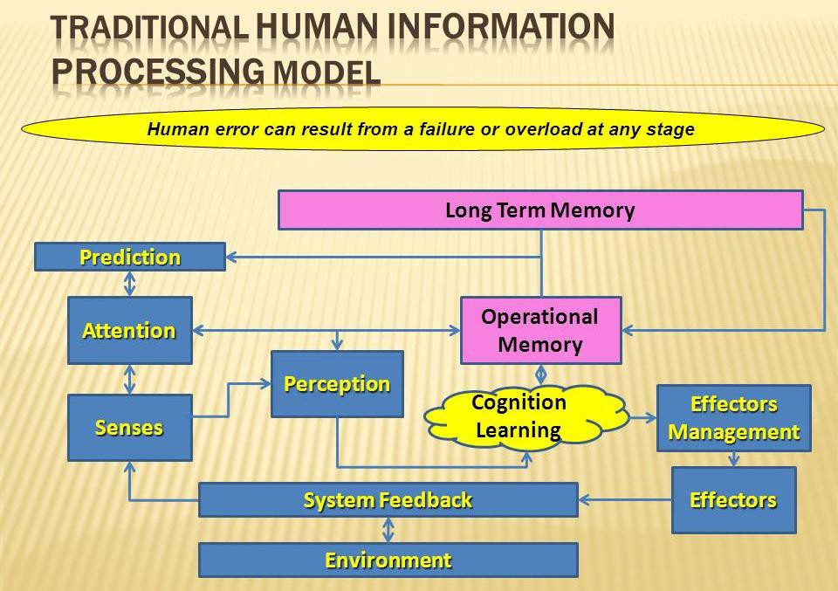
ACTIVITY 1:

Group Exercise: Discuss and describe each of these stages with regard to this class.

- Attention

A particularly vulnerable stage is the attention mechanism.

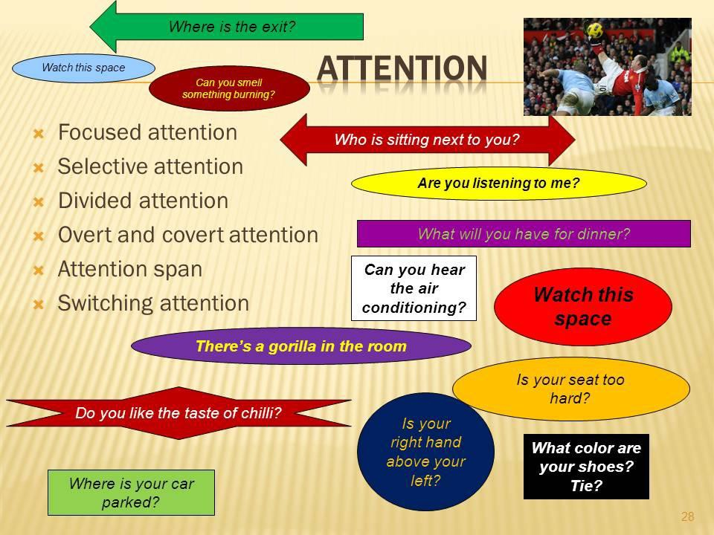

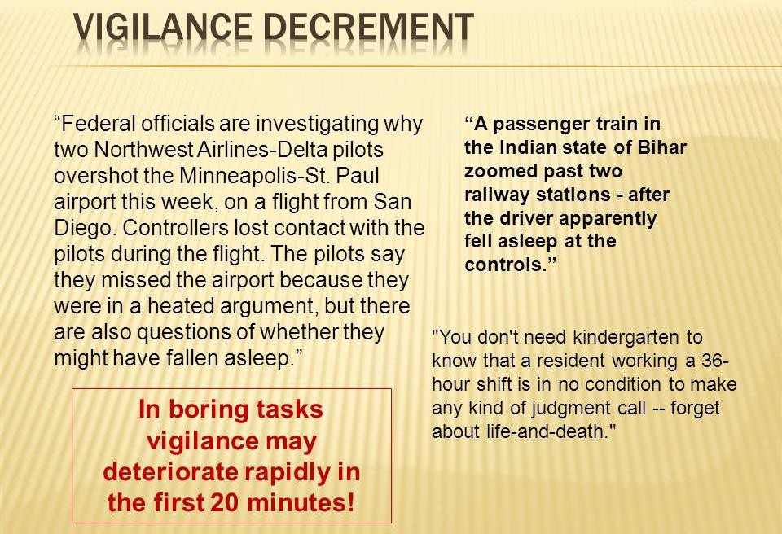
ACTIVITY 2:

Group Exercise: Discuss and describe the attention demands on a bus driver or pilot.
- Cognition
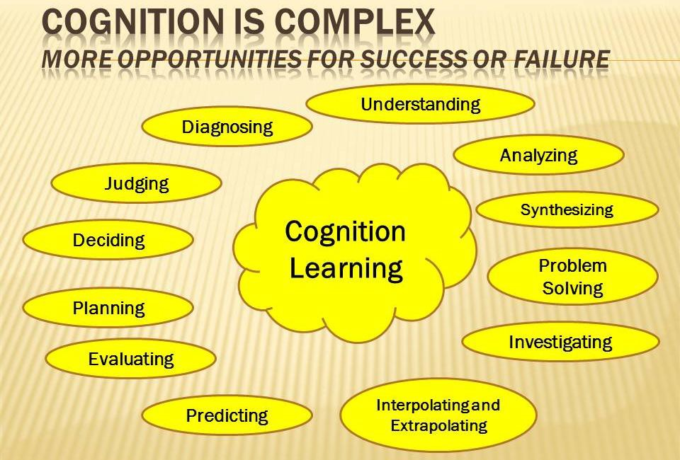

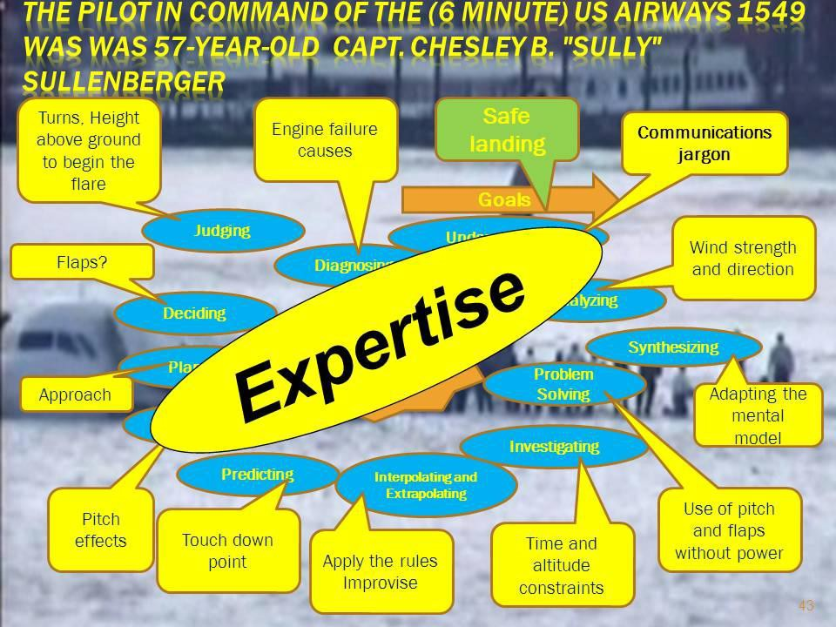

ACTIVITY 3:

Group Activity: Discuss how a failure in any of these cognitive processes would have changed the outcome of this incident.
- Memory

Operational Memory is vulnerable.
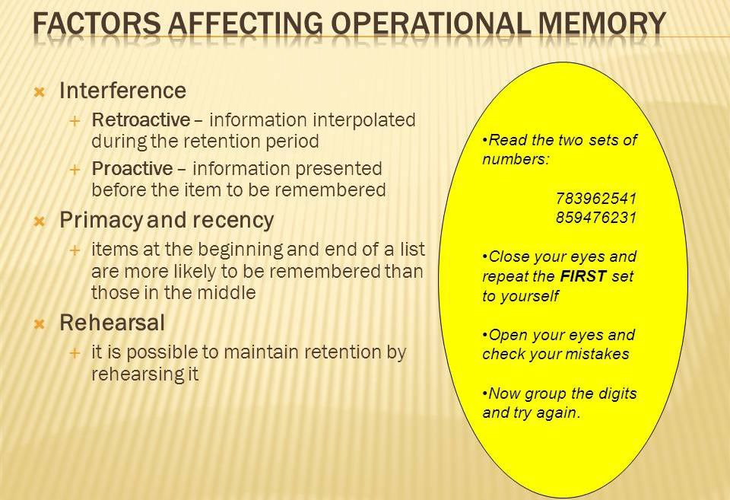
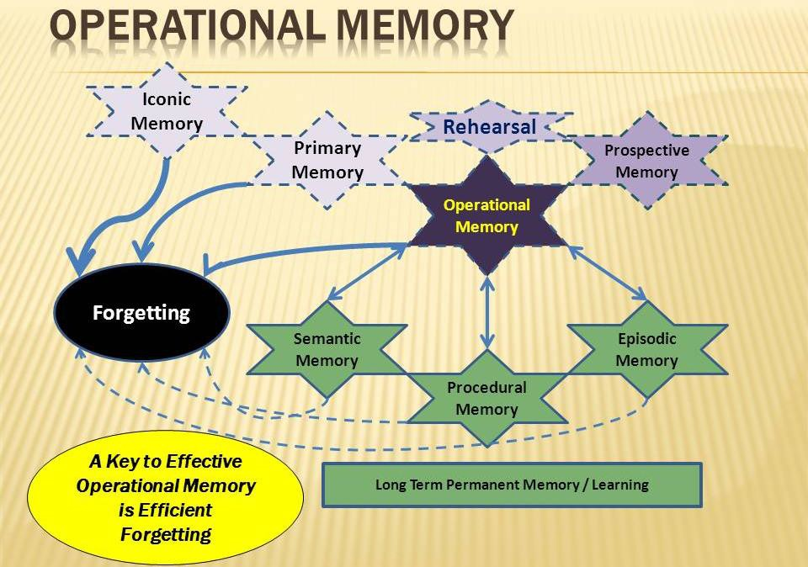
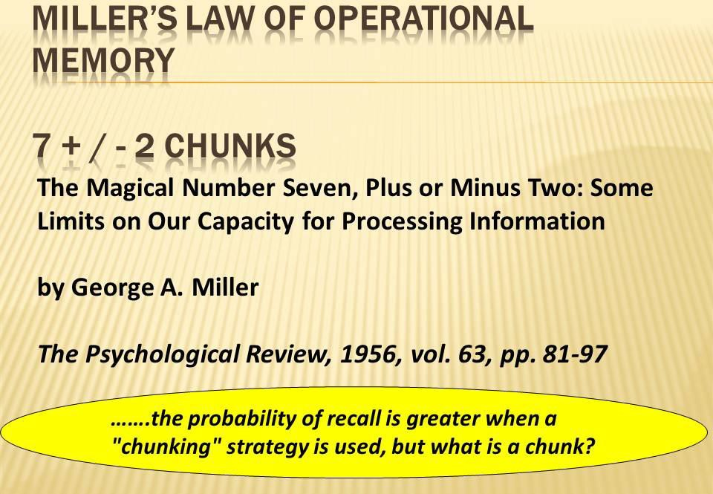

ACTIVITY 5:

Group Exercise: Speak some number and letter groups of various lengths to your classmate, have them repeat the numbers or letters back. Record the errors. Plot the relationship between letter or number group size and errors.
ACTIVITY 4:

Group Activity: Discuss and describe a “chunk” of information. How are learning and expertise linked to chunking?
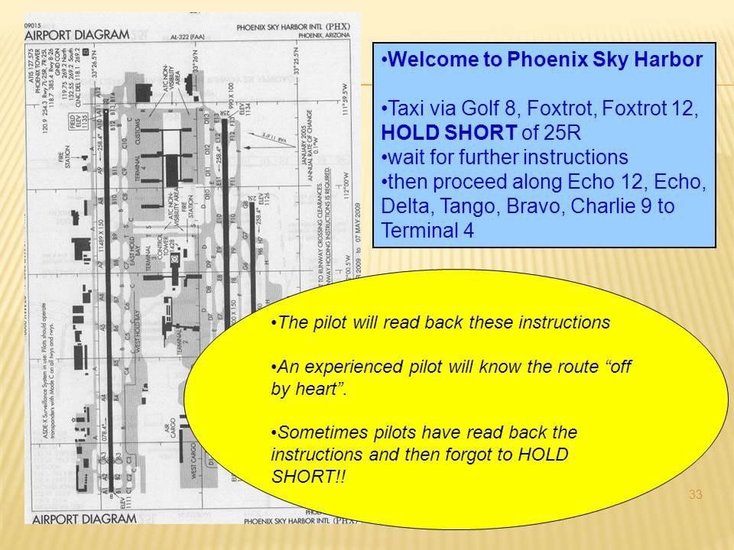
ACTIVITY 6:

Group Exercise: Develop a set of instructions for the journey between your home and your work, communicate the instructions to your group members and have them read the instructions back. Document the errors. Discuss and describe the causes of the errors.

  - Human-Machine Systems and Control

One perspective of Human Factors is to observe the activities and information flow in a "Human-Machine System.” In a simple system, like a hand tool, the user has direct vision of the task and interacts directly with the tool (although handle length does allow some force gain and control adjustability). With a more complex system, like a car, displays are added to provide system (e.g. engine temperature) and operational (e.g. speed) performance. Also the steering wheel and foot pedals are connected to the front wheels, engine and brakes via various linkages and power amplifiers. These additions of sophisticated controls and displays make control much more precise.

- Interface Design

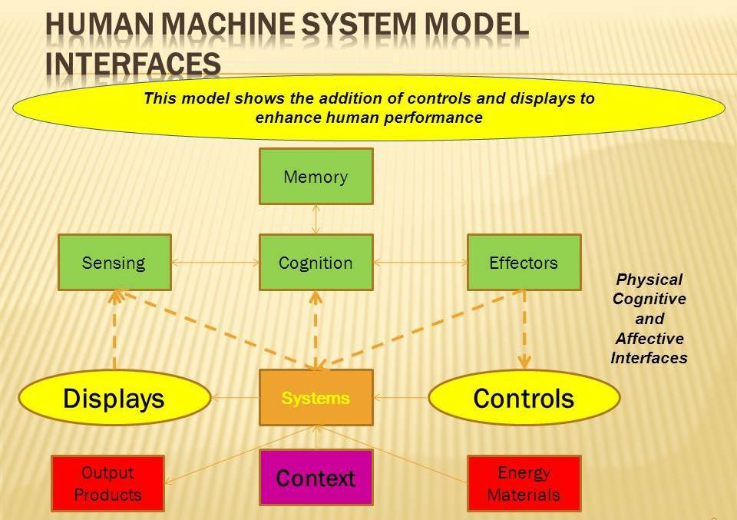
ACTIVITY 7:

Group Exercises:

- Discuss and describe some physical information and affective interfaces.

- Consider the control of the Mars Rover or surveillance UAV and describe these Human-Machine Systems in terms of functions of the machine and human components and their interactions. What might be the causes of system failure?

An alternative model of human machine interaction is based on feedback control theory. In this model the operator has an objective, anticipates the effects of uncontrollable external forces and provides an appropriate system input. He / She then observes the output (feedback) and modifies the input accordingly.

Control
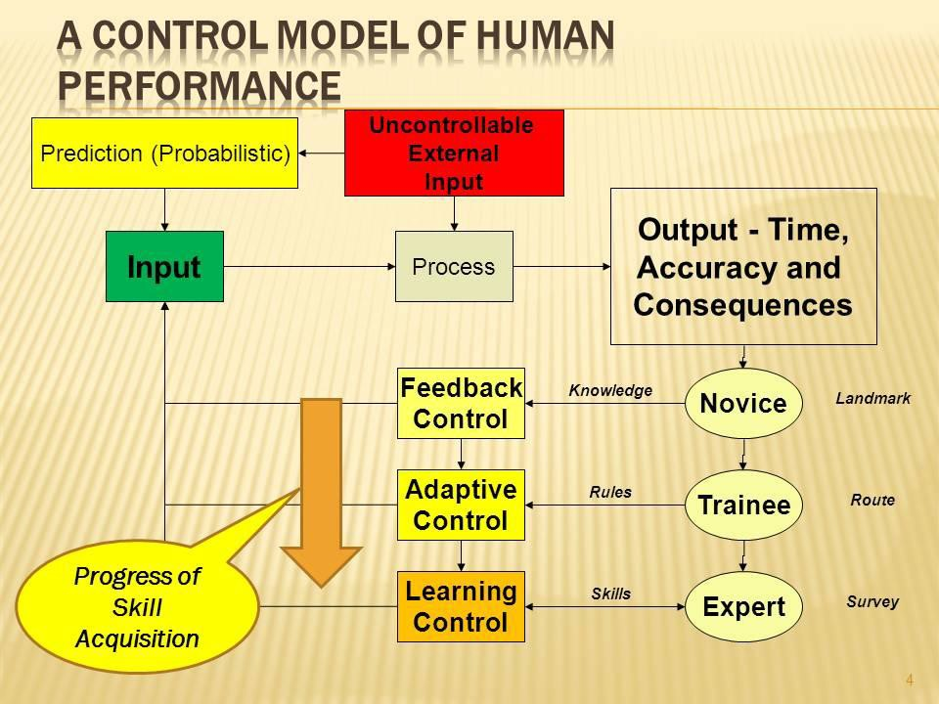
ACTIVITY 8:

Group Exercises:

- Place a coin on your desk top and push it with your finger to a target about 20 cm away. Now repeat the activity iteratively with your eyes closed while you push and open to inspect the error. Repeat the exercise again with a partner providing feedback. Discuss the effects of degraded and delayed feedback.
- Using a more complex demonstration, carry out a pencil and paper simulation of an emergency approach and landing. Discuss how practice / learning can improve your performance.
- Investigate how time pressure affects accuracy by placing limits on task completion time.
- Discuss how sophisticated displays can be used to achieve this task when vision is degraded (instrument landing).

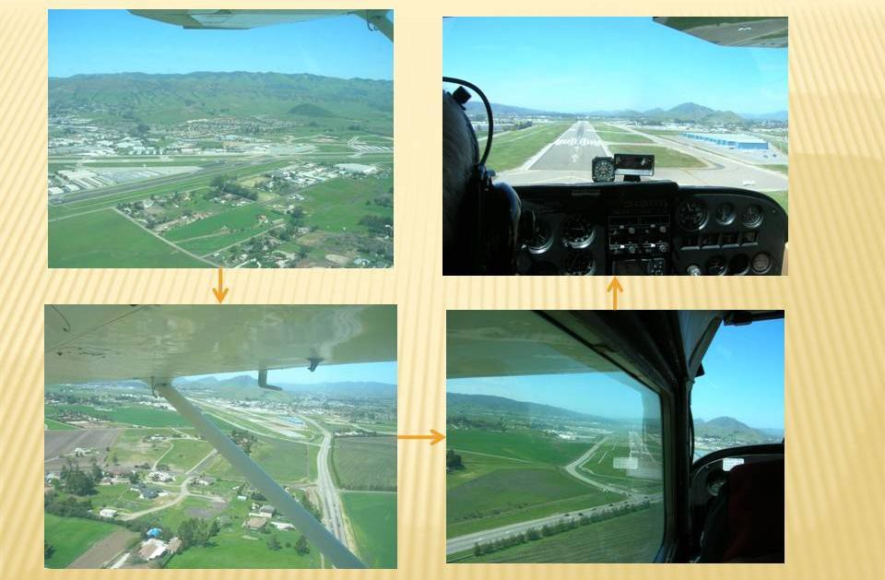

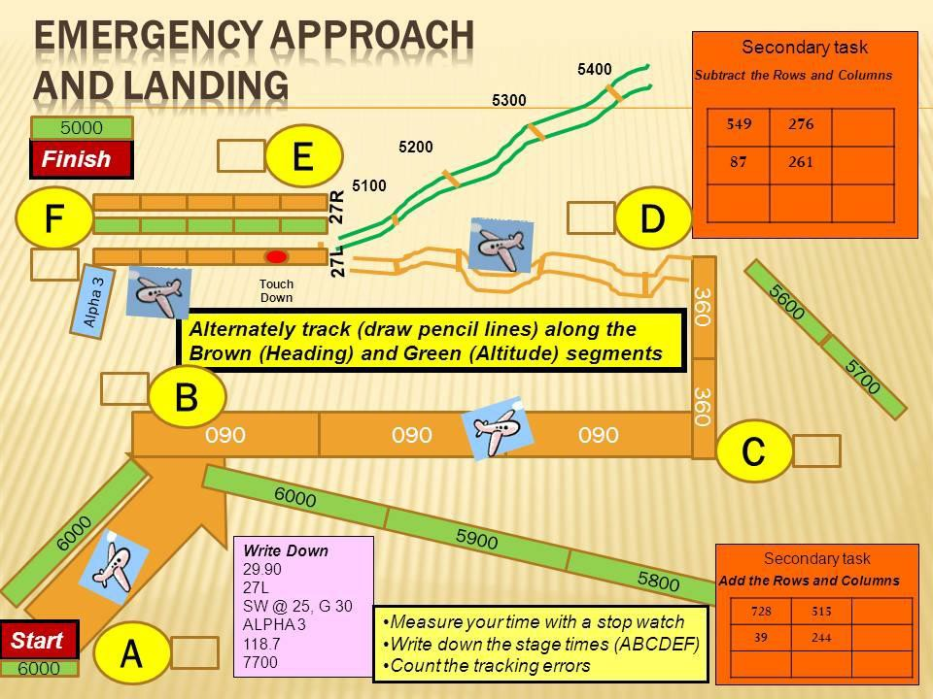

- Communication
Communication is a generally familiar concept, but breakdown of communication is probably the most frequent cause of system failure. Analysis and prevention of communication elements are therefore important in system safety. Communication starts with an idea, concept or objective which is then translated into some semantic form; the next step involves the choice of a physical mode of communication. The information is then transmitted to the receiver who has physical reception capabilities (eyes and ears); next the receiver interprets the transmitted signal and translates it into some memory or action. The communication pathway is very dependent on the prior knowledge (added information) of the sender and receiver; also all of the stages are very vulnerable to noise and lost information.

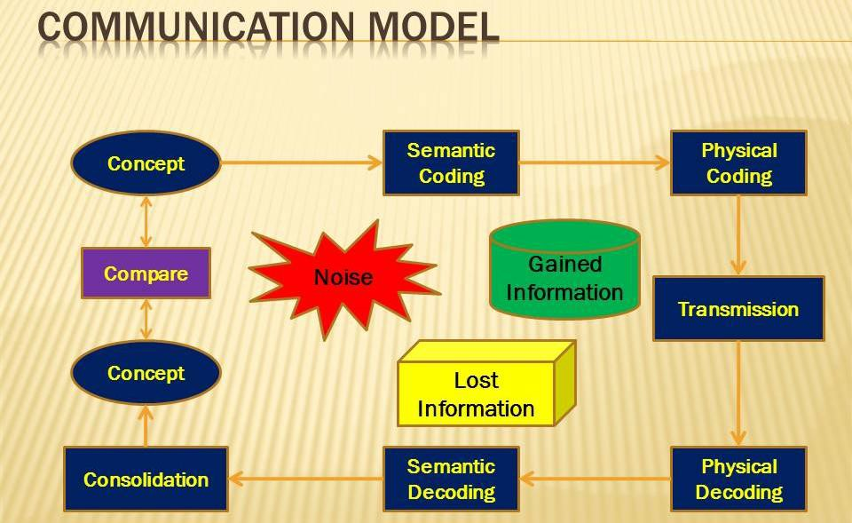

ACTIVITY 9:

Group Exercise:

Carry out some of the following communication activities to explore the knowledge requirements of the sender and receiver and the potential physical and semantic causes of communication failure:

- Instructions for getting to the bus stop or MRT station

- Design instructions for making a paper airplane

- Requirements for a group ergonomics project

- Discuss and describe the cognitive, including attention, perception memory, judgement and decision making, functions associated with the successful ditching of US Airways Flight1549.

- Discuss and describe the human information processing functions of aviation maintenance mechanics, air traffic controllers or security inspectors.

- Discuss how task aids such as checklists, instructions and procedures can be designed to support and improve human cognitive performance.

- Discuss how computer and automation can be used to supplement or even replace human cognitive activities.

- Explore and evaluate the pertinence of Fitts Lists in the light of contemporary computer and mobile technology.

- How can knowledge of human information processing functions be applied to accident causation and analysis?

Human Factors in Aerospace

STUDY UNIT 4

OBJECTIVES

At the end of this unit, you are expected to:

  - Describe the elements of manual control and sensory motor skills
  - Investigate human manual control performance using Fitts Law and de Jong's Law
  - Perform basic flight maneuvers using Microsoft Flight Simulator or Google Earth
  - Compare part and scenario based training methods

OVERVIEW

This module addresses the human operator as an element in simple and complex control systems, the changes that can be expected with learning and the design of training regimes to maximise training effectiveness.

Sensory Motor Processes
Sensory motor processes involve sensory input (visual, auditory, tactual, etc.) and usually continuous "motor" or manipulative output, as opposed to verbal or discrete manual actions. Examples include driving a car along a highway lane, writing, adjusting the flow of water from a tap, playing the piano or landing an airplane. It can be seen that sensory motor skills vary enormously in complexity. Usually. they are measured in terms of accuracy and time. They are very amenable to learning with repeated practice, given appropriate (visual, auditory or tactual) feedback. Sensory motor processes are susceptible to all the human information processing functions described earlier.
READ:

Hawkins Chapter 9

4.1 Sensory Processes ‒ Vision and Hearing

- Vision
The retina of eye converts light energy into an electrical signal which is interpreted in the visual cortex of the brain. The pupil and lens are responsible for controlling and focusing the incoming light on the retina. The retina contains cones which are concentrated around the fovea and are sensitive to color, especially under high light levels. The rods are distributed around the outer parts of the retina, have a higher sensitivity, but are not sensitive to color.
ACTIVITY 1:

Group Exercise: Using the Internet to download images of the eye, identify the principal components and their functions.

Functions of the Different Eye Structures

  - Sclera ‒ the eye's white outer protective coat, normally seen as the "white of the eye".
  - Cornea ‒ the transparent, curved structure at the front of the eye. • Iris ‒ the coloured part of the eye ‒ blue, brown, green, grey, etc. ‒ that can be seen through the cornea.
  - Pupil ‒ the black part of the eye in the middle of the iris. It constricts or dilates according to the amount of light passing through it.
  - Lens ‒ the transparent disc (with both sides being convex) immediately behind the iris and pupil.
  - Aqueous humour ‒ the transparent fluid (with consistency similar to water) that circulates behind the cornea and in front of the lens.
  - Vitreous humour ‒ the material (like transparent jelly) that fills the eyeball between the lens and the retina.
  - Retina ‒ the light-sensitive layer of millions of nerve cells that line the back of the eyeball. The cells consist of two main groups, called rods and cones due to their appearance under the microscope.
  - Rods ‒ more numerous, spread out over the entire retina with more towards outer edge, respond to low levels of light.
  - Cones ‒ far fewer, concentrated around the fovea, respond to colour and to details.
Optic nerve and beyond ‒ the "cord" of nerve cell connections that passes from the eyeball to destinations throughout the brain

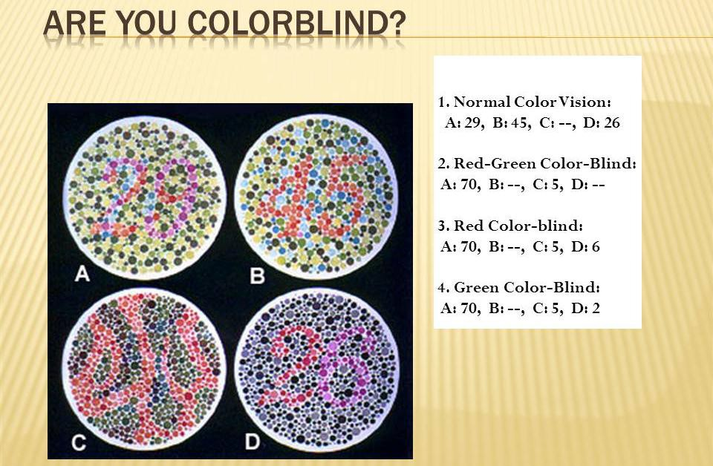
ACTIVITY 2:

Light Measurement: Download and use an app on your smart phone or tablet to measure the illumination (lux) on various surfaces under various lighting conditions.

Visual Acuity

Visual acuity is dependent on the amount of light (especially that falling on the fovea where the cones are concentrated) and the visual angle subtended by the target. Visual acuity may be assessed by the familiar eye charts or by more elaborate devices.
ACTIVITY 3:

Visual Acuity Exercises:
- Move a newspaper away from you and measure the relationship between distance and the minimum font size you can read.
- Repeat the activity under different light levels.
- Hearing

Sound waves are concentrated along the outer ear canal and cause vibrations in the tympanic membrane which are transmitted through the middle ear by the ossicles to the nerve endings in the inner ear or cochlea.

Functions of the Different Ear Structures
ACTIVITY 4:

Group Activity: Search the Internet for images of the ear, discuss and describe the various structures and functions.
ACTIVITY 5:

Sound Measurement: Use an app on your smart phone or tablet to measure the sound intensity at a location and measure the effect of distance from the source.
The ear is differentially sensitive to different frequencies being most sensitive in the human speech range – from 300Hz to 4000 Hz.
ACTIVITY 6:

Group Activity: Split into two subgroups. Take turns for each subgroup to speak lists of words in a normal voice level; have the other subgroup listen in and then answer questions regarding the conversation content. Record the accuracy of the answers. Repeat the exercise at different distances. What is the relationship between distance and hearing performance?

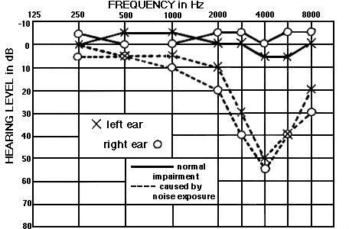

- Fitts Law

Fitts Law demonstrates that the time taken for a particular (reciprocal tapping) task is affected by both the amplitude and target width. This relationship can be extrapolated to a wide variety of control tasks.
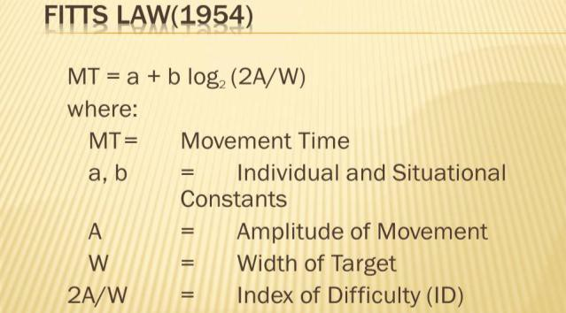

ACTIVITY 7:

Group Activity: Have each of the group members carry out the following pencil and paper exercises, record the times and errors. Develop a graph to show the relationship between the Index of Difficulty and time.

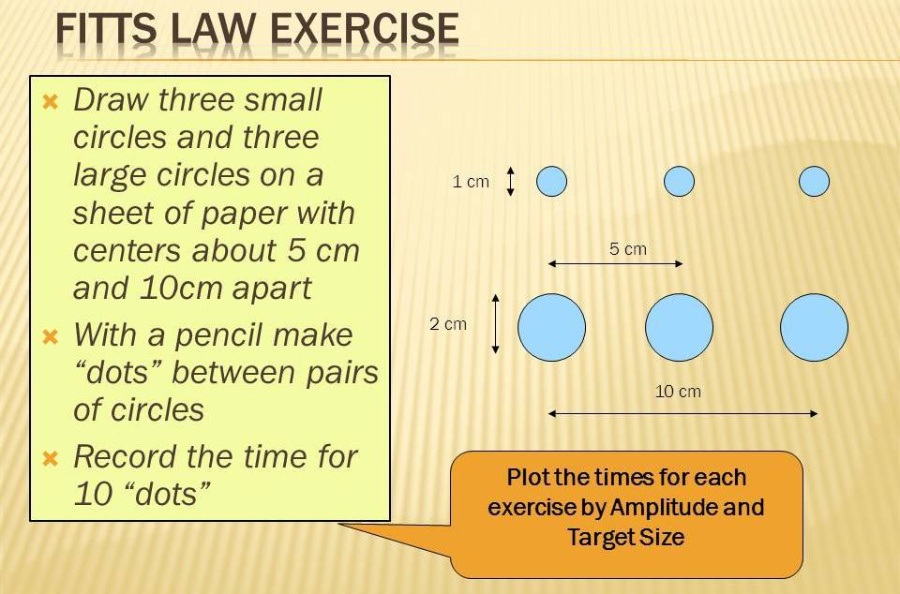

- Hicks Law

Hicks law demonstrates that more difficult decisions, in terms of the amount of information that is needed to be processed, require longer times. This can be clearly demonstrated by the following Choices Exercise.
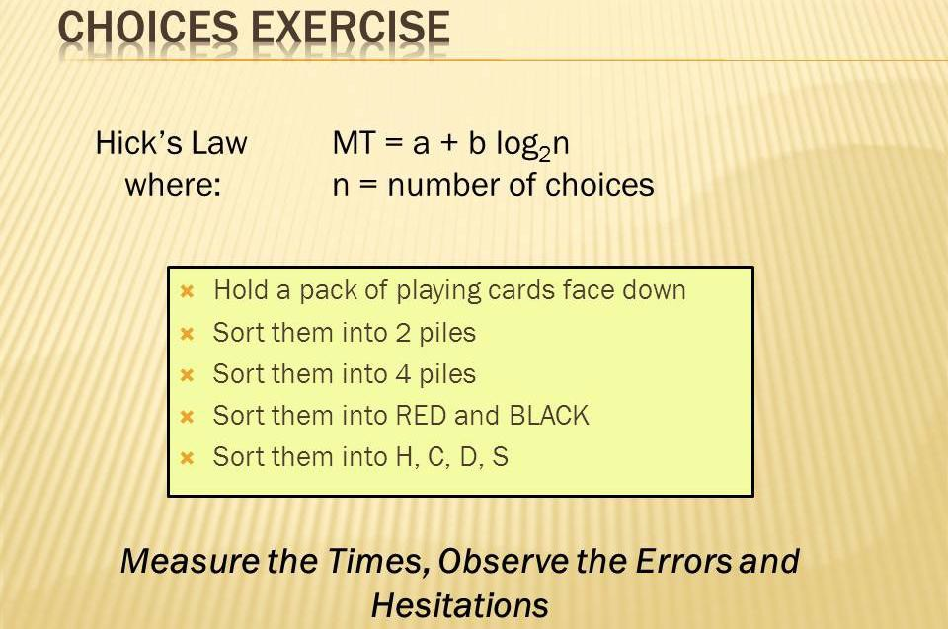

This relationship between the log of the number of choices and decision time can be extrapolated to many complex information processing tasks. It must be noted however that the decision itself is significantly affected by the value of the outcome and the time available to make the decision.
ACTIVITY 8:

Discuss and describe time and accuracy in the following situations:

- The decisions made by basketball, soccer or other games players regarding their actions

- Referee decision making
- Inspection of complex equipment fault alternatives
- The response to a multiple choice question where the alternative answers are grammatically complex
- Financial decisions associated with investments or product purchase

- De Jong’s Law

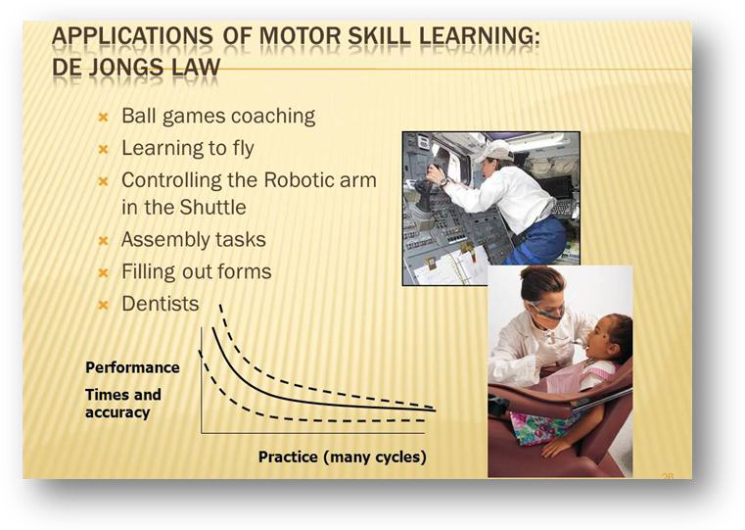
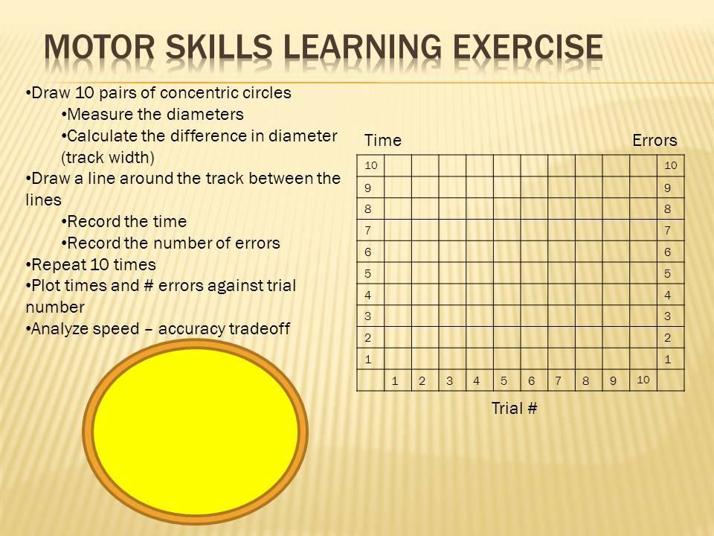
Motor skills and decision making improve with practice as described by de Jong’s Law.

- Mental Work Load
ACTIVITY 9:

Group Activity: Discuss and describe the extrapolation of de Jong's Law to complex learning situations such as assembly work, driving or controlling a multi degree of freedom crane or manipulator.

Repeat the pencil and paper emergency approach and landing exercise.

ACTIVITY 10:

Carry out the complex sensory ‒ cognitive motor task of flying a simulated traffic pattern as described below.
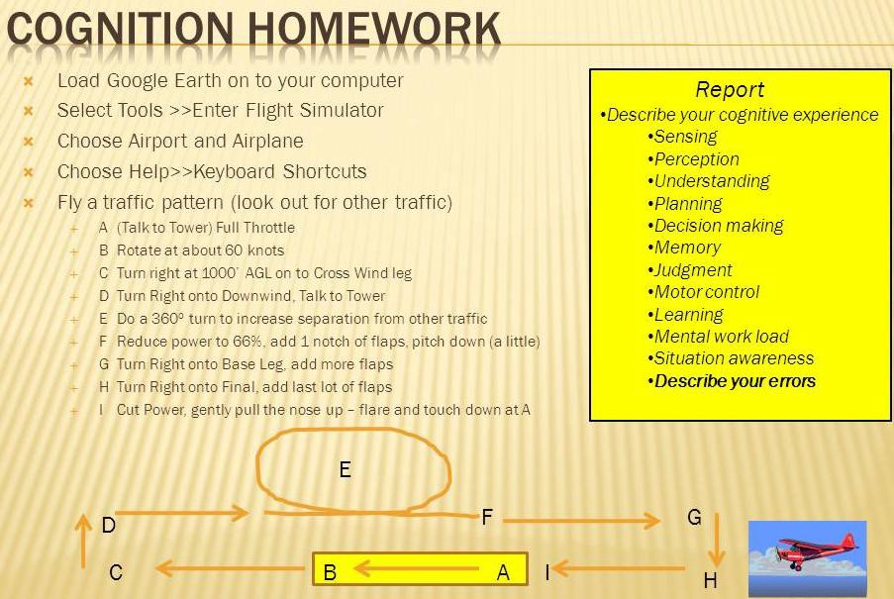

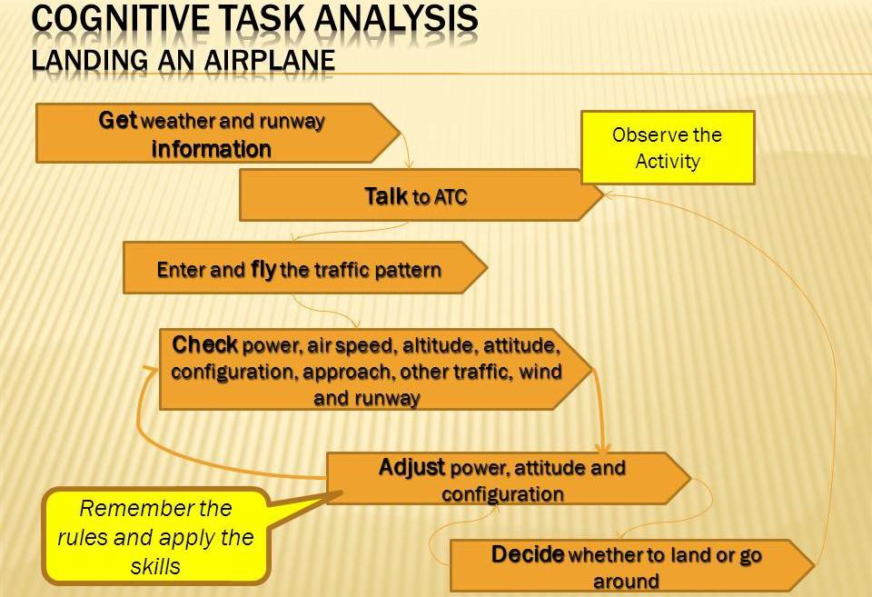

Note the physiological effects of stress during a student pilot’s solo landing.

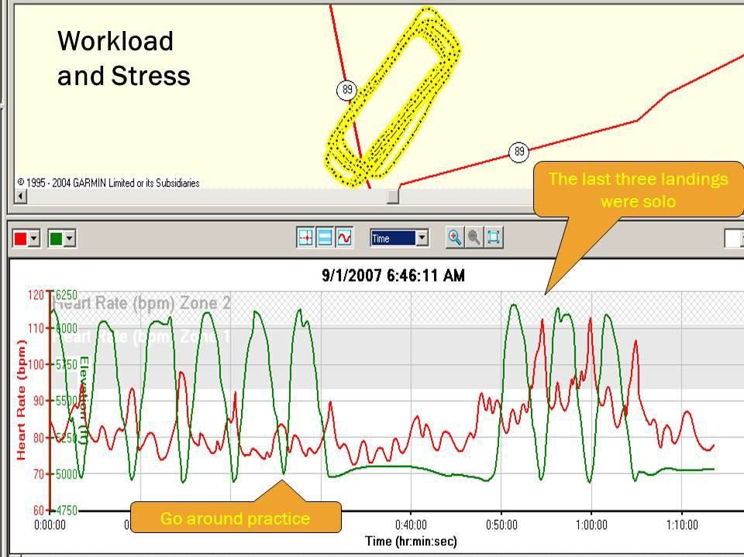

ACTIVITY 11:

Group Activity: Use the NASA TLX (Task Load Index) to describe your experience at different stages of the flight and as you gain experience with repetition.
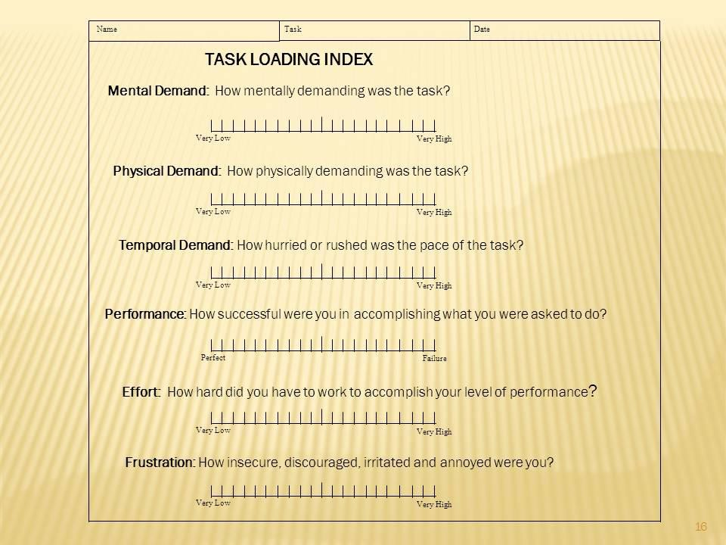
ACTIVITY 12:

Group Activity: Discuss and describe the challenges and measurement of mental workload and performance experienced as you repeat this task multiple times.

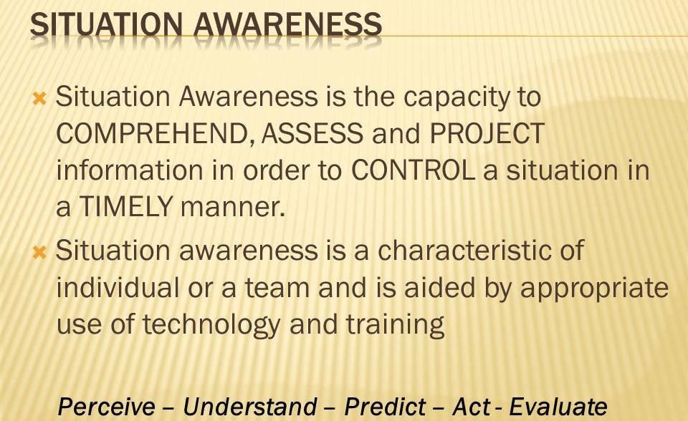
- Situation Awareness

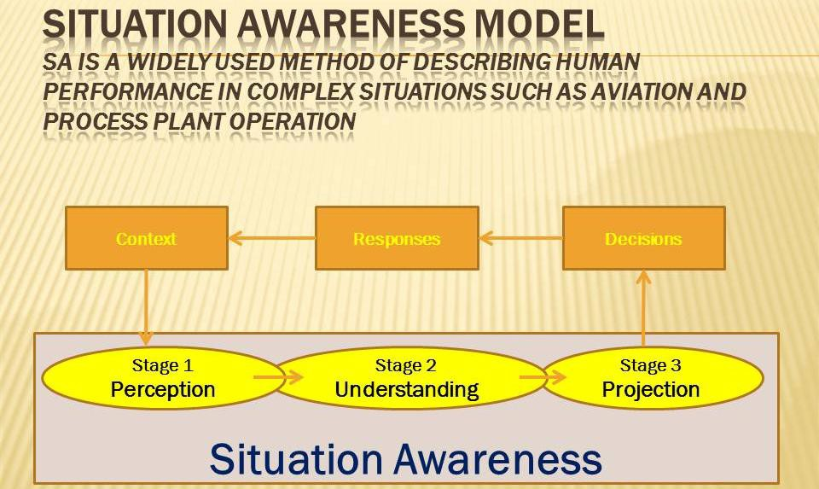

ACTIVITY 13:

Group Activity: During the Flight Simulation activity, carry out the SAGAT method of measurement of Situation Awareness as follows:

- Develop a detailed simulation of complex situation

- Air Traffic Control, Driving, Process control

- Alternatively use pencil and paper techniques

- Periodically stop the simulation

- Ask subject (pre-prepared) key questions about attitude, heading, altitude

- Have subjects rate their levels of confidence

- Record, omissions and other discrepancies

- Have Subject Matter Experts rate the performance

- Compile overall performance scores

Human Factors in Aerospace

STUDY UNIT 5

Crew Resource Management

Objectives

At the end of this unit, you are expected to:
- Describe the nature of team work, including division of labour, communication and collaboration
- Create a simulation of a CRM situation from the Aviation domain

OVERVIEW

Crew resource management is about optimising team situation awareness and decision making. Many complex situations, such as flying, surgery and managing an organisation such as a university of business operation require a significant division of labour (including automation) and good communication among the team members. The success of failure of such operations is dependent on effective crew resource management.
READ:

- The Evolution Of Crew Resource Management Training In Commercial Aviation
Robert L. Helmreich, Ashleigh C. Merritt & John A. Wilhelm Department of Psychology
Aerospace Crew Research Project The University of Texas at Austin

- CAP 737
Crew Resource Management (CRM) Training
Guidance For Flight Crew, CRM Instructors (CRMIS) and CRM Instructor-Examiners (CRMIES)
www.caa.co.uk
5.1 Introduction to CRM

Crew Resource Management (CRM) is the application of human factors knowledge and skills to the conduct of flight (and other) operations with the objective of efficiently using all available resources (equipment, systems and people) to achieve effective, efficient and safe operations.

Commercial air transport remains one of the safest methods of moving people and goods from one point to another and number of fatal incidents per mile travelled is extraordinarily low. But a single accident may have a disastrous outcome and the image of the safety practices in the industry gets negative publicity. It has been widely estimated that around 75% of accidents are caused by human error but what this term fails to recognise is that humans are but one part of the wider environment ‒ they must interact with many components including weather, technology, social systems, etc. Despite this, humans are at the most very basic level the root cause of almost every incident because humans ultimately design and/or interact with all elements of the wider environment. In most complex operations even though individuals may make errors, good CRM will provide the redundancy to avoid adverse outcomes.

Modern crew resource management focuses upon the management of all available resources to reduce error among all groups of aviation specialists (e.g. air traffic controllers, pilots, cabin crewmembers, mechanics and dispatchers) through goal setting, teamwork, awareness and both proactive and reactive feedback. Training of Crew Resource Management for commercial aircrew has become a mandatory practice under the majority of the world aviation regulatory environments and practice of Crew Resource Management is an integral part of commercial airline operations.

The successful application of CRM in aviation has been recognised and equivalent training methods are now widely applied in a range of other high risk industries including, for example, medicine, fire services and maritime operations.

Leadership
- Leadership depends on the situation, not the rank
- There are important cultural differences
- A prerequisite of leadership is a team with the appropriate knowledge, skills and abilities
- The primary purpose of leadership is to motivate others to contribute, collaborate and communicate and to make hard decisions
- Leaders need to understand the motivations of the other team members
- Important components of motivation are goal setting and feedback
- Leadership is about continuous improvement in the processes and team capabilities

Human Factors in Aerospace

STUDY UNIT 6

Accident Investigation

OBJECTIVES

At the end of this unit, you are expected to:

- Apply the Edwards SHEL model to the analysis of aviation accidents
- Comprehend the implications of the Reason Swiss Cheese model
- Implement the HFACS approach to the analysis of aviation accidents

OVERVIEW

System failure may be assessed from the human error perspective or from a more sophisticated analysis of the factors described in the SHEL, Swiss Cheese and HFACS models. Students will apply the skills that they have derived throughout the course to the analysis of a selection of aerospace accidents.

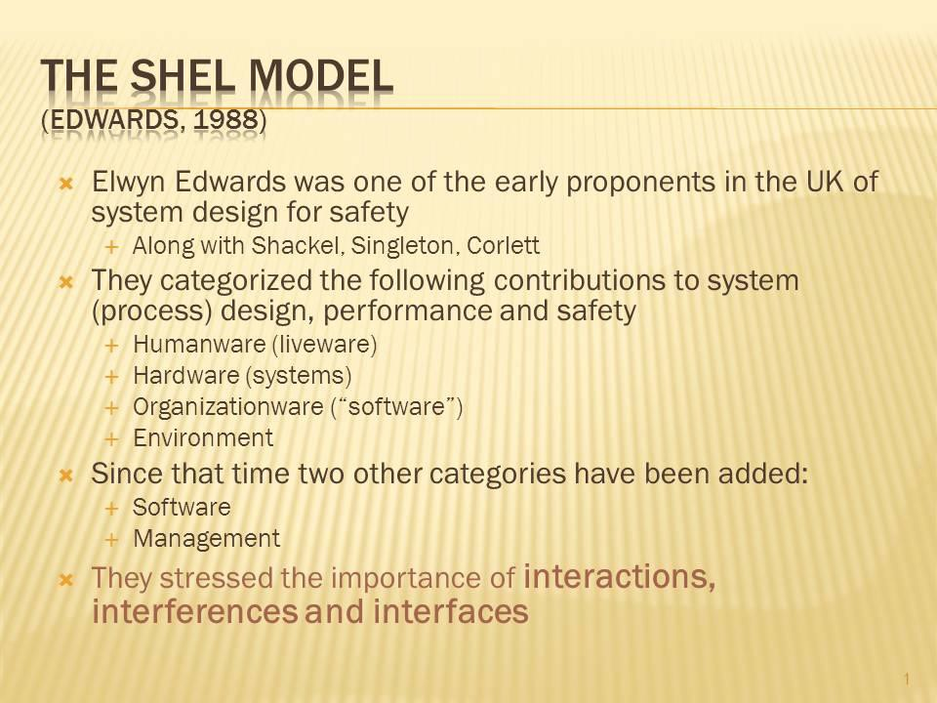
6.1 The SHEL Model
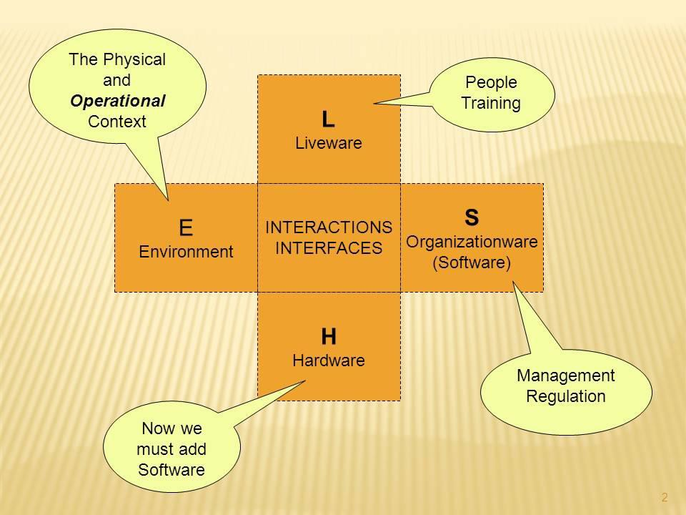

ACTIVITY 1:

Group Activity: Use the SHEL model to describe the interacting constituents of an airport baggage handling or security system.

- The Swiss Cheese Model

Reason proposed an alternative view of system complexity and outcome success and failure. He argued that any “unsafe act” could be traced back to the predisposing conditions, operator supervision, selection and training, and eventually to organisational factors associated with procedures and behaviour. For example, a bad landing could be due to adverse weather conditions or organisation policies about weather prediction and avoidance or pilot training.
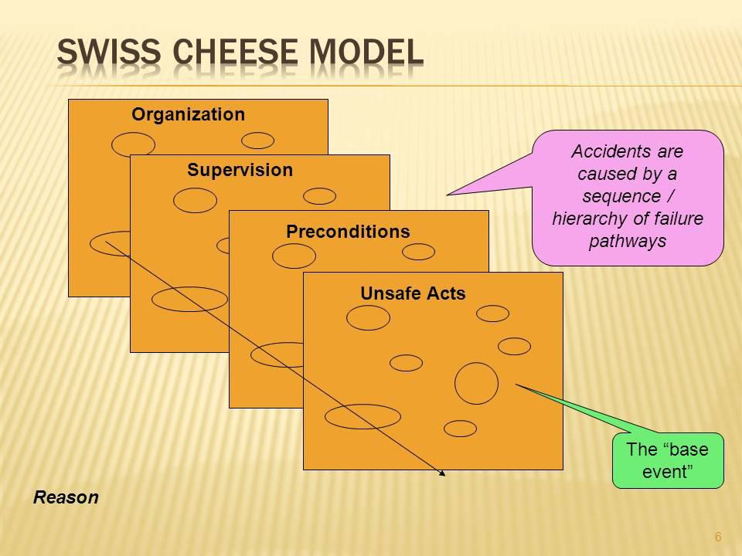
ACTIVITY 2:

Group Activity: Use the Swiss Cheese model to describe a simple home or complex aviation accident.

- Human Factors Analysis & Classification System

Shappel and Weigman converted this model into a formal accident analysis method
– the Human Factors Analysis and Classification System ‒ that is now used widely in aviation, medicine and maritime operations.
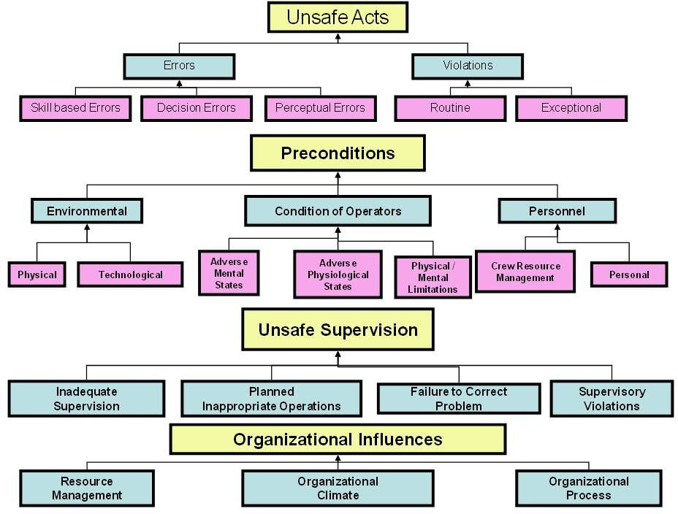

Unsafe Acts

Unsafe acts may be errors or violations – unintentional or intentional. Errors may be due to any failure of the Human Information Processing system, particularly perception, decisions and skills. Memory failures are another common cause of errors. Violations may be occasional or routine.
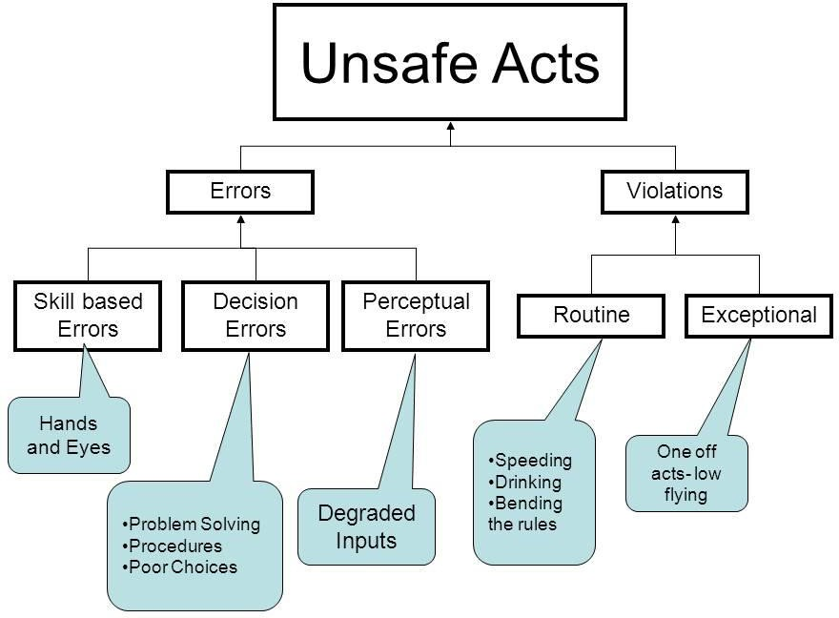

ACTIVITY 3:

Group Activity: Recall any road or home accident. Assess the form of unsafe act that might have been the cause.

Preconditions

In almost all accidents there are latent preconditions – “accidents waiting to happen” – such as a slippery floor, a staircase without a handrail, a tired operator, or routine risky behaviours. Commonly, these preconditions may be physical as with the design of equipment or the environmental context. On other occasions they may be due to human, procedural or organisational limitations. As discussed earlier with the SHEL model, these technological, human, contextual and operational factors may interact to create preconditions conducive to system failure.

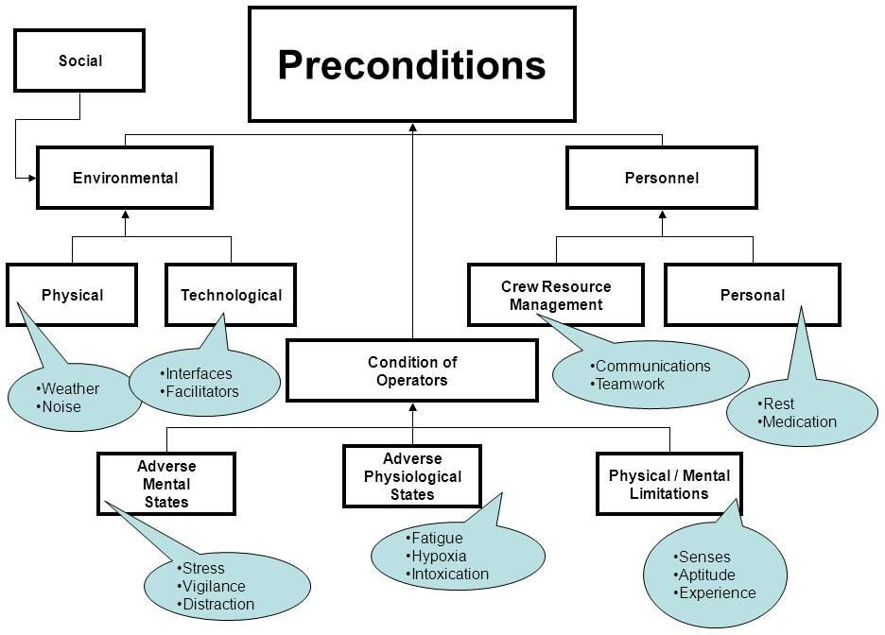
ACTIVITY 4:

Group Exercise:

- Discuss and describe the preconditions that may lead to a pedestrian accident at a bus stop or crosswalk.
- Discuss and describe the preconditions for system failure during
aviation baggage handling or “air side” ground transport operations.

Unsafe Supervision

Many forms of inappropriate behaviour occur because of lack of supervision – some authority making sure that operators follow safe procedures. The “authority” may be anyone – a parent, colleague, instructor, supervisor, police or security officer. The unsafe supervision opportunities may be occasional, planned or routine.

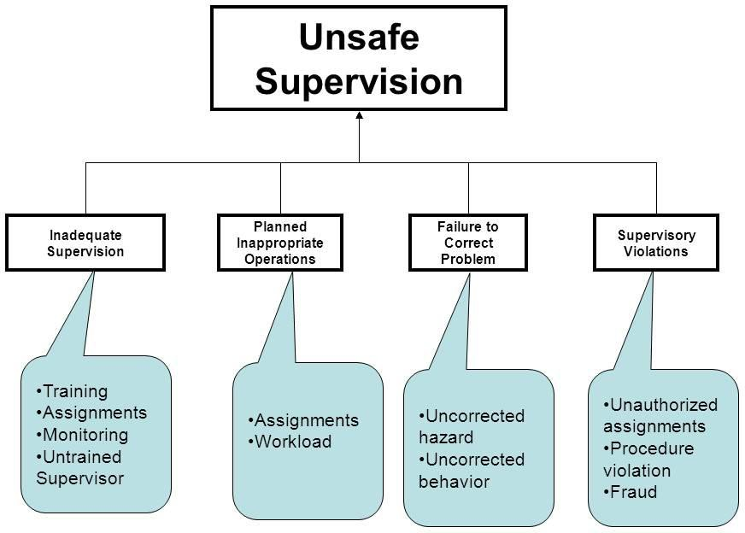

ACTIVITY 5:

Group Exercise: Discuss how unsafe preconditions may occur due to unsafe supervision of customers and conditions in shopping malls or food courts.

Organizational Influences

This is the most insidious form of latent system failure causes. They include a lack of or non-adherence to safe working policies and procedures, perhaps for productivity or cost cutting reasons. Other inadequate policies may include inappropriate assignment of under trained personnel.

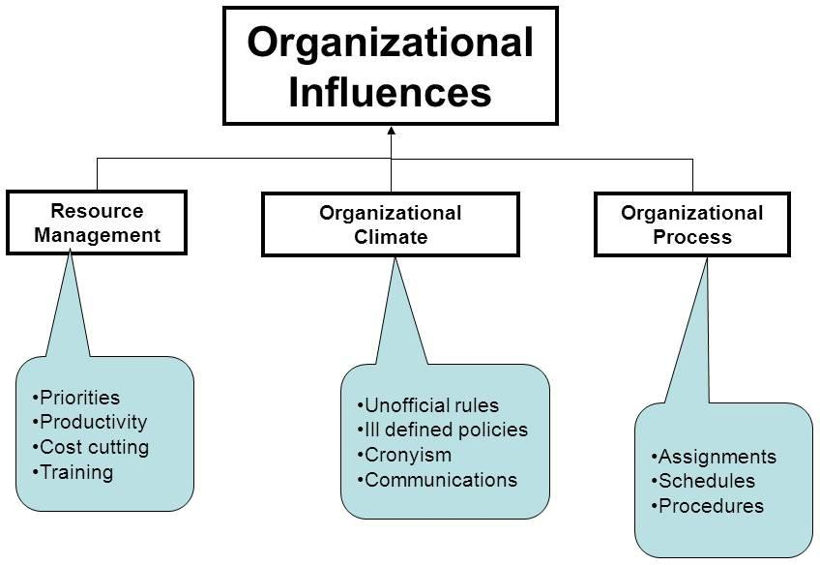
ACTIVITY 6:

Group Activity: Contrast the use of safety motivational slogans and ergonomics interventions in building site safety.

The following spread sheet offers a somewhat quantitative approach to HFACS analysis:
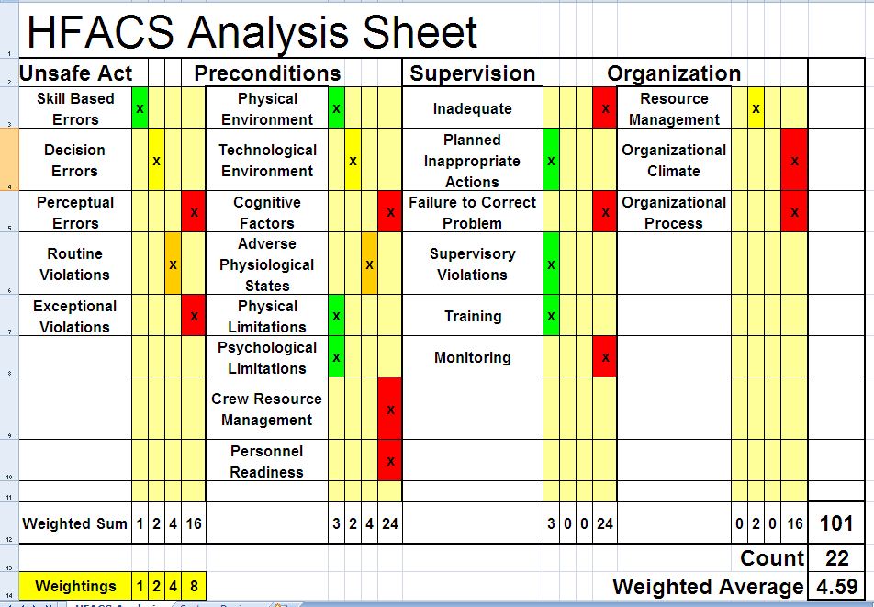

ACTIVITY 7:

Group Exercise: Use the HFACS Analysis Sheet to discuss an aviation accident of your choice.

- HFACS Case Study
ACTIVITY 8:

Group Exercise: Read and discuss the following HFACS analysis of the Midwest Flight 5481 accident.
