The Hamburger – A metaphor for everything
July 6, 2008
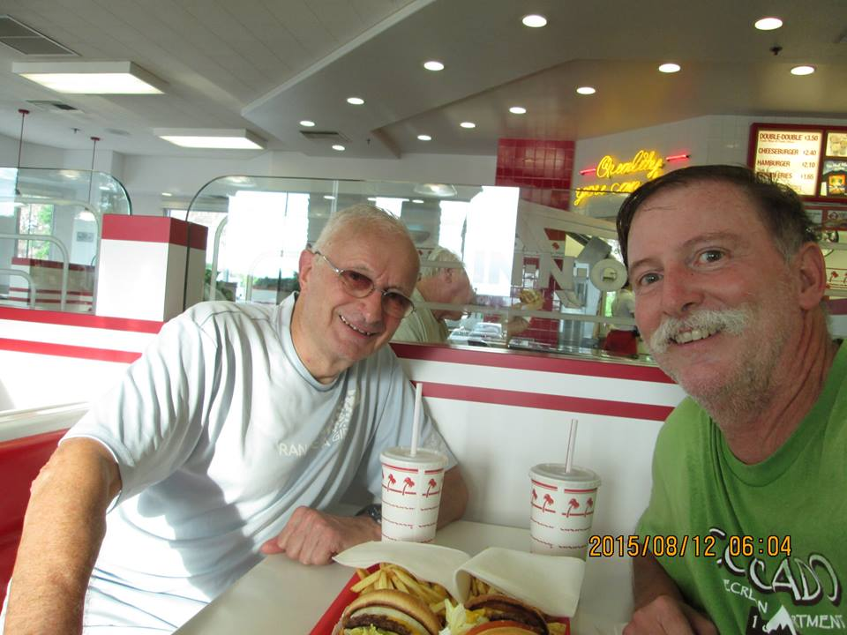
In the beginning, a few thousand years ago, men improvised mechanical tools to hunt deer, bison and fish. But man was sophisticated and soon grew tired of raw meat; so he invented fire to cook the meat. Meanwhile, back home, woman grew corn to make bread and lettuce and tomatoes and the meat grinder to make use of much more of the game. And the hamburger was born. Then along came Ronald McDonald who invented the franchise and the rest is history.
In the beginning, a few thousand years ago, men had time on their hands while out hunting so after dinner they looked at the setting sun and rising moon and concluded that these two celestial bodies must be the reason why the earth existed as such a welcoming place for people to grow and prosper. So they invented Sunday as a day of rest from the hunt. But they soon tired of rest so they started writing stories and poetry and songs about the sun and moon and love. The men also invented “the game,” which became a surrogate for war that burnt off their excess energy. Soon the Olympic games will be played out in Beijing with myopic newscasters.
Shortly after the beginning the sun and moon worship thing became passé. It was too simplistic. Anyway the scientists threatened to expose the sun as moon as mere components of one particular galaxy. So great leaders of men invented religions as much less tangible, but more attractive, ways of explaining the meaning of life. These wise men recognized that, by developing a simplistic explanation of a complex phenomenon, gullible men and women would grasp on to the idea. Meanwhile some wise men invented the tithe and religion franchising blossomed. Then came the secret.
Shortly after the beginning Hilary pronounced that “it takes a village to raise a child,” so women created communities. And this village idea caught on and prospered and towns and cities arose, like New York and Tokyo and Mexico City and Dubai. And social workers realized that it takes a city to ruin a child. But it was too late. Wise men got together and created nations, with castles to prevent other nations from capturing them. And George said let us defend our nation on the streets of Bagdad rather than the streets of New York. But he was a bit late in the empire building game, Rome, Turkey and England had been there and done that.
I don’t remember who invented the motor car, but Henry Ford is credited with inventing the production line. It is easy to build a car, but building a thousand cars a day takes real management skills. And along came Toyota who is credited with inventing 5S to make production even more efficient. But really it was the mothers in the growing villages and towns who really coined the idea of a place for everything and everything in its place as a way of managing efficiency and growth. They also said “waste not, want not”, but the hunter gatherers in their SUVs liked to live for the moment at 8 miles to the $4 a gallon and rising. And great business leaders used the stock market to further their ambitions. Now we have nations, religions and big business and war, but still the game rules
The hamburger franchises recognized that SUV drivers in big cities did not have time to “stand beneath the boughs and stare as long as sheep or cows”, so they introduced packaging and food to go. Little did they know that the latter day environmentalists in England used to recycle newspapers to wrap fish and chips to go, providing you didn’t pour on too much vinegar and so cause the newspaper to disintegrate. But the hamburger franchisees were smart – they saved money on providing tables and recognized that they did not have to pay for the discarded packaging trash to be collected – that was the job of the city government through the imposition of taxes on the consumers – a double whammy. Even the game got soiled by beer and hot dogs, a poor substitute for the hamburger. The game also got mixed with religion as the spectators bow their heads and pray for victory. And big business puts their logos on the athlete’s clothing.
Meanwhile man invented war. Villages grew into cities and cities grew into nations and nations developed empires and companies got bought up by holding companies and religions consolidated, and hamburger franchises fought the good fight. There was friction. Fights for survival arose. Wendy’s hamburgers were advertised as being better than Burger King’s, Toyotas better than Fords, America better than China and Christianity better than Islam. The ideologies of growth and survival became blurred. War becomes complicated when nations, businesses, hamburgers and religions intermingle. Back in the day, Henry of England got ticked off by the Pope who disapproved of his philandering and lack of fidelity to the time honored institution of the family. So he invented a new Anglican movement which for the next few hundred years became the excuse for empire building. Perhaps the most unfeeling comment by the wife of a national leader regarding the plight of the nation’s poor was “let them eat cake.” Because hamburgers were not available.
The usual method of expansion of nations, often with the backing through prayer of their religions and money through their businesses, is to find nations who are short of hamburgers and who therefore charge less for their labor. Africa had cocoa and India had tea, useful commodities for empire builders. In recent years the commodities of interest are oil and cheap labor. Unfortunately, the oil rich countries have conflicting religions, but the cheap labor countries are willing participants in pseudo expansionism, because they see the long term benefits of pulling manufacturing capability out of the greedy consumer nations. Did you know that hamburgers eaten by Americans are made in China from meat grown in America? Say grace before dinner and make thanks that you have more to eat than the people who harvested and packed your food.
“Ludum non victoriam amare”. We love the game not the victory. If this is the case then the game is not a surrogate for war. But “the game” has been exploited by nations and businesses and the ideology of the game comes a poor second to the excitement of winning. Winning is good for the ego, losing is good for the soul. So why do we pray for victory? I suspect that the Romans who invented the catch phrase were the spectators to the battles between the gladiators and the Christians. The real game is amateur cricket. You play all afternoon, have tea, play on into the evening, one team wins, no matter which, you drink some beer and promise to return next year. “Ludum non victoriam amare.”
Sometimes the game wins, even in times of war. India plays Pakistan at cricket, America played ping pong against China, England played football against Argentina, although on one occasion the hand of god attached to Maradonna influenced the result. Once, at the highest level the Australian cricket captain bowled under arm to insult the New Zealanders and there was talk of war in high places. So the boundaries between war and games are blurred. Fortunately for our youth most of their education is played on computer simulations of battles between the good guys and the bad guys with the only physical harm being Nintendo thumb.
Back to the main theme of hamburgers, religion, nations and games. They are all born out of great intentions, but all fail eventually because of the insatiable appetite of people for growth. We eat hamburgers, which are delicious, but make us fat. We pay lip service to the ideals of religion and become holier than thou. How do you measure holiness, except by comparison with the unholy? As a child I was taught to sing:
“Land of Hope and Glory, Mother of the Free,
How shall we extol thee, who are born of thee?
Wider still, and wider, shall thy bounds be set;
God, who made thee mighty, make thee mightier yet!
Truth and Right and Freedom, each a holy gem,
Stars of solemn brightness, weave thy diadem.
Tho' thy way be darkened, still in splendour drest,
As the star that trembles o'er the liquid West.
Throned amid the billows, throned inviolate,
Thou hast reigned victorious, thou has smiled at fate.
Land of Hope and Glory, fortress of the Free,
How may we extol thee, praise thee, honour thee?
Hark, a mighty nation maketh glad reply;
Lo, our lips are thankful, lo, our hearts are high!
Hearts in hope uplifted, loyal lips that sing;
Strong in faith and freedom, we have crowned our King!”
It sounds very much like a varsity fight song, sung of course by the spectators and the subjects.
In a few months we will crown a black liberal appeaser or a white warmaker as king of America. And we will sing patriotic songs and revel in the number of medals won by our athletes in Beijing and celebrate the opening of the one millionth hamburger franchise in India, albeit without any beef in the hamburger. And bemoan the death of the auto industry in this country.
But there is an answer to all this gloom and doom. We must turn global warming around and reinvent the ice age. We should reduce, recycle and reuse. We should walk to work, even if we live in the suburbs 50 miles away.

