The Great Lakes Relay
September 2008

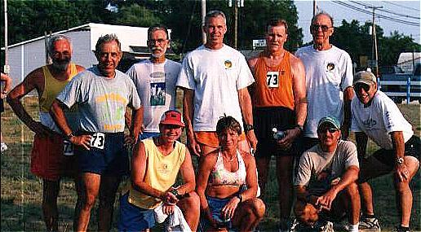

275 miles, 66 teams, 10 to a team, 3 cars to a team, state parks, back roads, forests, swamps, rivers, rain, heat, hills, dust – that is one way of describing the 11th running of the annual relay race across Michigan – the Great Lakes Relay. An alternative would be high schools, colleges, running clubs, young, middle aged and old, men, women and youths, blood, sweat and tears, laughing, crying, shouting, swimming, climbing, going to the bathroom in the woods, mixing with the locals and running, running, running until you have earned your beer.

The wide variability in ability due to sex and age is dealt with partially by a handicap system – women get 13%, 40 and over get 1% per year, 50 and over get an additional 1 1/2% per year. The handicaps of all the team members are added together and divided by ten to get the team handicap. The rest of the rules are more or less common sense aimed at managing the movement of about 700 people and 200 vehicles from Mio to Rogers City (on Lake Huron) to Grayling and on to Empire, which is on Lake Michigan.

The legs vary between 3 and 9 miles and each team member must run at least 24 miles over the three days – most competitors run 5 legs. Most of the legs are sponsored by local businesses and they all have unique characteristics. The Swamp Run follows a curving path through a forest, up and down hills, through mud and thick undergrowth, under or over fallen tree trunks for 8.7 miles. The best runners achieve about 70 minutes while others may get lost for a couple of hours. The Tommy Toyota run is another classic, as is the early morning second leg on day three that ends by the runners wading across the Manistee River. The “Last Hill and Testament” lives up to its name – The crowds at the changeover point at the top of the very steep half-mile long hill cheer as runner after runner plods gamely upward and, if he is lucky, onward. The glory leg over the sand dunes and along the beach ends with the teams accompanying their last runner before doing justice to the chilly waters of the lake and even more chilly beer. Analysis, memories, photographs and “see you next year.”

There are some fast legs – on black top or well-used dirt roads. Good runners do better than 6 minutes a mile pace. The winning team of the 2002 race – the Fox(es) and Hounds finished with an adjusted time of 28 hours and 33 minutes, whereas the first team home with much less handicap finished with a gross time of 29 hours and 30 minutes. To win the race, your adjusted time must be close to 6 minutes per mile. The average age of the Fox(es) and Hounds team – there are two foxes and 8 hounds - is 55.

The trick is not to get lost, which is easier said than done. The instructions, checked many times for accuracy by the organizers, are usually something like:

Continue straight along Fowler for 1.5 miles to a T in the road (Rayle, no sign)
Turn right on Rayle for 3 miles to a T at Pettengill

At .6 miles on Rayle go right at the Y
At .8 miles go left at the Y
At .05 miles go left at the lake
At 1.5 miles go right at the Y
At 2.4 miles go left at the Y
Turn left on Pettengill for .9 mile to the exchange at the blue Shore to Shore post on the left.

There are also maps, which are not sufficiently detailed. Some legs allow vehicle support, others bicycle support and some no support. Don’t get lost they say – you’ll cost your team dearly – and many do. Successful teams help the runners wherever possible – running without having to navigate and knowing where on the leg you are takes away some of the strain. Also a swig of water, a cold sponge and raucous encouragement are often very welcome.

The core of the Fox and Hounds team has been together for about six years and the team has usually finished in the top half dozen – notable exceptions being due to one or more team members getting lost (not always on solo legs) or being penalized for having a vehicle on the running route instead of a designated “auto detour”. The detours are necessary on narrow lanes as they kick up a lot of dust when it is dry and often slow down the runners. On occasion, in the past, the backlog of traffic has caused a runner to be late for his leg, which leads to a great kafuffle. On dry sandy roads runners have been known to finish way ahead of their bicycle support.

At least a few team members’ friendships went beyond the race. Jim Gilroy painted our 4000 sq ft house and Wayne Zimmerman’s wife catered our daughter Georgina’s wedding after the Cider Mill had let us down at the last moment. Both did excellent jobs. On the other side I get to stay at Jim Karner’s house when I return to Rochester every year or so. I see a lot of the others on Facebook. Dan Horvath writes a running blog that contains the same introspective drivel readers of these pages get. Not sure about Terry Elsey, I think he still runs.

Students of sociology can learn a lot about team mood and behavior. Successful teams are overly happy and sometimes throw caution to the winds, often with dire consequences. Teams that get lost or lose a runner due to injury or are not well organized with their logistic arrangements are often seen to be overly sad, or mad. Moods swing. But they usually return year after year and usually finish the race even though they are out of the running for a major prize. All competitors receive a handsome stein for their efforts and coffee or beer.

Those who wish to learn more about this memorable event should go to the web at: www.greatlakesrelay.com.

