Only You Can Do It (With a little help from your friends)

September 2007

Much is written about motivation and clichés abound. This article is about the motivation to keep in good shape and being “successful” at how you do it, with no apologies for clichés.

Nature and nurture. These are the two fundamental contributors to being in “good shape”. As you can’t choose your parents (yet) all you can rely on are your own behaviors. There are a few other unchangeables – your age and illness / injury. A congenital or developmental neuromuscular disorder, a misbehaving thyroid gland, diabetes, cardio vascular disorders, an injured back or cancer are indeed major hurdles, but even these can be regarded as an opportunity by some. Two other factors that influence nurture are social constraints and personal priorities. If you live in a big city, work 10 hours a day, travel to and from work for another two hours and have to deal with a family, then addressing your personal fitness needs may not rise to the top of the list. That is until you realize that you are going downhill and look like a “before” picture on the magic solution television advertisements. Simon Covey has written a lot of encouraging material about balance and priorities, but this article addresses just one of those priorities – keeping in good shape. Much has been written about this topic also – mainly about what to eat and how to exercise. Some of this material is altruistic – the (informed or uninformed) writer has nothing much to gain by providing this gratuitous advice – but other, sometimes good, sometimes bad, information comes from people and organizations who have a lot to gain by selling a product, which usually costs $19.95 +S&H.

Your cheer leaders. Many people look externally for motivational support. Some look to religion and some to family and friends. Some listen for the roar of the crowd. Others rely on gurus, who may or may not be well informed. There is no doubt that external sources of motivation can help, at least in the short term. One has only to look at the successful coach, the drill sergeant or competition with others to see how individuals can be helped to improve their performance by changing their behavior. Running buddies are the salt of the earth – they get you up at six in the morning.

What is success? And how does it work to motivate someone to improve. In sports, success is measured by the record books. The timer does not lie. Nor do the weighing scales. Objective evidence is incontrovertible. Many years ago I carried out a formal study of the relative effects of external encouragement and objective feedback on a simple strength test. The subjects sat on a table with their foot strapped to an isokinetic dynamometer – a machine that measures how hard the subject is pushing. There were four groups of experimental subjects and all were asked to push as hard as possible. The first group had no feedback regarding their actual performance. Members of the second group were encouraged by a student physiotherapist to “push”, push”, “push”. The third group was given objective feedback of how hard they had pushed, as measured by the machine, by looking at the dial. The fourth group members were given both objective feedback and encouragement. Guess what? Those with objective feedback performed better than those who only received encouragement, who in turn performed better than those with no feedback. Now the skeptics may say that this small (published) study may not generalize to all situations and all people. And while I will agree that this may not be a universal truth, it does merit attention. Readers interested in this subject should seek out a book by John Annett – “Feedback and Human Behavior.” (John was the external examiner for my dissertation and drew my attention to the fact that during my defense I misquoted the title of his book, oops!)

Now ask yourself – would you really have your friends tell you how good you look or do you rely on the bathroom scales or whether you can fasten the button on your jeans? I suspect that the scales may win, but not by a landslide. It’s nice to hear people say nice things about you, especially if you know they are lying. But beware of “alfing” – praising the unpraisworthy - it is disingenuous. Furthermore it may encourage unproductive behavior. Runners rely on the results list as well as their stop watches. Runners are a bunch of losers – most runners lose all of the time and all runners lose some of the time. It all depends who else turns up on race day. So why do we keep on trying when we don’t win and many of us are unlikely ever to win. There must be something other than winning that drives us. Consider also golf. Five good shots and 100 mediocre shots bring us back next week.

A tale of two knees. Some 50 years ago I worked as a physical therapist in an accident hospital. I had learned that I brought two things to the bedside – my knowledge of physical rehabilitation and my ability to “get into the minds” of my patients, who may have just suffered an enormous shock and may be in considerable pain. One Monday morning I walked into the orthopedic ward with a list of patients who had recently suffered substantial road injuries. Two new young patients were in neighboring beds, both had similar fractured right femurs with the break going down into their knee joints. Both injuries had the same cause – overtaking on a left hand bend while riding a motorcycle and hitting an oncoming car. (In England we drive on the left side of the road.) My job was to gradually improve the range of motion of their limb joints and maintain the strength of their quadriceps (and other) muscles. After two months one patient had almost full motion in his knee and was up and walking, whereas the other was struggling and still complaining of the pain. Why? You tell me.

Some memorable results: Joe’s fifty yards in front and slowing on the hill. Over the years I have had lots of age group competition in road races. Two notable competitors were named Joe, others were Garry, Gary, Bill, Don, Dan, Mike, Murphy, Tom, Lily, Caroline and Veronica. I remember seeing Joe Washburn, 50 yards ahead of me, begin to slow down up a hill with a mile to go in the Annual Apple Amble around Oakland University. I stretched my stride and “pulled him in” with half a mile to go. Should I pass him now and risk being caught in the final stretch or should I wait and take him in the sprint? I opted for the former strategy and destroyed his mind with a quick 10 yard lead. I did the same to the other Joe – Joe Fernandez – in the New Bedford Half Marathon; Joe was 76 – 10 years older than me!! Garry had the inside route on the corner into the Cobo Center for the finish of the Detroit Turkey Trot; he edged me out with a little elbow (that’s my story) and beat me by 5 yards. I caught Gary at mile 10 in an eleven miler and buried him, he turned the tables a couple of months later in the Phoenix marathon. Murphy and I always raced up Dutton Hill on training runs. Of course he always won – he is 20 years younger than me. But we went through the same ritual every Saturday morning. He is also a Clydesdale – we buried him on the long runs. Ha, ha!!

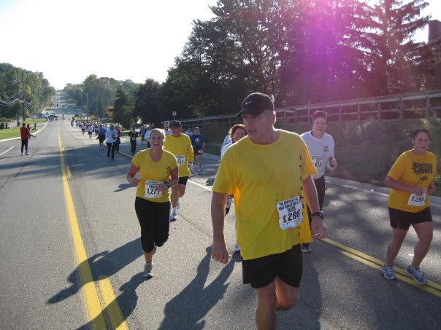

I passed Bill Hill with 50 yards to go down the Flint cobblestones in the Crim 10 miler, he re-passed me with 5 yards to go, bad strategy. Don caught me on a hill a mile out in a Providence race and, much to his glee, kept his distance. However, a few weeks later I turned the tables on this wiry bargee / truck driver / embroiderer in a Western Massachusetts mountain race and rubbed it in mercilessly. I caught Dan with a mile to go at Boston, he was having a bad day. With 50 yards to go I told him that we were not going to break 3.50 and then accelerated to beat him by a yard, not a very collegial act. A photo finish clearly showed that I was the victor over Mike in another Crim; he still debates the camera angle. At mile 22 in the Detroit marathon, son Tom caught me and we finished together for a priceless Kodak moment. Daughter Lily passed me on the up hill in a Reno mountain race, but I caught her on the flat last mile – another Kodak moment as we crossed the finish line together. No 3 daughter Caroline has beaten me soundly in two marathons and plans to continue to demonstrate her superiority or youth; I must train harder and catch that whippersnapper. Her big sister, Ginny beat me at swimming when she was ten!! Veronica is a boisterous blonde NW Airlines cabin crew member, now a mother of two. We were always quite close at the finish in Houston area road races. On one occasion she beat me by 5 yards, but the numbers got mixed up in the chute and I was declared the winner for posterity.

The purpose of this personal reverie is to describe how a little motivation allows one to dig deep at the end of a race and find that little extra. But the story isn’t about winning and losing, at least not about the beating or losing to the people in the story. It’s about running buddies, who bring out the best in one. Ludum non victoriam amare. Winning is good for the ego, losing is good for the soul.

No pain no gain. Training never gets easier, but tolerance of effort does. Drill instructors and coaches preach this lesson as their charges are panting for breath and some are losing their breakfast. It is true that training is hard, at least training hard is hard. The harder you push the stronger you will become, given the constraints inherited from your parents. If it doesn’t kill you it will make you stronger. That’s true, sometimes. However spare a thought for those army recruits who have spent all their life to date, not on the football team, but playing video games, eating fast food and watching TV. They are compared with the strong ones in the platoon; they are dubbed “the weak sisters.” When you get into the desert or jungle with a full pack and a heavy rigid bullet proof vest it isn’t good to not keep up; you put your colleagues in danger as they wait for you. The hardened corporals, whose job it is to make men out of the recruits, believe that collateral damage – a few broken recruits - is the price of creating a strong army. For what? To fight against the enemies of your people, whoever and wherever they are and for whatever reason.

Nothing ventured, nothing gained. The hardest step is the first step, at least that is what they say, but in a marathon the 20,000th step is quite hard too. But I suppose that if you don’t try to run a marathon you never will. When I was in my late 40s I took stock. Should I go back to school, study for my MBA and become one of those ten a penny empire building managers rather than be a technical manager which has less risk or should I deal with the physical challenges of aging? I chose the latter, sought out running buddies and started running marathons. On reflection, it was the best choice. Many of my contemporaries in industry retired in their late 50s and withered away. Although some showed a temporary improvement in their golf game.

Practice makes perfect. Somewhat. Motor skills have a mixture of physical and mental components. In general the more we practice the better we get. The Dutch psychologist – de Jong – showed a logarithmic relationship between the number of repetitions and performance time. This relationship is however asymptotic – some skills are limited by physics. But every now and then there is a breakthrough, like the four minute mile and a three hour marathon by a seventy year old. When will we hear about a 2 hour marathon? sometime very soon I predict. One measure of improving skills is a reduction in the time taken to carry out a movement. Another is a reduction in the variability of the times as we approach our asymptote. “Perfection” is more to do with the latter than the former measure.

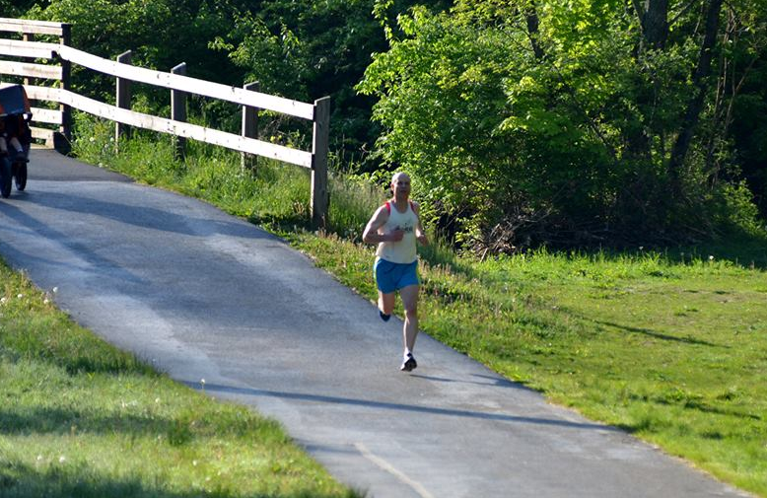

Happy first birthday Bob. At age 73 my neighbor, Bob, recently celebrated his first anniversary. It was a year ago when a neighbor was summoned to the steps in front of Bob’s condominium, where Bob had just had a heart attack. Neighbors Ken and Nancy administered CPR and saved his life while they waited for the ambulance and Bob’s golf game is still improving He even sold me his condominium. Nice guy. He will be the first to tell you that being alive beats the alternative – he’s very motivated to stay alive and celebrate with all his children.

It’s not the will to win; it’s the will to train. That’s true. Winning is more to do with your location on the inevitable bell curve than it is with your will to win. You can move up (and down) the pecking order, but you can’t make a silk purse out of a sow’s ear. Anyway pigskin purses are more durable and silk is expensive. If you have the will to train you will move up the pecking order and win a lot of local races, but, at the national level, the competition is a little more difficult. If you are in the top 10% of ten you are first, if you are in the top 10% of a thousand, you could be 100th. After you have been running or exercising for a while you know where you stand. You can’t beat the Kenyans but you can beat a bunch of others who either weren’t born with your genes or didn’t train hard enough. The real fun is beating your running buddy or your son and daughters; their turn will come.

Pressure. I’ve seen pressure among top athletes, who are expected to win – just look at Paula Radcliffe. Remember the Athens Olympics when she was expected to win the marathon, but just couldn’t do it. On the front of her book she put the picture of herself sitting down crying on the road side when she had given all she could muster in the heat but couldn’t catch the leaders. Now that was brave. Some people get angry when they fail – cricketers throw their bats, golfers their clubs and tennis players their racquets. Runners don’t have anything to throw. Throwing a soggy running shoe just wouldn’t be sufficient vent. Middle of the pack runners laugh at their misfortune and congratulate the guy in front in the finishing chute.

The mind goes before the legs. Sometimes at the end of a race you do have something left and when you catch sight of a competitor ahead of you or preferably the one in front of him you can dig deep and find that little extra. Especially if you started out slowly. Young inexperienced runners and old stupid runners often start out too quickly. Dream on. During the race you should punch your stop watch at every mile split. All too often when you make a plot of your mile splits you find a steady slowing in the second half of the race. I have run “negative splits a few times – the second half of the marathon was quicker than the first – but usually I exhibit the stupid old runner behavior and don’t learn from my training times just how fast I should run on a particular day. But despite all this stupidity, I still run. There must be a message there somewhere.

Over the years I have played many team sports. We lost as many as we won; that is why we played. Winning against lesser mortals is boring and unsatisfying. Although team sports often do require collaboration among team members they can always be reduced analytically to individual execution. But do we try harder because we are on the team? Sometimes I think we do and coaches are very fond of the go get ‘em speech. But does this change our behavior and performance? I think not. I do however believe that factual information about our personal role, team strategy and the strengths and weaknesses of the opponents can alter our behavior and the outcome of the game. Take cricket (if you wish) or baseball (if you must). The striker may wish to send the ball flying out of the ball park with a high risk of failure, but with one run needed for victory he or she is often expected to play a less heroic role, and execute it just as skillfully. Go team. Running relays are great fun. The Great Lakes Relay involves teams of ten running 270 miles across Michigan, in three days. Of course some team members are faster than others and they may carry the heaviest load, but age based handicaps level the playing field, somewhat. All team members must run 25 miles, made up of 3 to ten mile legs. The famous Fox and Hounds – a team consisting of one or two girls and a bunch of elderly gentlemen – won the race twice. Did we try harder on the swamp run because we were on the team? I don’t really think so. Did we deliberately get lost in the forest so that our team would lose? I don’t think so. Did we have more fun because we were on the team? Absolutely.

Because training is never easy, many people give up and blame their knees or something. Often this is just a plausible excuse. Sometimes it’s real. I have the answer. Television!! You should get a stair stepper, indoor ski machine or elliptical trainer and park it in front of the TV. These gadgets are low impact and often easier on the knees. And there’s a lot of interesting and entertaining stuff on TV. Spare a moment to think about the astronauts. Without gravity their muscles, bones, hearts and lungs waste away – they could be a physical wreck when they hop off the space ship on Mars. It’s called disuse atrophy. It’s like prolonged bed rest or couch potatoitis. But astronauts have TV. They strap themselves down with bungee cords on the treadmill and run, run, run, sometimes all around the world, while watching their favorite movies. They are not very keen on kidney stones. They also grow, because they don’t have gravity to compress their spines and this growing sometimes results in damage to their spinal columns and associated structures. Perhaps we weren’t meant to go into space or perhaps we should take a little gravity along in the form of a centrifuge. You may ask “what is this space and gravity stuff got to do with running excuses?” It shows us that there is (hardly) any exercise problem that can’t be resolved with a little ingenuity and motivation. “In nature, there is no disability but the mind. None can be called disabled but the unkind.” (Anon)

You are only as good as your next race. Running buddies have very long memories for their occasional successes but very short memories for the last time they told their running buddies that story. “I remember when” is a clear signal to predict what is coming next and running buddies often join in the story, especially if the facts are likely to be distorted or the times exaggerated. The debate about who beat whom in the “Run through Hell” in 1996 can last at least 10 miles. The facts only spoil the debate. One amusing memory came from the 20 mile warm up run for the Detroit Free Press marathon. It was an out and back race and Garry and I were running together, at a great rate of knots may I say. Various people coming towards us kept saying to their buddies “That’s Garry Watson, he’s a great runner!” I was quick to point out that I was running stride for stride with this great runner and deserved some of the accolades. But I must not be hard on Garry – for the past 20 years he has given me his cast off running shoes. He is a shoeaholic; sometimes the shoes have no miles on them – he just didn’t like the color! We do agree on one thing though – the result of the last race is good conversation on the drive home and for many training runs to come – but what is really important is the next race. I mentioned Joe Fernandez from Massachusetts – he is ten years older than me and still competitive. There is also John Kolmetz from Detroit, he is the same age as Joe and still going strong. These are the ones to beat in the long run. Then there is Bob Cross a very fast runner, now slowed by knee operations, perhaps I’ll catch him one day. And Jim Karner, less gifted but made it to Boston. And Wayne and Chuck, ironmen. I also need to mention Dave Kanners, also from Detroit. He is a gifted runner and trains very hard. He has also climbed the highest peaks in all the United States, except Denali. Go Dave, beat that pancreatic cancer.

Are you sure what you just guessed is true – statistics. When we answer a question or simply offer gratuitous information we may be factual or simply guessing. If we speak loudly it can have the effect of converting fiction into fact. Unfortunately facts about running are often used to make inferences about the general state of the world. Today I won the race so I must be a better runner. This would be just fine if there were no day before yesterday or tomorrow. We are all a bunch of guessers. We really do need to study the statistics of chance, and the laws of probability. But facts are boring, guessing is more fun. Marketers, consultants, presidents and runners do it a lot.

Early intervention. Get ‘em while they are young and mold them. This is certainly true of many athletes who show their talents at an early age. But it also works for those who are less fortunate than us. There are very many children born with “developmental disorders” – now there’s an oxymoron, unless of course you are talking about fetal development, which may be subject to environmental interferences. Babies are born with disorders that affect their development, such as autism. But if appropriate intervention is applied early they can be all they can be, which is a whole lot more than if they don’t get the intervention. Nature sometimes beats nurture, but good nurture can often trump nature. What is winning? Winning is being all you can be, anything less is unconscionable.

You are only as good as your next race. It’s not the will to win; it’s the will to train. Ludum non victoriam amare. The mind goes before the legs. Only you can do it (with a little help from your friends.)

