Man versus Horse
October 5, 2008

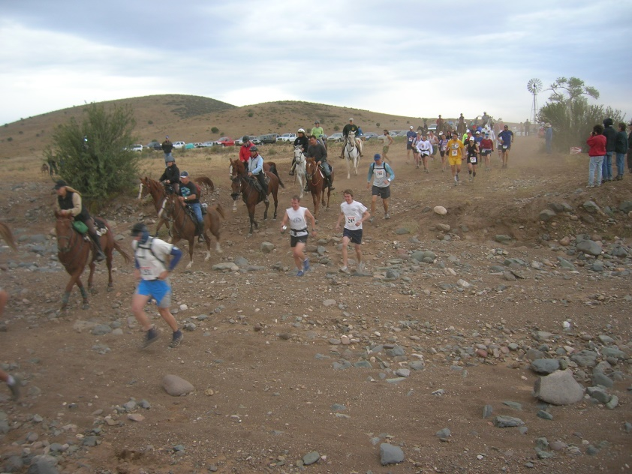
Back in the day man found that he could go further and faster on a horse because horses have more feet than men. Horses are also good at carrying things. Nowadays horses are mainly used for entertainment; people like to ride them, and lose their shirts on horses that do not live up to expectations. Horses are like people in terms of strength, stamina and skill. Big horses can pull a plough or cart or even a trailer full of beer, horses can gallop like the wind and carry the mail from coast to coast in next to no time; horses can skillfully walk or trot over rough terrain. Horses, like men, need to have the right genes for the right job and also need to be trained, just like runners. Some runners are like race horses – long, light, lithe and like lightening; others are ponderous and persistent, like Clydesdales – they trade heart for genes. Most people do not run.
Competitive man likes to pit his wits and abilities against all new technology, like horses and airplanes. Unfortunately, Icarus found that sometimes the airplane melts, especially at high altitudes close to the sun. The competition between horse and man has been waged for centuries. It is rumored that had Pheidippides used a horse on his 140 mile jaunt over the rugged terrain to Sparta to gather allies for the Battle of Marathon, history may have changed. In the 1920s a bunch of endurance runners set out to run across America. Their challenges were both the distance and the cost. Many dropped out and the others had to use all sorts of schemes to raise money, like prize fighting and racing against horses.
Moving forward to yesterday, I had dubious pleasure of prolonging this perverse predilection of runners to match their stamina against horses over the rough terrain on Mingus Mountain, over which the sun rises to lighten the day in Prescott, AZ. This “Man against Horse” competition has been going on for 25 years; it has three levels – 50 miles for real men (and women), 25 miles for wannbes and a 12 mile flat course for wimps. I ran the twelve mile race for reasons that I’ll be pleased to explain if you have a couple of hours to spare one day.
Sometimes the horse wins. On yesterday’s occasion this was definitely true. At the start of the 25 mile race a horse got spooked and started bucking violently throwing it’s rider up and then down onto the stony bank of a wash. A very big ouch that generated calls for nurse race participants, ambulances, fire trucks and a helicopter. I have not heard yet about the injuries as the 12 mile race started soon after this terrible sight. I hope the rider is OK, at least she was “in stable condition” when she left.
The record is as follows – Ken Eckman - 50 miles, outstanding. Steve Orth - 32 miles – heroic. Jim Pullaro - 11.08 miles, fast. Dan Munsell - 11.08 miles, color coordinated, Brian Peacock - 11.08 miles, also ran; Julie Munsell – photographic excellence. After bonfire and chilli - both hot. Other eats - tasty and healthy. Organization - apparently casual – like herding cats, horses and runners all at the same time – but most effective.
But what about the race you may well ask? It all depends on your point of view. Sane observers would suggest that loose sand that gets into your shoes, hills that take your breath away, rocks that jump up and trip you, bushes that scratch you, snakes and trolls that wait for the next billygoat to pass and a day that was conducive to sitting on the couch watching football, are sufficient reasons for all but the terminally insane to avoid this event. On the other hand, insanity aside, runners actually like this stuff, or perhaps the endorphins that go with it. What could be better than watching the aforementioned sun rise over Mingus Mountain, man and horse moving gracefully like a natural canvas worth a thousand charcoals, oils and electronic bits, and runners of all kinds just doing their thing? And then sitting around the bonfire eating trail mix, bananas and hot dogs discussing how great once we were and how good we will be next time, punctuated of course by serious discussions of metatarsophalangealitis, planterfaciitis, iliotibialbanditis, lumbosacralitis, laryngitis, bronchitis, alveolitis, gastritis, dermatitis and intercraniallobitis.
Unlike our hero, Pheidippides, we all lived to run another day. We soaked in the tub, ate a burger and drank some beer. One more for the record book.

