Garry’s
September 24, 2003

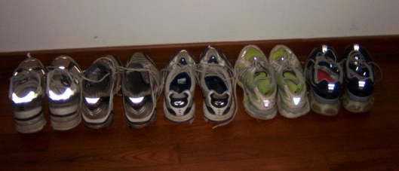

Garry is spelt with two r’s . Garry is married to Mary, spelt with one r. Garry used to be called “Ace” Watson, because he had 11 letters in High School. When he graduated from Michigan State University he bought a brand new Corvette. He then became a schoolteacher, runner, golfer and father. But Garry developed a chronic disease. He cannot resist buying new running shoes.

About ten years ago yours truly was a member of the now famous Fox and Hounds relay team. This team competes with sixty or more other teams in the annual Great Lakes Relay, which traverses the upper part of Michigan’s Lower Peninsula, covering about 250 miles in three days, along highways and byways that become very muddy when it rains. One year, when the team returned to civilization, many team members left their beaten up running shoes in my van. Being of a thrifty nature, I laundered and recycled these shoes.

When I told this story to my running buddy, Garry, he said, “I have some old shoes in my closet which you are welcome to try on.” Now some of these “old” shoes had at least 500 miles on them, while others had no more than 50. Since that time Garry has given me about 30 pairs of shoes, some straight out of the box. So when I am asked what kind of shoes I prefer, I answer, truthfully, Garry’s.

Some of you may wish to be critical of this practice on grounds of fit. You may enquire as to our relative foot sizes and introduce issues of support, stability and shock absorption. You may predict catastrophic orthopedic insults. I would respond to such comments by saying that the shoes vary between size 9 ½ and 10 ½ and that over about 15 years, 15,000 miles and 50 marathons I have never had an injury, other than a (badly) sprained ankle while taking a leak in the woods half a mile into the Boston marathon. I continued the race, in some discomfort, but with only a marginal deviation from my predicted time. I have had blisters occasionally, on the ends of a toe, at the base of my big toe and at the side of my Achilles tendon. These can be explained, respectively, by: my foot sliding slightly forward on impact – that happens to all runners, blame Newton; one foot rolling slightly inward during the stance phase; and those infernal “tendon supports.”

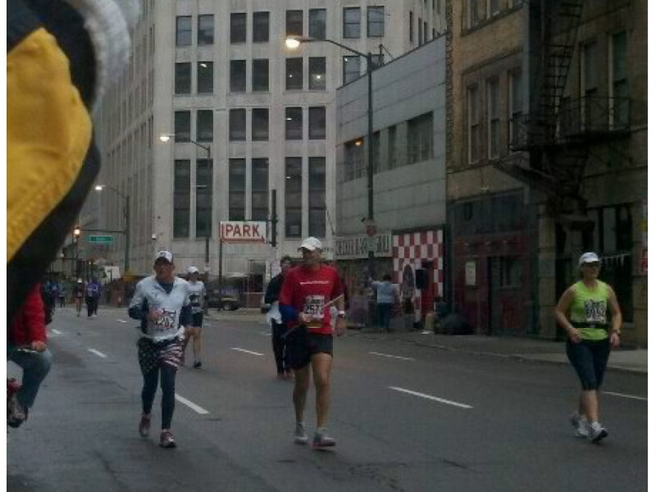

There is an old saying in the world of science that theory without data is philosophy, whereas data without theory is noise. There is a lot of philosophy in shoe talk and much of the data is anecdotal at best. Enter instrumentation and objectivity. It is possible to observe the motions of various leg and foot joints with video and other optical goniometers and one can examine the forces with force plates, strain gages and pressure sensitive inserts. It is even possible to record the electrical activity of many leg and foot muscles with electromyography. The challenge, however is the analysis of this data and the prediction of musculoskeletal disorders, mainly because acute sprains are usually the result of an obvious cause, not related to shoe design, and the development of chronic disorders are logistically difficult to track, with any degree of reliability.

The shoe experts need not despair. Runners are a gullible lot. They are also the only judges of comfort. Most runners are not interested in statistics, other than their times. They are a fashion friendly bunch who spends the pre-race time stretching and extolling the virtues of their new pair of shoes, which give them blisters half way into the race. As for me I will stick to Garry’s. One day I will return a few dozen worn out shoes for recycling.

