Arizona
August 3, 2008
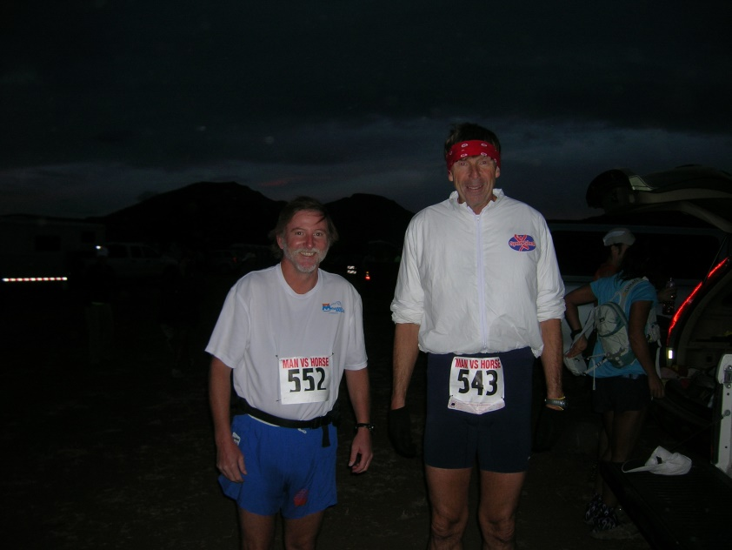

Union Street, New Bedford, MA has a hill up from the harbor and the New Bedford half sports a couple more hills around Mt Vernon and another at mile 12 on County Street. These hills are sufficient to slow down one’s pace somewhat, especially late into the run or race. There’s another little hill on Hix Bridge road where two elderly gentlemen used to be seen puffin’ and pantin’ and dreamin’ of yesteryear on Wednesday mornin’s. These two elderly gentlemen once took a ride up North to a “mountain” race where the more elderly one got his butt severely kicked. The Boston marathon also prides itself on its undulations, especially the Newton hills which are to be found between miles 16 and 21. Flatlanders whine about these trivial challenges.
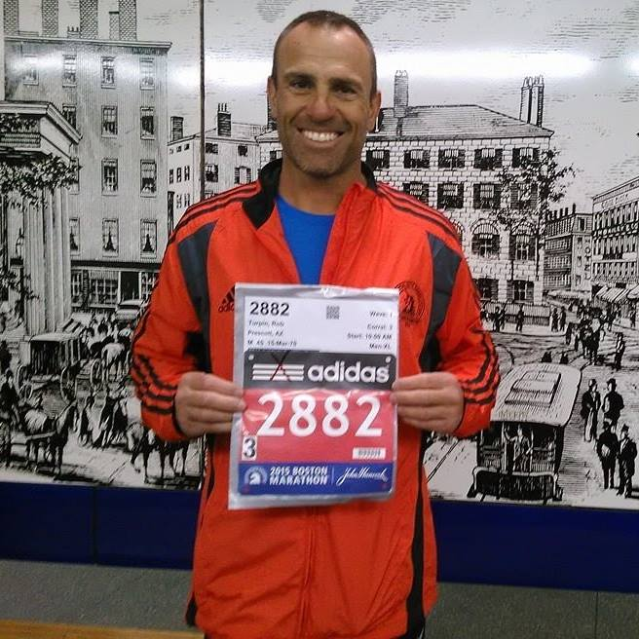

Whereas MA has hills, AZ has mountains. Also MA has rain and gentle warmth but AZ has desert heat and occasional violent monsoons. Phoenix, AZ is down in the valley, where the mercury can rise to 120⁰. Prescott is at 5000’, Flagstaff at 7000’ and Mt Humphrey tops out at 12633’. Now aviators learn all about lapse rate and will be quick to tell you that, under normal circumstances, the temperature goes down 3.6⁰F for each 1000’. Also the air is “thinner” – standard pressure at sea level is 22.92in.Hg. but this pressure drops about 1” per 1000’. The physiological result of these geographical factors is that one gets less oxygen per gulp and needs more red blood cells to push the good stuff to one’s legs. The performance effect is that one runs more slowly in the mountains until one’s body adapts. The good news is that when one travels from the mountains to the lowlands one becomes an awesome spectacle. That is, if age and senility don’t get in the way.

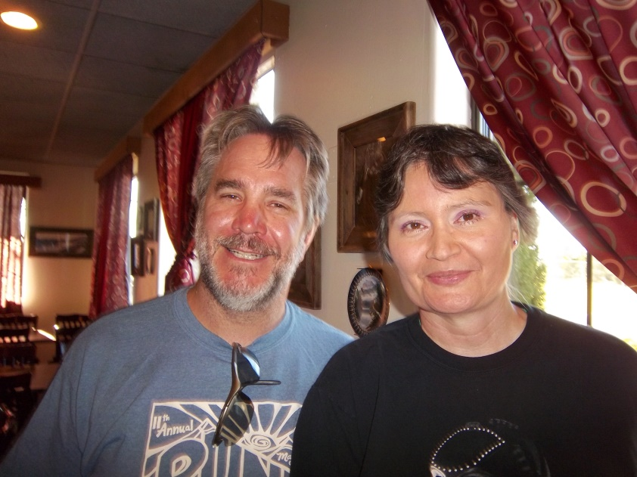
My morning run takes me around two golf courses – the narrower North Course and the newer and wider South Course. There are New Bedford-like hills on these courses and the perimeter distance is about 5 miles. On Mondays, Wednesdays and Fridays I run clockwise and on Tuesdays and Thursdays I unwind. The trick is to do this at the crack of dawn before the golfers emerge from their retirement homes. I must mention that as wisdom comes with age, seniors flock to the Prescott climate and ambience. In winter, when the frost is on the ground I must keep to the roads and paths or risk the wrath of the green keeper who is very protective of his treated grey water lush green grass. On an average day I find three or four golf balls and once I found a dozen. After three years, I now have hundreds of these white and sometimes yellow nuggets sitting in wicker baskets all around my house.
Saturday often takes me around the airport and up a hill for a seven mile out and back. Alternatively I do a six miler around the beautiful Willow Lake or a 10k along the Brownlow trail in Pioneer Park. Now this last mentioned trail has hills. One needs to add about 10 minutes to ones 10k time. Lately I have run on Wednesday evenings and Saturday mornings with members of the local running club – the Mountain Milers (check out www.MountainMilers.com.) Surprisingly I didn’t come across this group until just recently although they have been around for a few years. A motley crew. The leader of the gang is about 6’6” and regularly runs ultra marathons, he is planning to do the annual Man against Horse 50 miler here in October; we also have a young school teacher who ran in the Olympic Trials, her husband is a Southwest Airlines pilot who also kicks a sprightly heel. Then we have a meteorology student / pilot who recently ran a respectable Boston and an aerospace student / pilot who is going to fly in the Navy. Then there is a school teacher who just rode his bike 1800 miles to Minnesota, with his dog. And there is the Staples manager whose excuse this morning was that he had to go gold panning. And a fifty some little lady who is about to do her first marathon – at St Georges. The good news is that these are all newbies – they haven’t heard my stories before. What could be more fun than listening to your own voice all the way through a long run; well not exactly all the way – just until these talented thin air breathers run ahead?
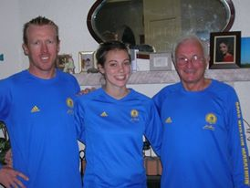
The other day we had to jump over a rattlesnake on the picturesque Peavine Trail, which meanders past the beautiful Watson Lake and through magnificent granite outcrops – a photographer’s paradise. We also see havalinas – ugly looking wild pigs – and rabbits, antelope in herds of 50 or more and all sorts of birds, including the occasional bald eagle. I haven’t actually seen a bald eagle here but there was a photograph in the paper, so that counts. Neither have I seen mountain lions, but there are warning notices on the trail and our lengthy leader recalls seeing one basking in the sun. After the summer rains the flowers are magnificent. All sizes and colors – white, yellow, purple, mauve, crimson, blue and maroon. Mostly the skies are clear blue, but from time to time they are flecked with fluffy white clouds and the occasional angry towering cumulus. The surrounding mountains provide navigation targets for pilots. Granite Mountain to the west shows many shades depending on the sun and the San Francisco Peaks to the north carry beautiful snow caps through the winter and spring. The magnificent sunrises and sunsets have been painted by artists for centuries.
Come and visit soon, I have a spare set of golf clubs. Bring your cameras and sunscreen, snake bite medicine and lowlanders lungs. If you’re lucky you may get to ride in the back seat of a 172 over the red rocks of Sedona.

